HARDSCRABBLE
Civil War Round Table of the Mid-Ohio Valley Newsletter
July 2021 – Vol 12

Notes from Nancy Arthur
In preparation for our November trip South, I’ve been branching out in my reading to several books about the Southern battles fought and places that I know little about.
Partisans & Redcoats is one I’m about to get into. Several of the authors who wrote recommendations are authors I enjoy, so that peaked my interest. The jacket of the book says it is “alive with incident and color” and “presents unforgettable portraits of real-life heroes and villians, Britons and Americans alike”. We could use a few heroes right now, don’t you think?
As I read more, I’ll fill you in next month, unless of course, I’m distracted by another book!
What I’m reading now is A Devil of a Whipping, The Battle of Cowpens by Lawrence E. Babits, the battle that inspired the movie The Patriot. It’s a little slow to start unless you are into weapons; the first couple of chapters talks a lot about the types of weapons and ammo used by both sides and the reason why. It will get better, I’m sure, and since Cowpens is one of the places we are going to visit, I want to have some background before we get there.
And I’m in the middle of South Carolina and the American revolution by John W. Gordon. If you want to do further research than this writing covers, Mr. Gordon has added a complete bibliography . He talks about the Carolina back country and explains the complicated groups of fighters. This was also a war of brother against brother in some families.
On the trip we took to Philadelphia and Gettysburg, the final stop was the George Spangler farm. I ran across an article about it in a past article from April of 2020 in The Civil War Time . If you are in Gettysburg, take the time to visit. George and Elizabeth Spangler purchased their farm in 1848 with 80 acres. With hard work, the farm had grown to 166 acres in 1863. The Spanglers raised four children here, working the farm, until a July morning when Northern surgeons rode up the lane and told the family they needed to leave for their own safety. The Spanglers refused and then were confined to one upstairs bedroom, along with a close neighbor until August 7.
With the close proximity of Baltimore Pike, Cemetery Hill, Little Round Top, etc., many injured were taken to the Spangler farm for treatment in the house and large bank barn. One of these injured was Confederate Brigadier General Lewis A. Armistead, arriving on the 3rd of July after being one of the leading members of Pickett’s Charge across that dreadful field.
Many injured already at the farm crowded around as he was brought in, hours after being wounded. Armistead was placed on a blanket near the barn, then moved to the summer kitchen, where he died on July 5th.
The army took over the farm, using the buildings for a hospital, the yards for the horses, the crops to feed the horses, the animals the Spanglers were raising for food and some of the lumber and fences for firewood. After the war, Mr. Spangler filed damage claims totaling about $5,000 to the State of Pennsylvania and to the federal government. In 1870, he received payment for six tons of hay, totaling only $90.
The Gettysburg Foundation purchased the 80 acres left of the property in 2008 and have restored the barn, summer kitchen and smokehouse. The house is now an education center. This is a visit that is well worth your time.
Some of the notable wounded at Spangler’s Farm, in addition to Armistead, were Brig. Gen. Francis Barlow of the 61st New York, Private George Nixon, great grandfather of President Richard Nixon, 73rd Ohio, and Captain Frederick Stowe, son of Harriet Beecher Stowe, author of Uncle Tom’s Cabin.
For more on this historic farm, read “Too Much For Human Endurance” The George Spangler Farm Hospitals and the Battle of Gettysburg by Ronald D. Kirkwood.
The following looks like a very interesting podcast……..
[Podcast] The American Civil War: Revolution and Counterrevolution (Control Click to follow link)
In Defence of Marxism
Almost a century later, in 1861, the country was plunged into a bloody civil war, which Marxists see as the second American Revolution. This podcast ...
Flag as irrelevant

The American Civil War: Revolution and Counterrevolution
- Print
Socialist Revolution (USA)
15 June 2021
United States Video Class struggle in the USA
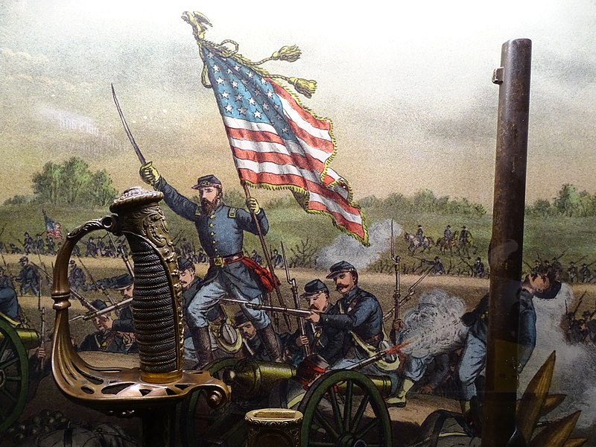
Image: Adam Jones
Share
The United States was founded in the cauldron of a revolutionary war against British rule between 1775 and 1783. Almost a century later, in 1861, the country was plunged into a bloody civil war, which Marxists see as the second American Revolution. This podcast, created by our US comrades at Socialist Revolution, explores this dramatic chapter in world history from a Marxist perspective.
The entire series is listed here, covering the background to the war, the events itself, the major players involved and the aftermath.

Four-part series

++++++++++++++++++++++++++++++++++++++++++++++++
Stories From Bill Teegarden

Here are some fun facts about the American flag you may not have known
By Josh Axelrod and Saeed Ahmed, CNN Today the American flag turns 244, but it doesn't look a day over 200. Here are some fun facts and common misconceptions about the iconic emblem.
Monday, June 14th 2021, 10:12 AM EDT
Updated:
Monday, June 14th 2021, 11:12 AM EDT
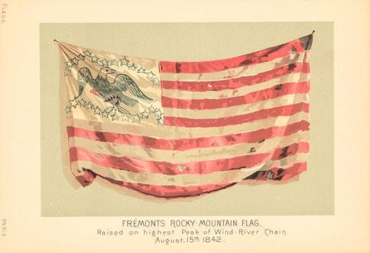
1/2
By Josh Axelrod and Saeed Ahmed, CNN
Today the American flag turns 244, but it doesn't look a day over 200. Here are some fun facts and common misconceptions about the iconic emblem.

Betsy Ross is a phony
Betsy Ross is considered an American hero, known for creating the American flag.
The story says that she lobbied Gen. George Washington to change the design, giving us the historic mock-up, we've come to know and love.
The truth is there is ZERO proof that this ever happened, although it is taught to elementary school children as history. Ross is more in line with American mythic legends Paul Bunyan and Johnny Appleseed than historic figures like Clara Barton or Benjamin Franklin.
Marc Leepson, author of "Old Glory, Flag: An American Biography," wrote, "Every historical study has come to the same conclusion. There's no good historical evidence that she did. But that doesn't mean she didn't. There's simply a lack of documentation. Most historians believe the story is apocryphal."
President Woodrow Wilson, in a ceremony recognizing the first national observance of Flag Day, was asked about his thoughts on Ross.
He replied, "Would that it were true!"
Turns out Betsy Ross is the biggest lie your kindergarten teacher ever told you (except that Bubbles the class gerbil was moving to a farm upstate).

The flag's gone through several make overs
Before the flag's current 50-star design, there were a number of versions, some wackier than others.

The current designer got a B-minus for his idea
The designer of our current flag was a 17-year-old Boy Scout named Robert Heft. What did this talented teen get in return for creating the iconic look? A grade of B-minus.
Heft's teacher asked students at Lancaster High School in Ohio to design a new 50-star flag, after Hawaii and Alaska joined the Union. Robert arranged it with five rows of six stars and four rows of five stars, spending 12 and a half hours sewing the flag.
His teacher said the design was unoriginal and gave him the mediocre grade, but offered to raise it to an A if the design was accepted nationally. So Robert wrote to his congressman and the rest is history.
And when his flag was adopted on July 4, 1960, his teacher changed his grade to an A.

Old Glory belonged to a sea captain
Old Glory is one of the most popular nicknames for the flag, along with the Stars and Stripes and the Red, White and Blue. The phrase is not just a generic nickname; it is actually the name of a specific flag, a 17-foot by 10-foot banner that still hangs in the Smithsonian National Museum of American History.
Old Glory was the most popular symbol of the Union during the Civil War and belonged to sea captain William Driver.
Driver received the flag from his mother and hung it from the mast of his ship. He journeyed for 20 years to China, India, Gibraltar and the South Pacific with the flag adorning his ship.
He wrote, "It has ever been my staunch companion and protection. Savages and heathens, lowly and oppressed, hailed and welcomed it at the far end of the wide world. Then why should it not be called Old Glory?"
In the midst of Driver's retirement from seafaring, the Civil War broke out. The sailor had been born in Salem, Massachusetts, but moved to Nashville, Tennessee, and his flying of the Union flag greatly angered Confederates.
Driver fended off numerous attempts from Confederate soldiers to steal Old Glory and waved it defiantly during battles.
Before he died, he passed along his prized possession to his daughter Jane Roland, saying, "This is my old ship flag Old Glory. I love it as a mother loves her child; take it and cherish it as I have always cherished it; for it has been my steadfast friend and protector in all parts of the world -- savage, heathen and civilized.

Historically speaking: Women soldiers in the Civil War
Vic Butsch
For The Bulletin
View Comments
There are sources that estimate that roughly 400 to 750 women served between the Union and Confederate Army. The reasons the women went to war were similar as the men: to collect wages, a feeling of strong patriotism, looking for adventure, wanting to abolish slavery, and to stay with their loved ones.
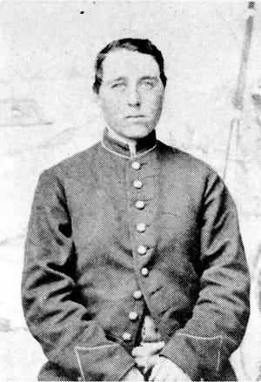
Sarah Edmonds Seelye, who signed on as Franklin Flint Thompson, when she joined the 2nd Michigan Infantry, said “I could only thank God that I was free and could go forward and work, and I was not obliged to stay at home and weep." After the war, she had the honor of being the only woman to receive a veteran's pension after the war.
Other women who served included Jennie Hodgers, who joined the 95th Illinois Infantry as Albert Cashier, and fought with her fellow soldiers in over forty different battles. Frances Clayton, one of the better-known women fighters, used her real name, fought with the 4th Missouri Artillery, and was wounded at Shiloh, and at Stones River. There are some conflicting accounts of her service and there is no official military record of her service. Lieutenant Harry Buford, who was really Loreta Janeta Velazquez, was both a spy and Confederate fighter. There were likely so many more women who fought, but their stories are lost to history.
Interestingly, the women who did join and fight, were not as easily exposed as we may assume. At the start of the war, the women who enlisted participated in the same military training as the men so therefore, their military inexperience was not out of the ordinary. To make it easier to “hide in plain sight” the Victorian morals of the time kept most soldiers from being exposed when sleeping or bathing. Additionally, the heavy cloth uniforms, which were generally poor fitting anyway, were perfect to hide a woman’s body. Further, many young soldiers did not grow a beard which helped the women keep their secrets.
The secret was most often discovered if the soldier was wounded and sent to the field hospital where they’d be discovered by the nurses or the doctors. Clara Barton, perhaps one of the most famous nurses at the time, was said to have discovered a few women soldiers. There were also times when, due to sicknesses, the doctors would want to inspect all the troops and the women had no place to hide.
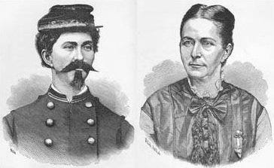
Such was the case for Florena Budwin from Philadelphia. She enlisted with her husband and served along side of him until he was killed in battle. She was captured in the same battle and sent to Andersonville prison and then to Florence prison in South Carolina. Her health deteriorated over several months as she tried to help at the prison hospital. During a mandatory inspection, she was discovered to be a woman. All her fellow soldiers were shocked. Both armies took care of her and women from the town of Florence sent clothes for her. She died on January 25, 1865, at Florence Prison and is considered to be the first woman buried with full military honors in a National Cemetery.
Vic Butch started the Norwich Civil War Roundtable and recently retired from Electric Boat. He served on the Board of Directors of the Norwich Historical Society for many years and gives Civil War Cemetery Tours of Yantic Cemetery periodically.
#########################
Why the Civil War Battle of Antietam Was so Horrific A bloody affair.
by Warfare History Network

The Battle of Antietam was pitched and especially violent. This is how brother fought brother.

In the late afternoon of September 17, 1862 the 7th Maine Regiment received new orders. The Battle of Antietam had raged throughout the day. Thousands were dead and even more lay wounded on the field or suffering in hospitals behind the lines. After horrible combat at places known afterward as The Cornfield and Bloody Lane, the fighting climaxed at the lower bridge over Antietam Creek that historians called Burnside’s Bridge in memory of Maj. Gen. Ambrose Burnside who failed to capture it in a timely fashion. The 7th Maine was about to enter this action and its place in the history of the American Civil War.

Twenty-one year-old Major Thomas Hyde, a native of Bath, Maine, commanded the regiment was part of Colonel William H. Irwin’s brigade of Maj Gen. William Franklin’s VI Corps. The unit was seriously understrength that day. Only 181 men remained of its original complement of 1,000.
Hyde’s regiment had gone into action at the Bloody Lane and then taken up a position behind limestone outcroppings on the rolling hills west of Antietam Creek that afforded it a measure of protection from enemy fire. In that location the men dodged desultory enemy fire. When they could, the regiment’s marksmen sniped at enemy artillerists and officers.
Hyde and his men expected that when night arrived they would be relieved; however, like other regiments they lacked knowledge of how the battle was progressing. Irwin eventually issued new orders to Hyde. He told the major to lead his regiment in an attack against the Piper Farm where Lt. Gen. James Longstreet and Maj. Gen. Daniel Harvey Hill had cobbled together infantry regiments and batteries for a final stand following the Confederate retreat from the Bloody Lane Hyde and his men expected that when night arrived they would be relieved; however, like other regiments they lacked knowledge of how the battle was progressing. Irwin eventually issued new orders to Hyde. He told the major to lead his regiment in an attack against the Piper Farm where Lt. Gen. James Longstreet and Maj. Gen. Daniel Harvey Hill had cobbled together infantry regiments and batteries for a final stand following the Confederate retreat from the Bloody Lane.
Hyde believed the order was foolish. He told Irwin that an unsupported attack against such a position was tantamount to suicide. He felt a personal responsibility for his men and was unwilling to lead them in such a perilous attack. Irwin repeated his orders and then asked an insulting question meant to goad Hyde into leading the attack. “Are you afraid to go, sir?” asked Irwin.
Hyde wanted the men of the regiment to know that it was Irwin’s idea and not his own. “Give the order so the regiment can hear it, and we are ready, sir,” Hyde said.
The 7th Maine obeyed its orders and advanced toward the farm. Waiting to receive their attack were the remnants of four Confederate brigades from Hill’s division and Maj. Gen. Richard Anderson’s division.
The Rebels poured a deadly fire into the small group of Union soldiers. The Maine men found themselves trapped in farmer Henry Piper’s sprawling apple orchard. The repulse of Hyde’s regiment was over quickly. The survivors limped back to their previous position. Of the 181 men who participated in the attack, 12 were killed, 63 wounded, and 20 reported missing. Of the wounded, 13 succumbed to their wounds. They later learned that Colonel Irwin had been drunk when he sent them forward in such senseless slaughter.
The Battle of Antietam is full of such small stories, tales that combine to reveal the horror of one of the Civil War’s worst days. Antietam is remembered as the bloodiest day in American military history. Union casualties numbered 12,400 men, and Confederates casualties amounted to 10,320.
The Union Army won a strategic victory for it repulsed General Robert E. Lee’s first invasion of the North, forcing him to retreat shortly afterward to Virginia. But that victory had a high cost. The story of this dreadful battle is told in detail in A Fierce Glory: Antietam—The Desperate Battle That Saved Lincoln and Doomed Slavery (Justin Martin, Da Capo Press, Boston, MA, 2018, 336 pp., maps, photographs, notes, bibliography, index, $28.00, hardcover).
Although there are many books on the Battle of Antietam, this one stands out for its superb use of first-hand participant accounts. The author weaves the broader story of the battle into the work in a seamless manner. He also describes the role of famous noncombatants associated with the battle, such as nurse Clara Barton and photographer Alexander Gardner. In addition, the far-ranging consequences of the battle are discussed at length.
The result is a work that engages readers and retains their interest page after page. The book includes a useful section for visitors to the battlefield park, helping them understand the terrain in relation to the action. For these reasons, the book is a worthy addition to the works available on Antietam and the American Civil War.
This article by Christoper Miskimon first appeared at Warfare History Network on January 18, 2020.
////////////////////////////////////////////////////////////
Books by Bill
I finished a couple of books that I found interesting.
Shiloh: Bloody April by Wily Sword. Having overlooked the battle of Shiloh, Wily was the person to put me straight. He spends a quarter of the book positioning both sides, then another half on the Confederates' first day, followed by a quarter on the Union's second day. His focus is the battlefield - who is doing what and was that move good or bad for the outcome. Thoroughly engrossing read.
The Civil War Chronicle by J.Matthew Gallman was a delight to read. The format is unique - day by day portrait of the conflict as told by soldiers, journalists, politicians, farmers, nurses, slaves and other eyewitnesses. I found a lot of "new" information and the things that I had read previously were old friends that dropped in for a visit. An amazing compilation of events into a nice read.
&&&&&&&&&&&&&&&&&&&&&&&&&&&&&&&&&&&&&&

