HARDSCRABBLE
Civil War Round Table of the Mid-Ohio Valley Newsletter
August 2021 – Vol 13

Notes from Nancy
Quarterly I receive a publication from the Gettysburg Foundation called Preservation & Progress. The recent edition is concentrated on Culp’s Hill and the restoration work being done on this often-overlooked part of the battlefield.

Culp’s Hill is located southeast of town and saw major fighting and repeated change of positions on both July 2 and 3. The Union fought off the Confederate force three times their size.

I had read change and clean up were coming but wow! When I was there in March, chain saws had been working overtime and by the time I went in April, there was a huge difference. I’m going back in October so watch for an update.

The Culp’s Hill area was proposed because, according to surveys, it is one of the least visited areas and is every bit as important to the battle. We have all heard of Devil’s Den, Little Round Top, the Peace Light Memorial, and others. But so much happened at Culp’s Hill! And the cleanup makes it more visible and easier to understand.

Thanks to the National Park Service and the Gettysburg Foundation combining resources, along with a generous donation from Cliff Bream III and his wife, Julie St. John, the site is being taken back to how it looked during the battle. He serves on the Foundation’s Board and his ancestors owned the Black Horse Tavern west of town. They currently reside in California and have provided a sizeable fund for restoration and starting a fund for continued maintenance.

The project started in February, on 18 acres of ground, by removing trees 5 inches or less in diameter and clearing off low lying brush to expose breastworks. Trails have been made or made safer and interpretive signs are being installed.

And the tower is reopened; in fact, all 3 of the towers of Gettysburg and the Pennsylvania Monument are ready to climb again and get a bird’s eye view of the battlefield. They were closed during the pandemic.

Stories from Bill Teegarden

Mountaineers Are Always Free

Celebrating the creation of West Virginia, a living testament to liberty.
Chris Stirewalt | Jun 21 | 100 | 54
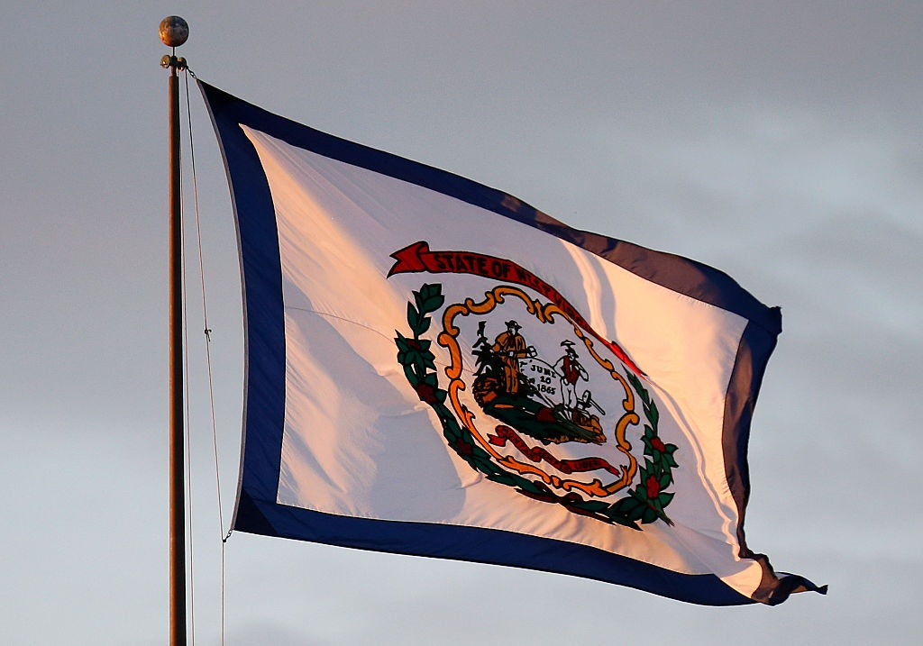(Photograph by Justin K. Aller/Getty Images.)
We have talked a great deal about the first federal observance of Juneteenth, and rightly so. There is much to grieve in the story of black Americans, and Martin Luther King Jr. Day, an honor for a martyr, is an appropriately somber occasion. But we must also always rejoice in our triumphs, and the destruction of slavery here is a triumph insufficiently celebrated.
“He has sounded forth the trumpet that shall never call retreat,” so the song goes. “Oh, be swift, my soul, to answer Him! Be jubilant, my feet!”
But you probably did not notice the weekend’s other triumphal holiday from the Civil War, unless you happen to be one of us lucky sons or daughters of the Mountain State. Sunday was West Virginia Day, the celebration of the 158th anniversary of the creation of the state, a living testament to liberty.
Its creation was, ahem, a little shady. Even the state’s great benefactor, Abraham Lincoln, could only summon this weak defense: The division of a State is dreaded as a precedent. But a measure made expedient by a war, is no precedent for times of peace. It is said the admission of West Virginia is secession, and tolerated only because it is our secession. Well, if we can call it by that name, there is still difference enough between secession against the Constitution, and secession in favor of the Constitution.
The Great Emancipator, paragon of the Founders’ vision, defender of the Constitution, lo, unto his death, could basically come up with “Yeah, and so’s your sister…” to defend granting West Virginia its statehood. Plain Virginia, as my children obligingly call it, had the better legal case to make for reunification after the war was over. And by this week in 1863, Americans were coming around to the idea that the war was going to be over and in the Union’s favor … probably.
The previous year was the closest the United States has ever been to the end. In 1862, Gen. Robert E. Lee and his forces had run circles around Gen. George McClellan. European powers, led by cotton-hungry Britain, might have forced a ceasefire that would leave America permanently divided and crippled. The country that 78 years later would answer to Winston Churchill’s plea, “the New World, with all its power and might, [will step] forth to the rescue and the liberation of the old,” was very nearly done in by American slavers boosted by British textile barons.
But, by this week in 1863, troops under Gen. Ulysses Grant had besieged the last Confederate stronghold on the Mississippi River at Vicksburg. Even better, Lincoln had in the spring evicted notable twerp and soon-to-be Democratic presidential nominee McClellan from command of the Army. Ominously for the South, the Battle of Antietam had shown that the slaughter of the war would be industrial in scale. The rebels could not match the ingenuity and productivity of the North. So, while the Confederate defeat at Gettysburg was still a week away, plans for life after the war were taking shape.
This is why West Virginia Day remains a big deal for the small population of the 35th state. The Constitution holds that no state can be divided by the federal government. Kentucky, Maine, and Vermont had all been part of other states, but their mother states had chosen separation and petitioned Washington. While the government in what was then Wheeling, Va., claimed to speak for the whole commonwealth—“the restored government of Virginia”—that was far from the truth. Richmond would not fall for nearly two years and the people on the eastern side of the mountains surely did not recognize a bunch of businessmen, abolitionists, German immigrants, and damnYankees 350 miles away as their legitimate government.
The western Virginians who broke away after the state joined the Confederacy two years prior had already provided most of the benefit they could to the federal cause. The Ohio River and rail lines to the west were secure and the foundries and factories along the river were churning out war materiel. The Confederates did not pose a significant threat west of the Allegheny Mountains even by the end of 1862, when the statehood bill had been presented to Lincoln. Certainly by the third summer of the war, it would have probably been better for Lincoln to maintain the status quo of the phony-baloney “restored government.”
The Radical Republicans in Congress had been pressing him hard for West Virginia statehood among other demands. Caving on a question of constitutional propriety did not appeal to Lincoln. It also could complicate his efforts to bring Virginia back. “Doubtless those in remaining Virginia would return to the Union, so to speak, less reluctantly without the division of the old state than with it,” he wrote. But West Virginians had “been true to the Union under very severe trials.” “We have so acted as to justify their hopes;” he wrote, “and we cannot fully retain their confidence, and co-operation, if we seem to break faith with them.” West Virginia had earned its place, the 35th star on the flag and the only state born of the Civil War.
Today is a state holiday and celebrations will take place across West Virginia’s 55 counties. That’s a lot of terrain. West Virginia stretches as far to the east as the suburbs of Washington, D.C., and as far to the west as Detroit. Her southern tip is below Richmond, Va., but she goes as far north as New York City. In all that space, there are just 1.8 million souls, about the same number as in the city of Phoenix. And today, they will proudly wave the state flag, at the center of which are three important reminders. The date of our statehood, the Phrygian or “liberty” cap that is the symbol of freed slaves, and our motto: Montani semper liberi, “Mountaineers are always free.”
So, if you want to keep going with the Juneteenth celebration of the defeat of slavery and the new birth of freedom, toast your friends in West Virginia today. (Moonshine is strictly optional.)
((((((((((((((((((((((((((((((((((((((((((((((((((((((((((((((((((((((((((((((((((()))))))))))))))))))))))))))

Last shot: Alaska’s odd role at the end of the Civil War
By SUZANNE DOWNING / MUST READ AMERICA
(Editor’s note: This column was published at Must Read Alaska on June 19, 2020 and is republished on June 22, 2021.)
Americans are being carpet-bombed by stories about Juneteenth, celebrating the day that 155 years ago the final fighters of the Civil War got the memo that the slaves were emancipated. We’ll leave that to the other pundits to discuss, because we’ve got our own Civil War history in Alaska to review.
While Texas was just getting word of the end of the war on this day in 1865, a Confederate war ship was still prosecuting a sponsored piracy campaign and taking down the commerce of the Union whaling industry.
Few in America have heard of Alaska’s unique role in the end of the Civil War.
In June of 1865, the Confederate raiding ship CSS Shenandoah was underway toward St. Lawrence Island, in the Western Bering Sea, where Yankee whaling ships were working.
The war ship was burning and sinking the U.S. whaling fleet in its path after the captain of the Shenandoah had gotten rough coordinates for where the Yankee whalers were working. He took them from a whaling ship in the North Pacific.
By this time in 1865, the Shenandoah had destroyed a number of these American whaling ships — as many as 20.
On June 22, 1865 the Shenandoah fired what is said in some accounts to be “the last shot” of the Civil War, aiming upon Yankee whalers, some 74 days after General Robert E. Lee had surrendered his Confederate forces at the Appomattox courthouse, and nearly two months after Confederate Army had actually ended the war on land.
There are lots of credible sources that say the event occurred on June 28, 1865, and that whaling ships were still being burned and sunk right and left on June 22, but most historians agree on one thing: This was a well-executed mission and it decimated the whaling fleet.
When Commanding Officer Lt. James Iredell Waddell of the Shenandoah learned of the South’s surrender, he made his way south. Some accounts say he didn’t believe the war was over and was heading to the young state of California to shell San Francisco, another commercial center. California had supplied thousands of soldiers for the Union war effort, and troops from California had pushed the Confederate Army out of Arizona and New Mexico in 1862.
On the way south, his ship encountered a British ship that confirmed the war had ended and that if he showed back up in the United States he would be tried and hanged.
By this time, Waddell had a bounty on his head and he decided to sail his teak-hulled war ship on to Liverpool, England, where he surrendered on Nov. 6, 1865.
Waddell’s was the last surrender of the Civil War, and he presided over the lowering of the Confederate flag on his ship while at anchor on the River Mersey.
The ship itself was put in the custody of the British government via a letter that Captain Waddell penned himself and walked up the steps to the Liverpool Town Hall, presenting it to the Mayor of Liverpool.
The Shenandoah is the only Confederate ship to circumnavigate the globe. Her flag is now in the possession of the American Civil War Museum, which brings it out only occasionally, due to its size.
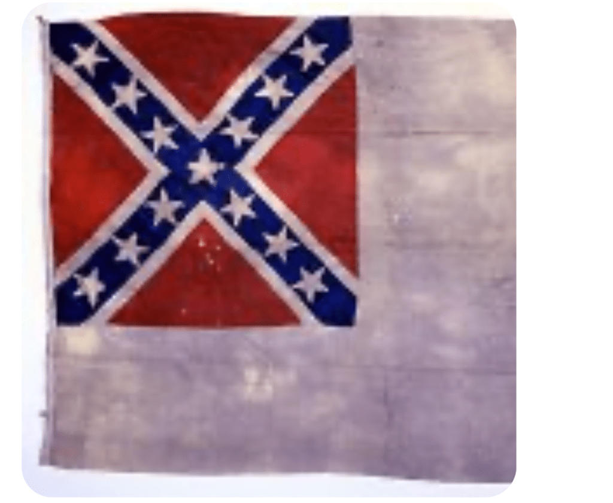 The Shenandoah’s flag is rarely displayed due to its size (roughly 7 feet x 12 feet).
The Shenandoah, which was commissioned to destroy the commerce of the North, had spent nearly a year at sea and had captured 38 ships — two thirds of them after the Confederacy had surrendered. Waddell had reportedly taken more than 1,000 Union prisoners.
The history of how the news reached Captain Waddell is conflicted. The Civil War Museum says that raids continued in Alaska, which was in Russian ownership at the time, until August.
After the Civil War ended, the whaling business fell on hard times, as it was no longer essential to the war effort, and with so many of the Union whaling vessels destroyed, America lost footing in the world as a leader in shipping.
And now, 155 years later, Democrats are destroying the monuments to their Confederate war heroes, and, ironically, they are still trying to destroy United States commerce. Also somewhat ironically, Republicans are still trying to respect the confederacy and its history, because it is the history of the nation.
Alaska had a unique role back in the 1860s. It was not American territory, but it soon became part of the United States under the advocacy of abolitionist William Seward, secretary of State for President Abraham Lincoln. Democrats in Alaska are now trying to remove the statue of Seward from in front of the Capitol.
A nation should be able to talk about its Civil War without getting into another one. The important lesson is that we learn from history, so that we don’t repeat it.
Suzanne Downing is editor and publisher of Must Read Alaska and writes a Must Read America column for NewsMax.

REVIEW

BOOK REVIEWS

A Woman Is Committed To An Asylum For Thinking In 'The Woman They Could Not Silence'
- Facebook
- Twitter
- Flipboard
- Email
June 23, 20216:13 AM ET
ANNALISA QUINN
Twitter
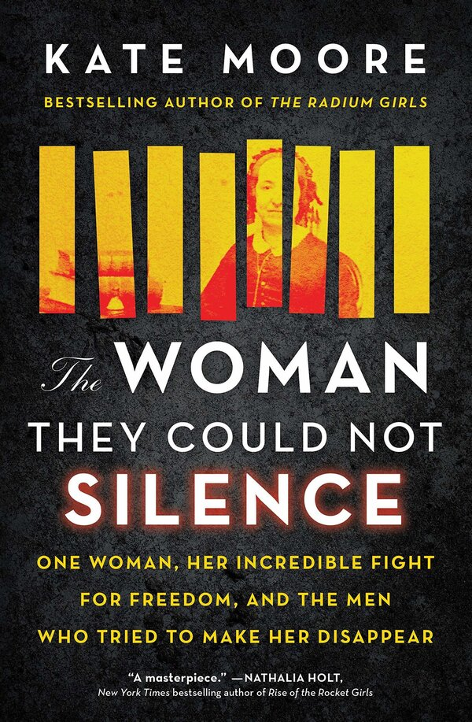
The Woman They Could Not Silence: One Woman, Her Incredible Fight for Freedom, and the Men Who Tried to Make Her Disappear, by Kate Moore
Sourcebooks
One day in the summer of 1860, an Illinois woman named Elizabeth Packard watched as an ax crashed through her bedroom window.
A wife and mother, her life had previously been relatively quiet, centered on home and church. But she and her husband Theophilius, a preacher, had begun having theological arguments. Disturbed by these, and the idea that Elizabeth was "becoming insane on the subject of women's rights," as he later wrote, Theophilius decided to have his wife committed to an asylum. Hence the group of men climbing through the broken window, and carrying her, immobile, to the train that would take her on to the Jacksonville Insane Asylum.
Incarcerated in the asylum for three years, she would go on to write bestselling books chronicling her experience and would campaign successfully against laws that allowed husbands to lock up their wives without trial. Kate Moore's The Woman They Could Not Silence: One Woman, Her Incredible Fight for Freedom, and the Men Who Tried to Make Her Disappear is the story of Packard's fascinating lifelong fight.
In an author's note, Moore writes that she wanted to look at the ways that women have been dismissed as "crazy" throughout history. But most of the stories she read were painfully bleak. "'Crazy' was a cul-de-sac, a one-way street that only ever ended with one outcome," she writes. One Illinois woman she read about was lobotomized in 1955 without any diagnosis aside from being "unfriendly" and "disagreeable." But in Packard, Moore found an ideal hero, one with a "spirit as wide as her skirt" who not only fought the system but won.
Article continues after sponsor message
Packard's writing, quoted generously, is the best part of the book — resolute, warm, both soulful and practical. But because it is quoted often without chronology or context, it is hard to see her intellectual development, the beginnings of her feminist stirrings, and the evolution of her relationship with her husband. Moore, the author of The Radium Girls, is a clear writer but prone to overreliance on metaphor, and painfully eager to make sure we never miss the point ("Quietly, she moved about the house...footsteps as muffled as a woman's gagged voice.")
A particular oversight is Packard's religious views, which are never fully explained or explored, despite being the primary justification for her incarceration. Packard's campaign was a feminist one, yes, but she also saw it as very much a Christian one. A kind of radiantly certain, almost Antigone-like figure, she thought she was doing God's work.
But the book's strangest and biggest omission is the subject of slavery. Packard's time in the asylum overlapped with the American Civil War, and she drew freely on the struggle for emancipation in her own writings. Moore, too, often juxtaposes the two movements, tying breakthroughs in Packard's case with particular battles or turning points in the war. But while Packard was an abolitionist, she also held deeply racist views, writing in one of her many political pamphlets, "It is my candid opinion, that no Southern slave ever suffered more spiritual agony than I have suffered; as I am more developed in my moral and spiritual nature than they are, therefore more capable of suffering." Moore never quotes these lines, or explores Packard's belief that she was more spiritually elevated than the enslaved people she relied on so often as metaphors for her own condition.
The book illustrates the particularly skewed incentives of inspirational biographies — to flatter, flatten, and portray someone in line with the presumed values of its values. In her author's note, Moore writes that she had to dig through a "century of received wisdom" about Packard before finally "the shape of the true woman stood before me." Perhaps this was a warning sign — how possible is it really to see someone's true shape? And perhaps more importantly, what person only has one shape? In The Woman They Could Not Silence, we meet Elizabeth Packard the inspiration — and she is an inspiration — but we don't quite see the radical, the believer, the racist, or the thinker.

^^^^^^^^^^^^^^^^^^^^^^^^^^^^^^^^^^^^^^^^^^^^^^^^^^^^^^^^^^^^^^^^^^^

Journalism in Montgomery County
The Sentinel's Legacy

THIS WEEK

Join us for a REWIND from the 2020 History Conference!

"Montgomery County Sentinel: The Evolution of Local Journalism Since 1855"
with Paul Schwartz, Tom Farquhar, and Daniel Kucin, Jr.
Premieres Monday, June 28

Enjoy this must-see presentation that brings attendees through a 164-year journey of local history as told through the news stories covered in the Montgomery County Sentinel: one of the most important sources of local journalism. The paper covered everything from civil rights to the Civil War, 20th century development, two world wars, and more. Though the Montgomery County Sentinel ceased printing in 2020, it still serves as an online news outlet.

Learn more about Montgomery History's digitization campaign to make the Sentinel and Montgomery County Gazette readily available.
﻿
There is no registration link for this talk. The REWIND will premiere on our website at 10:00 a.m. on Monday, June 28 and be available to watch through Sunday, July 4.

NEXT WEEK

“I commence my journal…”: What Carrie Miller Farquhar Told her Diary…and What She Left Out
with Joanna Church
Wednesday, July 7 @ 7:00 p.m.

Like many women of her generation, Carrie Miller Farquhar (1842-1904) kept a diary for much of her life. These twelve volumes, now in the Montgomery History collections, detail both her young adulthood in Alexandria and Sandy Spring, and (after a gap of nearly two decades) her married life on a farm in Norbeck. Carrie’s words offer present-day historians a wealth of detail about mid-late 19th century education, faith, politics, war, agriculture, child-rearing, and social activities in Montgomery County. At the same time, we know from other sources that there are many stories and events that Carrie did not choose to write down, including her somewhat tumultuous courtship with Roger Brooke Farquhar, Sr., whom she married in 1867. This presentation will reap the benefits of this wonderful primary source – sharing Carrie's story, using moments described in her diary from the exciting to the mundane – and examine the limitations of relying on a single voice, even a seemingly candid one, to study the past.

Click here to register!

P.S. If you missed last week's talk "The Tubman Country Experience," catch up now on our website!

If you have questions about accessing History Conversations, please contact Matt Gagle, Director of Programs, at MGagle@MontgomeryHistory.org.

***************************************************************************

Rewriting History
Education professor Chara Bohan on how the Lost Cause narrative came to dominate U.S. history books — and the lingering effects of our miseducation.

Interview by Jennifer Rainey Marquez
If history is written by the victors, then post-Civil War America is a rare exception to the rule, says Chara Bohan, professor of educational policy studies in the College of Education and Human Development.
Last year, Bohan and her collaborators, including Dean’s Doctoral Fellow Wade Morris, analyzed history textbooks published in the decades after Reconstruction and found the “Lost Cause narrative,” which advocates a heroic view of the Confederacy, not only predominated in Southern classrooms but crept into history textbooks used across the North as well. By the 1930s, the so-called “mint julep” portrayals of figures including John Brown, John Wilkes Booth and Nathan Bedford Forrest had become the national consensus.
This recasting of history carries on today, says Bohan, as publishing companies continue to print different versions of history books to comply with the priorities and educational standards of various states. We spoke with Bohan about her research and the lingering implications of Americans’ miseducation.

How did these “mint julep” history books come about?
After the Civil War, from the 1870s through the 1910s, public schooling became more widespread in the South, and Confederate sympathizers wanted to ensure that their children received an “appropriate” education on Southern history and culture. To that end, Southern states developed statewide adoption policies for textbooks. This allowed the state textbook committees to control content by demanding changes or threatening to cancel book contracts unless the publishers acquiesced. Today, most of the states with statewide textbook adoption policies are still in the South.
To keep their business, Northern publishers began adapting history books to appease Southerners, essentially publishing a separate version of Civil War history for those states. These editions reinforced a Lost Cause narrative for Southern audiences. For example, they depicted enslaved people as happy and content. Officials even counted the textbook lines to make sure authors had mentioned Jefferson Davis or Robert E. Lee as many times as Abraham Lincoln or Ulysses S. Grant.
What our research shows is that as time progressed, increasingly the Southern version of events began infiltrating Northern textbooks as well. As the Southern and Northern narratives merged, Southerners really influenced how and what Americans learned about the Civil War no matter where they lived.

The North won the war, but the South still got to write the history?
The South certainly won the textbook war, although it happened gradually.

Can you give an example of how the Southern perspective seeped into Northern textbooks?
One example is how the books depict Abraham Lincoln’s assassination by John Wilkes Booth in 1865. In the 1890s, “mint julep” textbooks either ignored the assassination or distanced Southerners from Booth’s actions by deemphasizing his accomplices. Meanwhile, Northern authors linked Booth to a broader conspiracy plot, thus implicating many Southerners in Lincoln’s murder. By the 1930s, though, Northern authors had begun mimicking their Southern counterparts, ignoring the conspiracy and focusing more on Booth’s mental state, dismissing him as an insane actor.

How did you get interested in studying these texts?
I’ve always found old textbooks interesting because they themselves become artifacts of the time period. You can’t escape the context of the times when you’re talking about history. In 2012, I edited a book called “Histories of Social Studies and Race: 1865-2000” and I was amazed at how racist these history books appear to modern sensibilities.
Textbooks also have dominated education for more than hundred years, providing a road map for the school curriculum. So they have a tremendous influence on what Americans learn and as a result, they’ve been heavily policed by interest groups from all sides.

For so long, history has also been told from an almost exclusively white perspective. What are some of the factors that have contributed to that one-sided lens?
The whitewashing of history is pervasive, although there have always been Black scholars, even during the period following Reconstruction, who have challenged these narratives. But they have typically been discounted as minority opinions. You also have to remember that before the Civil War, there were laws banning the teaching of literacy to enslaved individuals, and after the war ended there was a real struggle to create schools for African Americans. As a result, there are fewer primary sources from that era that center on Black voices. There are many groups left out of the story and many of those same groups weren’t educated, which made it harder for them to get their stories told. Now we have a multiracial coalition of people who are recognizing how much we have never learned.

You’ve also looked at how history textbooks affect the way people view Confederate monuments.
You have two sides that have two different understandings of history and of the world. People latch onto histories, like the narrative of American exceptionalism, yet slavery and the fight to preserve slavery is a deeply shameful part of our past. For decades, white Southerners studied a version of the Civil War that all but ignored the experiences of the enslaved and glorified the actions of Confederate leaders. These are deeply held beliefs that transcend generations and changing minds will not be easy.

How does the whitewashing of history affect students of color?
There’s a book by Terrie Epstein called “Interpreting National History” about what happens when students’ racial identities rub up against their teachers’ pedagogies. What she found is that white students tend to trust this grand narrative of American exceptionalism that they’re being taught. Meanwhile, Black students tend to be more skeptical of these lessons, because they’ve had family stories passed down to them that counter what is being presented in the classroom. Epstein also found that teachers often shut down students who push to interrogate issues of racism or racial violence.
For Black students, there can be emotional harm if they can’t trust what they’re being taught, and yet these inaccurate perspectives are being perpetuated while their own stories are left out. For example, many history books don’t acknowledge things like African cultural retention — the traditions and customs that we think of as “American” but that were actually brought from Africa by enslaved people.

What’s the best way to do get to a place where all students can trust what’s being taught?
One way is to go to primary sources and really search to find different voices and perspectives. I’m working on a new book, “Teaching Enslavement in American History,” which I coauthored with Georgia State historian Robert Baker and LeGarrett King at the University of Missouri, and we were purposeful about incorporating Black voices and Black agency.

Do educators need to reconsider how they’re teaching history?
Most teachers in America are white and female, yet most cities have majority-minority student populations, so we need teachers to understand the complexities involved in teaching history and question their own assumptions. Remember that teachers grew up learning these things, too, and not just in the South, as our research shows.

In 2016 and 2018, you received a grant from the National Endowment for the Humanities to fund a summer program for U.S. history teachers to discuss slavery and equality as constitutional issues. How important is continuing education for teachers?
As a teacher, you have to keep educating yourself because the historical evidence changes. For example, when I started teaching in 1990, experts didn’t know the precise location of the Jamestown settlement. Eventually the brick outlines of the buildings’ foundations were discovered, and now they’ve learned more about how people lived in that first permanent settlement in North America that was run by the British. I phrase it that way because there were other permanent settlements that predated Jamestown, but we don’t talk about those because they were run by the Spanish. In the U.S., the British narrative tends to dominate. Why? Because the British defeated France and Spain prior to the American Revolution. The winners write the history. That’s why I’m so fascinated by the idea of Southern textbooks — it’s such a flip of the typical story.

…………………………………………………………………………………………..

Books by Bill
Uncounted
https://www.google.com/url?rct=j&sa=t&url=https://www.marketplace.org/2020/09/21/how-black-americans-have-been-blocked-from-voting-throughout-u-s-history/&ct=ga&cd=CAEYACoTODc2MjIwNTA3ODA5MTg5NjU4NTIaYmFmYWNiYzIxYTg5YmViZTpjb206ZW46VVM&usg=AFQjCNH6YtJFZbBRVoQyS84CP1YnlbjEJA
Camp Randall Prison
https://www.google.com/url?rct=j&sa=t&url=https://www.greenbaypressgazette.com/story/news/local/door-co/2020/09/25/camp-randalls-civil-war-prison-detailed-book-door-county-writer/3534440001/&ct=ga&cd=CAEYACoTOTA2NTc2NjQwODE2NTg5MTkwNzIaZWM4MTNkOWI2ZjZiZmFjNjpjb206ZW46VVM&usg=AFQjCNFVFHZBoKZHRjqvsBr38pk8g_6mJg

I Jonathon
https://www.google.com/url?rct=j&sa=t&url=https://www.prnewswire.com/news-releases/civil-war-novel-sees-conflict-through-new-eyes-301143512.html&ct=ga&cd=CAEYACoUMTQyMTM0ODQ4NzYwMjY2MTg0NDEyGmVjODEzZDliNmY2YmZhYzY6Y29tOmVuOlVT&usg=AFQjCNEIO1jrQ8J--ktnfjngorzOMKTFPQ
Bullets & Bandages
https://www.google.com/url?rct=j&sa=t&url=https://www.dailyamerican.com/ourtownjohnstown/news/bullets-and-bandages/image_5fc825e4-fdde-11ea-a5f6-3f89f6eab9eb.html&ct=ga&cd=CAEYCSoTMTg0NzQyOTkwMjcwOTA2OTEzNjIaYmFmYWNiYzIxYTg5YmViZTpjb206ZW46VVM&usg=AFQjCNFx_ykPOnBX_TIGiNFdgydS7kPUKQ
Congress at War
https://www.google.com/url?rct=j&sa=t&url=https://www.postandcourier.com/features/book_reviews/review-congress-at-war-examines-republican-reformers-in-wartime-and-their-accomplishments/article_abd7b2ae-0263-11eb-a0dd-e33b515829e1.html&ct=ga&cd=CAEYBCoQMzEwMzE1NTgwNzg1NjU4NDIaYmFmYWNiYzIxYTg5YmViZTpjb206ZW46VVM&usg=AFQjCNGkaZ4P9gSACocN0SFVKYRMZjG84Q
Civil War and Slavery
https://www.google.com/url?rct=j&sa=t&url=https://www.donaldheald.com/images/upload/civil-war-slavery-september-2020.pdf&ct=ga&cd=CAEYLSoUMTQyMTQ4NTk3ODY3MzY1NzQyMjYyGmVjODEzZDliNmY2YmZhYzY6Y29tOmVuOlVT&usg=AFQjCNFcZXWfEjo6MJqCav3wvHia-nyDng
Lincoln’s Lie
https://www.google.com/url?rct=j&sa=t&url=https://brooklyneagle.com/articles/2020/10/06/lincolns-lie-brooklyns-elizabeth-mitchell-to-lead-discussion-of-her-civil-war-caper/&ct=ga&cd=CAEYByoTNjU4Nzg0NDYwNTE3NTM0MDg5NzIaZWM4MTNkOWI2ZjZiZmFjNjpjb206ZW46VVM&usg=AFQjCNHXaf4MAsX2_DAtAs0H_qRPOZaYFw
Down Along with That Devil's Bones
https://www.google.com/url?rct=j&sa=t&url=https://www.wkyufm.org/post/down-along-devils-bones-dives-confederate-memorial-debate&ct=ga&cd=CAEYBioTNjQyNjA3MjUwNzg2NjI4NjEzNjIaYmFmYWNiYzIxYTg5YmViZTpjb206ZW46VVM&usg=AFQjCNHR4YkaFlihMJ0qqlfpsOQ_govfAg
History of the 1st Ohio Calvary 1861-1865
https://www.google.com/url?rct=j&sa=t&url=https://www.newarkadvocate.com/story/news/local/2020/10/03/veterans-column-lt-scott-fights-through-civil-war/5873136002/&ct=ga&cd=CAEYAyoUMTgyNDQ1NDE2NjExNjY3NzY3MjQyGmVjODEzZDliNmY2YmZhYzY6Y29tOmVuOlVT&usg=AFQjCNF6c_O6iQyHrYPcJtxm50IsQCXfVQ
The Free State of Jones
https://www.google.com/url?rct=j&sa=t&url=https://www.wsws.org/en/articles/2020/10/05/bynu-o05.html&ct=ga&cd=CAEYASoUMTU4MjgyNzcxODMyMDU5NzMyMDkyGmJhZmFjYmMyMWE4OWJlYmU6Y29tOmVuOlVT&usg=AFQjCNFHfagnsssaKRp5Zt9vR4eZcutfkw

