HARDSCRABBLE
Civil War Round Table of the Mid-Ohio Valley Newsletter
April 2022 – Vol 17

Notes from Nancy Arthur
Partners in Preservation

Our Leadership Team is planning A "Retreat from Gettysburg" trip in November from the 3rd to the 6th. The first day is planned to go to Chambersburg, where Longstreet's men and others, spent the days before marching down Chambersburg Pike to Gettysburg. One of the sites we will see is the reported first shot marker, located on Pa. St Rt 30.

The Gettysburg Foundation works with the Gettysburg National Military Park and the Eisenhower National Historic Site. They operate the Gettysburg National Military Park Museum & Visitor Center. If you haven't been to the museum, you will be excited to see the Cyclorama, Film and Museum, which changes exhibits periodically.

Recently completed as a preservation partnership project was restoring the

Wisler House. On the morning of July 15
\
1863, the 8th Illinois Cavalry was

camped here. Because the house sits on a bank, it was an excellent place to see Confederate troops advancing on the road from Chambersburg. At 7:30 a.m.
Union men spotted Heth's division coming from their encampment at Cashtown. Lt. Marcellus E. Jones borrowed the carbine of Sgt. Levi Shafer and fired the first shot of the battle. Some have other ideas about this, as to where the first shot came from but this is the one with the marker.

Other projects in the works are Culp's Hill (almost done with the clean-up), Little Round Top & Devil's Den (erosion correction), and repair of some of the equestrian statues. John Reynolds needed some extra wax on his shoulder, then it gets heated with a blowtorch, and finally a park preservationist applies a protective coat of wax. I'm curious how long this process takes, then last
Traveller, Lee's horse needed some work to the head, as well as Meade's,

Howard's, Hancock's, and Slocum's.

How interesting would it be to spend a week or so helping around the Battlefield
? And if you are interested, they have a program for volunteers to do just that
Stories from Bill Teegarden

Benjamin Harrison: From Ohio political royalty to Civil War hero to White House
- Larry Phillips, Managing Editor

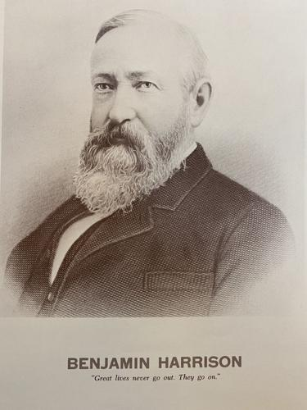
Courtesy of the Ohio History Connection

Editor's Note
This is the sixth in a nine-part series looking at Ohio's history of presidents. Some of the information was gleaned from a kit provided by the Ohio Historical Society released in 1967 titled "Portraits of Ohio Presidents." Knox Pages has entered into a collaborative agreement with the Ohio History Connection to share content across our sites. Part I, an introduction, was published on Feb. 9. Part II, on William Henry Harrison, was published on Feb. 16. Part III, on Ulysses S. Grant, was published on Feb. 23. Part IV, on Rutherford B. Hayes, was published on March 2. Part V, on James A. Garfield, was published on March 9.
Although his linage suggested American political royalty, Benjamin Harrison was born on a humble farm south of Cincinnati in North Bend, Ohio on Aug. 20, 1833.
He was the son of John Scott Harrison and grandson of William Henry Harrison.
Benjamin attended Miami University and graduated with distinction in 1852. The next year he began practicing law in Cincinnati and married Caroline Lavinia Scott. The couple had two children.
In 1854, after two years studying law, Harrison moved to Indianapolis to establish his own practice. Upon arriving in Indiana, he found the area a fertile ground for his political ambitions.
Thus he ignored his father’s advice that “none but knaves should ever enter the political arena.” Instead, Benjamin became an active participant and leader in the newly formed Republican Party.
Just after being elected Reporter of the Supreme Court, Harrison answered the call of Indiana governor Oliver P. Morton to fill the quota for Union Troops in the Civil War.
Harrison started as captain of the Indiana volunteer infantry in 1862 and quickly moved up to colonel. While serving under General William Sherman's Atlanta campaign, Harrison’s achievements at the battles of Resaca and Peachtree Creek earned him a promotion to Brigadier General.
In later life, Harrison participated in many Civil War reunions and during his presidency was a champion of providing pensions for Grand Army of the Republic veterans.
Standing just 5-foot-6, Harrison was described as a kind man of stout principle who possessed a keen intellect and a phenomenal memory. He willingly sacrificed valuable political support rather than abandon his convictions — as in 1882, when he opposed the Chinese Exclusion Act on the ground that it would abrogate rights guaranteed to the Chinese by the Burlingame Treaty of 1868.
A deeply religious man, he was an elder in the Presbyterian church for 40 years. He was defeated in an 1876 bid for Indiana governor, but became a U.S. Senator from 1881 to 1887.
In 1888, Harrison received 100,000 fewer popular votes than Grover Cleveland, but carried the Electoral College 233 to 168.
Hallmarks of Harrison's administration included unprecedented economic legislation, including the McKinley Tariff, which imposed historic protective trade rates, and the Sherman Antitrust Act “to protect trade and commerce against unlawful restraints and monopolies,” the first federal act attempting to regulate trusts.
Harrison also facilitated the creation of the national forest reserves through an amendment to the Land Revision Act of 1891.
Harrison's wife grew gravely ill and died in the final months of his presidency as he campaigned very little while attending to her. Cleveland defeated him in the 1892 presidential election 277-145 in the Electoral College.
He retired to his law practice in Indianapolis and was in great demand as a speaker. At age 62, Harrison married his dead wife’s niece, Mary Lord Dimmick, and they had one daughter.
Harrison died on March 13, 1901 in Indianapolis. He was the last Civil War general to serve as president.
_____________________________________________________________________________

The Civil War’s Oldest Soldier, A Direct Descendent Of Pocahontas, Is Buried In Rural Iowa
If you were to guess how old the oldest soldier to serve in the Civil War was, what age would you guess? Fifty – maybe sixty? How about eighty?!
During these uncertain times, please keep safety in mind and consider adding destinations to your bucket list to visit at a later date.
Yes, Curtis King, a descendent of Pocahontas who was farming near Chillicothe, Iowa, in Wapello county when the war broke out, enlisted at the age of 80. Two companies had turned him down due to his advanced age before the Iowa 37th Infantry Regiment of the Union army accepted him.
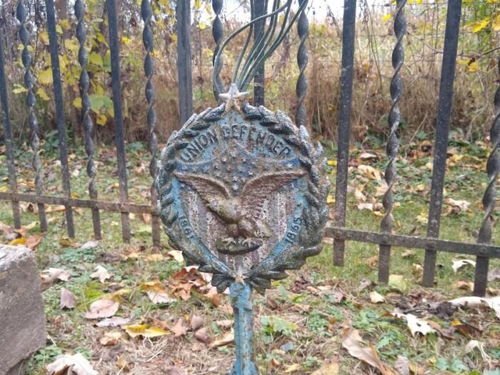
Laura S. / Used With Permission
The 37th was also known as the “Graybeard Regiment” because all the men in it were over 45, old fellers by 1860s standards and past the accepted age for military service. Iowa had to request special permission from the Secretary of War to form this regiment, and it was the only state to send such a tough, wizened old regiment off to preserve the Union.
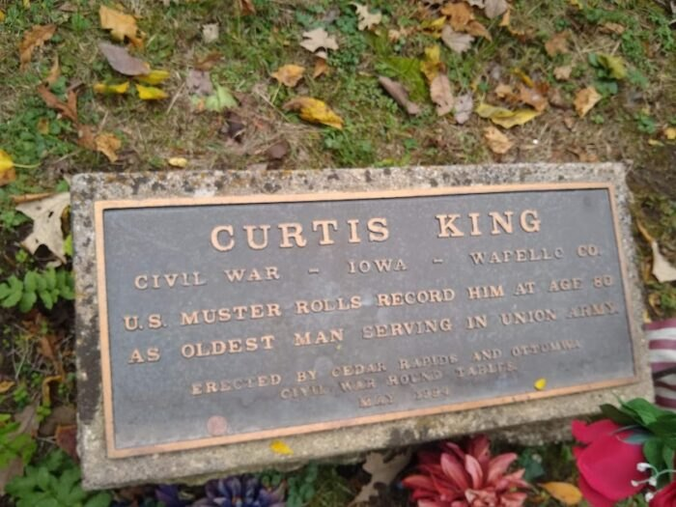
Laura S. / Used With Permission

+++++++++++++++++++++++++++++++++++++++++++++++++++++++++++++++++++
A most interesting area lady….

Frances “Frannie” Lightburn Cressman
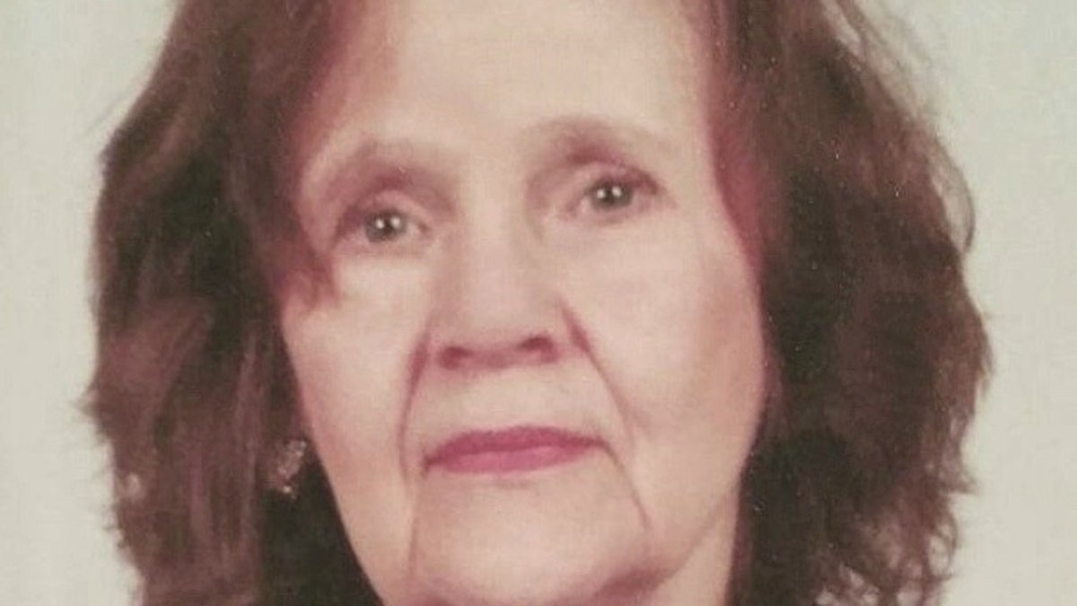
Frances “Frannie” Lightburn Cressman(Frances “Frannie” Lightburn Cressman)
By Master Control
Published: Sep. 19, 2021 at 12:04 AM EDT
BRIDGEPORT, W.Va (WDTV) - Frances “Frannie” Lightburn Cressman, 87, of Main Street in Jane Lew, died unexpectedly following a brief illness on September 16, 2021. She was the daughter of Joseph “Joe” B. Lightburn and Susan Davisson Lightburn of Jane Lew. Joe Lightburn was twice Mayor of Jane Lew, a long time merchant there, and a conservative politician who, among other offices, ran for President of the United States in 1964 on the Constitution Party (third party) ticket. Frances Lightburn Cressman was also a Great Granddaughter of Union Brig. Gen./Rev. Joseph A. J. Lightburn of Lewis County.Frances was born in Jane Lew on November 10, 1933. She was converted to the Christian faith as a teenager at the Methodist Protestant Church on Main Street in Jane Lew. She joined said church as a teenager and remained a member when that church became the First United Methodist Church of Jane Lew. Upon maturity she left our state to seek employment elsewhere, but later returned home to Jane Lew. She resumed her membership in said church where she served 20 years as organist (circa 1984 to 2004) and 25 years as a member of the choir. She later attended Grace Baptist Temple, Park Avenue, Jane Lew, where she served occasionally as pianist. Later she attended Broad Run Baptist Church of Jane Lew. She retained her strong Christian faith until the end of her life.Frances graduated from Jane Lew High School in 1951, attended Davis and Elkins College, and graduated from West Virginia University with a Bachelor of Arts Degree in 1963. She was a member of the Phi Mu National Social Sorority. She studied classical music extensively throughout her life and with professional teachers.From 1963 until 1982, Frances lived in New York City, Los Angeles, CA, and Philadelphia, PA, where she was employed at large law firms as a legal secretary and as a paralegal. She was at one time employed as secretary to the famous Philadelphia lawyer, Howard Kellogg. From 1974 to 1982 she was employed as Office Manager of the prestigious Fredrick C. Fiechter Law Firm in Philadelphia. Upon retirement from that occupation in 1982, she moved back to her residence in Jane Lew. There she opened a business, the Cressman School of Music, where she taught piano and voice for over 20 years (circa 1985 to 2007) and produced well-attended recitals in which her students exhibited their musical skills. Frances also invested in real estate and enjoyed remodeling and furnishing her properties by shopping Facebook and taking “Facebook Adventures” with her family. Because only incomplete or inaccurate biographies of her Great Grandfather, Union Brig. Gen./Rev. Joseph A. J. Lightburn, were written heretofore, around 1995 Frances began extensive research on the general whose military campaigns during the Civil War, both in West Virginia and elsewhere, were so significant to the formation of West Virginia and to the history of our nation. Since knowledge of the Civil War was necessary in order to compile an accurate account of the general, around this time she also began a thorough study of the Civil War, which study escalated through the following years.In 2004 Frances wrote a manuscript entitled, “Here By a Quarter Of an Inch”, and up-close biography of General Lightburn. Said manuscript was published in the Weston Democrat newspaper in 2004. In 2012, in observance of the celebration of West Virginia’s Sesquicentennial, Frances updated said manuscript on General Lightburn (to include additional facts) and also wrote, published, and sold or distrusted the following books (regarding his military campaigns in West Virginia) to various individuals, colleges, and libraries: (1) The Jones-Imboden Raid through Western Virginia from April 24 to May 22, 1863, (2) Kanawha Valley Campaign of 1862 or “West Virginia History Lost and Found”, including the History of the Union WVW 4th Volunteer Infantry Regiment, and the Letters of Union Private William Van Brown of the Union WV 4th describing the Kanawha Valley Campaign of 1862. In observance of the American Civil War Sesquicentennial celebration, Frances, using the research she compiled over the years, wrote, published, and sold or distributed in 2014 her long two-volume book covering the American Civil War entitled, “A Great Civil War Has Come Upon Us-The Lives and Times of Union Brig. Gen./Rev. Joseph A.J. Lightburn and his friend, Conf. Lieut. Gen. Thomas J. “Stonewall” Jackson”. While covering the war in detail, this book features the lives of these two Civil War generals, describes their special historical connection to Lewis and Harrison Counties, their attendance at Broad Run Baptist Church as young boys, their close friendship, their service in the was, Stonewall Jackson’s tragic death, and Rev. Joseph A.J. Lightburn’s Baptist ministry after the war. The book is available to the public through Amazon.com and at Lightburn’s Family Diner in Jane Lew, WV.Frances appeared in the documentary film, Still Standing, The Stonewall Jackson Story, and spoke about the close friendship of Lightburn and Jackson. The premiere of this film, produced and directed by Ken Carpenter of Franklin Springs Family Media, was shown at nearby Jackson’s Mill on November 11, 2007. On February 14, 2012, Frances, upon invitation, gave a speech before the Stonewall Jackson Civil War Round Table, in Bridgeport, on the Jones-Imboden Raid through West Virginia. Frances’ only sister, Mary Lightburn Stern (originally from Jane Lew), of Henderson, NV, expired in 2012. Her only brother, Joseph “Joey” B. Lightburn, Jr., who expired in 2015, was a well-known and respected merchant who owned and operated Lightburns Hardware on Main Street in Jane Lew for many years. In later years, Frances was an investor in Lightburn’s Family Diner in Jane Lew and a volunteer shopper for the restaurant. On February 27, 2018, the Lewis County Chamber of Commerce sponsored a luncheon at Lightburn’s Family Diner at which Frances was the special guest speaker. She spoke about her books and the Civil War. Frances was also preceded in death by one grandchild, Johannah Grace Fay. Frances is survived by treasured friends and beloved relatives. Her relatives include her only daughter, Dianne Cressman Fay Castro and husband, Danny, of Jane Lew; six grandchildren: John Joseph Fay and wife, Joy, of Philadelphia, Jason Michael Fay and wife, Hali, of Jane Lew, Jacquelyn Dianne Fay of Beckley, and James Thornton Fay, Jr., Joel Aaron Fay, and Julia Grace Fay all of Jane Lew; three great-grandchildren: Deanna Marie Fay of Philadelphia, and Laila Marie Fay and Kelsee Delynne Fay both of Jane Lew; first cousin, Mary Virginia Rinehart of Weston; the latter’s many decendants; and several other cousins, nieces, and nephews. In lieu of flowers, Frances requested that sympathy cards are greatly appreciated or donations may be made to your local Salvation Army. Family and friends will gather for Visitation at Pat Boyle Funeral Home and Cremation Service located at 144 Hackers Creek Rd. in Jane Lew from 12-2 p.m. on Saturday, September 25, 2021. Funeral Services will begin at 2 p.m. in the Pat Boyle Funeral Home Chapel with Pastor Allen Burnsworth officiating. Interment will follow at Broad Run Baptist Church Cemetery in Jane Lew. We, at Pat Boyle Funeral Home and Cremation Service, are honored and privileged to serve the family of Frances “Frannie” Lightburn Cressman.

