Civil War Roundtable New Birth of Freedom trip – October 17-20, 2019
This was another combined Civil War and Revolutionary War trip. It included among other sites, a visit to historic Philadelphia, Valley Forge, and a return to Gettysburg.
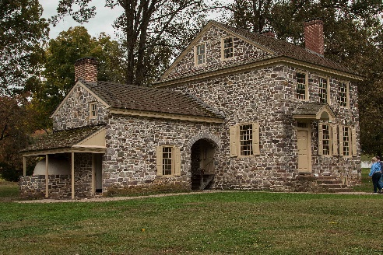
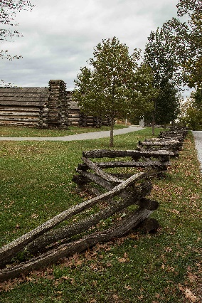
Valley Forge was a site of the winter of misery spent by the Continental Army in 1777-1778. The lack of housing when the army first arrived at camp made building cabins the first priority. However, as time went on, the lack of adequate food, clothing, shoes, and blankets was caused by a disastrous supply crisis which Washington and others worked hard to overcome. They remained in this camp until June of 1778 and when the weather improved, time was used to retrain and reorganize the troops into a more disciplined army. At right is a photo of the home used as Washington’s headquarters.

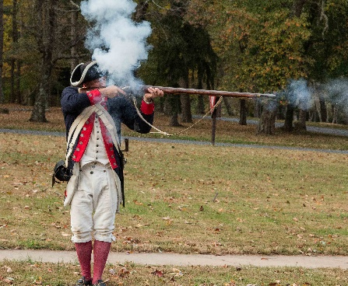
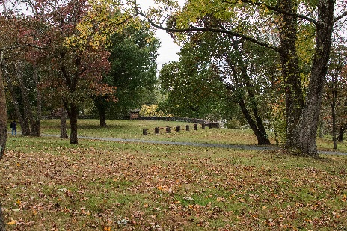
We visited the site of Washington’s crossing of the Delaware River on Christmas night 1776. He moved his troops across an icy river to attack the Hessian troops quartered in Trenton, NJ. It was a complete surprise for the Hessians and resulted in a much-needed victory for Washington and his men. While there, we were treated to a demonstration of the firing of the type of musket used during this time period. The whole process involved many steps before the gun would be able to be fired successfully and there was no guarantee that it would fire when needed.
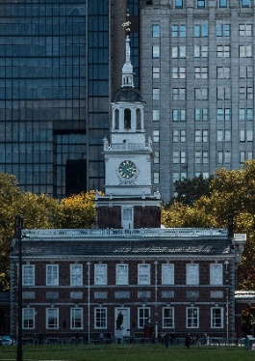
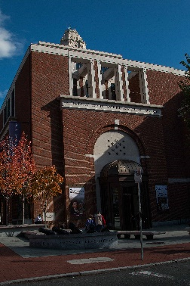
In Philadelphia, we missed our time slot in enter Independence Hall, but did see the famous bell by looking through a window and took a walking tour of one of the older sections of the city. We passed the cemetery at Christ Church where Benjamin Franklin is buried and stood outside the building where he had his printing shop. Scott Britton then led some of the group on an extra walking tour while others took the opportunity of visiting other sites. We chose to see the Museum of the American Revolution which was really interesting and very well done.
The return to Gettysburg was interesting because Steve Magnusen, the author of To My Best Girl – the story of Rufus Dawes and Mary Gates Dawes, was with us. Steve was able to read portions from his book when we visited such sites as the railroad cut where Rufus Dawes led the 6th Wisconsin in a heroic charge at that location. Visiting the Gettysburg Battlefield is always a moving experience and we always see new sites and hear about some events that add to our knowledge of this important battle of the Civil War.

