HARDSCRABBLE
Civil War Round Table of the Mid-Ohio Valley Newsletter
October 2022 – Vol 22

Notes by Nancy Arthur
On our upcoming field trip to Gettysburg in November, one of the locations we are going to visit is Barlow's Knoll. The park has been trying to protect this area for years and finally, in 2016, the Trust purchased these 35 acres from Adams County.
During the fighting on July l, 1863, this ground was the far right of the Federal line and was commanded by Brig. Gen. Francis Barlow. Barlow had two brigades deployed in the fields before the controversial decision he made to advance them across land on a small rise about 700 yards away. Barlow thought the elevation would be an advantage for his artillery, but he overextended his men and was moved out.
As he retreated toward the Adams County Almshouse, Barlow attempted a rally but was severely wounded. He laid on the ground for quite a while until a Confederate officer attended to him.
With this property being saved for the park, former National Park Service Chief Historian Emeritus Ed Bearss called this ground "as important to understanding the first day at Gettysburg as Sickles position in the Peach Orchard is on the second day of the battle."
I particularly enjoy going slowly through this area to see all of the Ohio
monuments: many of our men fought and died or were wounded on this very ground.
An app that has been around for a while is the Gettysburg AR An app that has been around for a while is the Gettysburg AR An app that has been around for a while is the Gettysburg AR Experience. Go to
www.battlefields.org/gettysburg-ar-experience
Another area we will visit in November is Culp's Hill; if you haven't seen it since the cleanup was started, you will be impressed. Now you can see more monuments, many of which are Ohio, and the lay of the land. Trails are easier to follow and overall, there is just a better view of the hill and what happened.
If you have already been on a field trip to Gettysburg, this will have some different experiences. I'm looking forward to it! Hope to see you on the bus.
Stories by Bill Teegarden

Join Marketing intern and new ’Berg alum Em Swain, ’22, as they visit local businesses only a short walk away from Heidelberg University’s campus. It's Walkable Wonders, our summer web series!
Happy Fourth of July Weekend!
In celebration of the U.S.A., I partook in the two most American things I can think of: eating an entire AJ’s pizza on my own and visiting a small-town American history museum. AJ’s Heavenly Pizza is one of my favorite restaurants in Tiffin – it was the first restaurant my family ate at when I moved in as a freshman. I cannot speak highly enough of it. This was the first time I visited The American Civil War Museum of Ohio, located across the street from AJ’s. I’ve been talking about visiting it for years, and I’m happy to have finally made the time. With both locations, the affordability cannot be beaten! I spent less than $11 on the trip as a whole and walked back home full of pizza and Union pride.

AJ’s Heavenly Pizza
AJ’s is owned and operated by John Hill (the “J” in AJ’s). Members of the Heidelberg community are frequent patrons of AJ’s Pizza because of its close location and affordability for large quantities of pizza! AJ’s is the “Home of the Jumbo” – a pizza that measures 17 by 24 inches. That’s nearly 3 square feet of pizza – for $22 (for comparison – the same square footage of pizza from a popular chain pizza shop is around $35.)
My favorite thing about AJ’s is the sauce. I’m not someone who enjoys a super acidic pizza sauce. AJ’s sauce is made with red bell peppers. When the pizza’s cold, you can really taste the bell pepper (which I enjoy) – but when it’s hot, you only really taste the sweetness that the peppers add. AJ’s sells pop by the cans in the storefront, which is something I always prefer over a two-liter. The meal I get is a 10-inch cheese pizza and a can of Dr Pepper – it’s enough to fill me up, but not too much that my friends ask for a slice. Just writing about it makes me want to go back and get some for dinner.
AJ’s Heavenly Pizza is located a 13-minute walk from the center of campus, at the corner of South Washington Street and Main Street. For more information, or to order online, visit their website.

The American Civil War Museum of Ohio
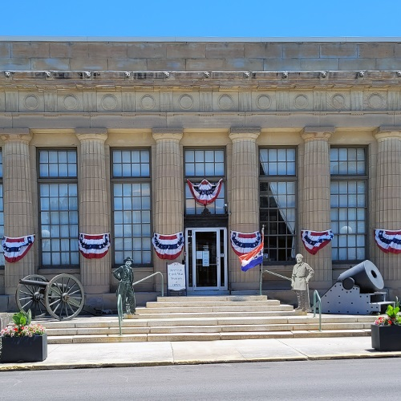The American Civil War Museum of Ohio is a nonprofit organization in downtown Tiffin, whose mission is to share information about Ohio’s involvement in the Civil War. The museum is arranged chronologically, beginning with an exhibit about the socio-political forces that contributed to the South’s secession, and ending with an exhibit in the basement about the reconstruction, complete with a documentary, “Ohio's Role in the Civil War,” and a library.
I enjoyed visiting the American Civil War Museum of Ohio! To go alone was an almost meditative experience, interrupted occasionally by my interest in the crossword puzzles and coloring pages they had at every exhibit. I got to spend a lot of time in the library, going through the museum’s book of Civil War-era songs, which I remembered pretty well from middle school choir. In all, I spent about 90 minutes at the museum – but I didn’t even stay to watch the documentary! It was a great way to refresh my knowledge of our nation’s history in time for Independence Day. Next time I visit, I fully plan to bring some of my roommates or my family members – I know they’ll be as invested as I was in the battle diorama in the basement.
The American Civil War Museum of Ohio is a 13-minute walk from the center of campus. It’s located on South Washington Street, in what was formerly Tiffin’s post office. You’ll know you’re there by the cannons stationed out front.
Admission is $3 for students, $6 for adults, and free for kids under 6. The museum is open from noon-4 p.m. Wednesdays through Saturdays. They’re currently hosting a visiting exhibit from the Hayes Presidential Library & Museums. For more information about their exhibits and events, check out their website.
Published on
Jun 30, 2022

^^^^^^^^^^^^^^^^^^^^^^^^^^^^^^^^^^^^^^^^^^^^^^^^^^^^^^
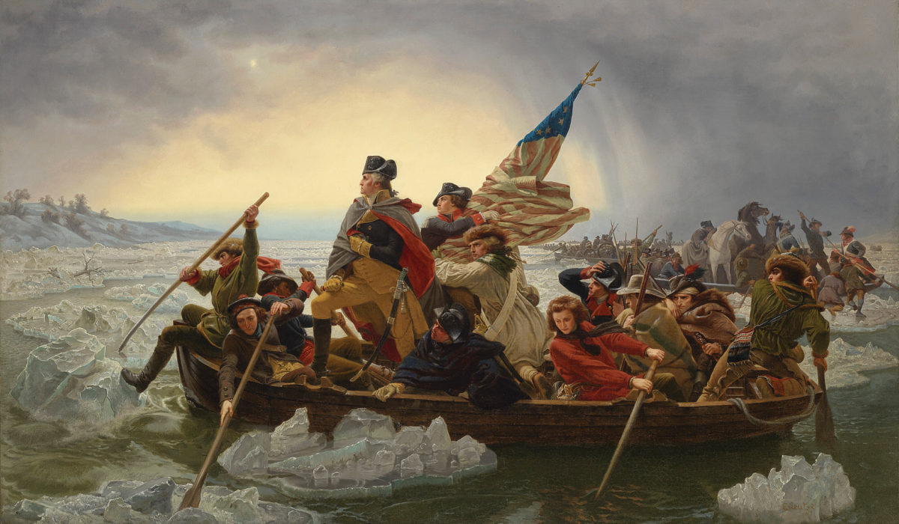
German immigrant Emanuel Leutze’s monumental painting Washington Crossing the Delaware is undoubtedly a stirring rendition of Continental Army Gen. George Washington and troops en route to capture Trenton from the Hessians on the night of Dec. 25–26, 1776. Historically speaking, however, it falls short, perhaps in part because Leutze painted the 149-by-255-inch oil on canvas in 1851—75 years after the fact.
Historians have flagged several mistakes, including the furled Stars and Stripes (Continental troops flew the Grand Union), the conditions (the crossing took place around midnight amid a snowstorm—albeit hard to capture), the vessels (Washington’s men crossed in larger flat-bottomed Durham boats) and the river (the Delaware is not as wide where they crossed).
The celebrated version on display at New York’s Metropolitan Museum of Art is actually a duplicate. The original hung in the Kunsthalle Bremen art museum until destroyed by a 1942 RAF bombing raid during World War II. A privately owned 40-by-60-inch version displayed at the White House from the 1970s through 2014 was the highlight of a recent auction at Christie’s in New York, fetching just over $45 million, more than double its presale estimate.
German immigrant Emanuel Leutze’s monumental painting Washington Crossing the Delaware is undoubtedly a stirring rendition of Continental Army Gen. George Washington and troops en route to capture Trenton from the Hessians on the night of Dec. 25–26, 1776. Historically speaking, however, it falls short, perhaps in part because Leutze painted the 149-by-255-inch oil on canvas in 1851—75 years after the fact.
Historians have flagged several mistakes, including the furled Stars and Stripes (Continental troops flew the Grand Union), the conditions (the crossing took place around midnight amid a snowstorm—albeit hard to capture), the vessels (Washington’s men crossed in larger flat-bottomed Durham boats) and the river (the Delaware is not as wide where they crossed).
The celebrated version on display at New York’s Metropolitan Museum of Art is actually a duplicate. The original hung in the Kunsthalle Bremen art museum until destroyed by a 1942 RAF bombing raid during World War II. A privately owned 40-by-60-inch version displayed at the White House from the 1970s through 2014 was the highlight of a recent auction at Christie’s in New York, fetching just over $45 million, more than double its presale estimate.

History comes to life at Prospect Place
Brandon Hannahs
Zanesville Times Recorder
View Comments
1:07
1:18
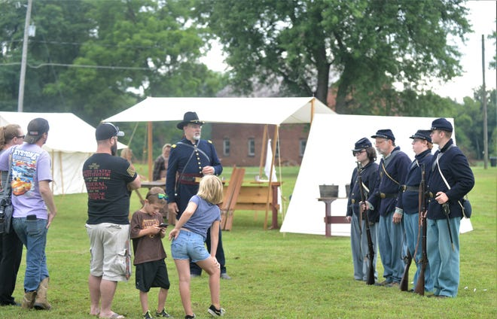

TRINWAY — The Civil War was a crucial part of American History, and Kevin McNamara takes pride in teaching those lessons to others.
McNamara has been a member of the 41st Ohio Volunteer Infantry since 2010 and currently serves as a captain for the group, which participates in Civil War reenactments throughout Ohio.
The unit was camped in front of Historic Prospect Place in Trinway on Saturday, as The G.W. Adams Educational Center hosted its inaugural Civil War Living History event.
"One of our goals is bringing history to life and drawing interest to that time," McNamara said. "We like to connect with local museums and historic sites and promote what they're doing. The Civil War was a big part of our country's history, and we want to engage with the public and show them what life was like during the war."
Prospect Place has a connection to that era. G.W. Adams, who built the mansion, came to Ohio after his father and abolitionist, George Beal, moved the family from Virginia. G.W. followed in his father's footsteps in being an abolitionist and shared the 150-acre estate with his brother, Edward, after their father passed away in 1826.
G.W., who was a businessman and served in the Ohio Assembly, built the original mansion in 1855, but it burnt down due to arson before being completed. The second mansion was built on the same site and completed a few years later, as G.W. used his home as a conductor in the Underground Railroad.
Connecting their namesake to the era was why the G.W. Adams Education Center decided to host the event, said Executive Director Jeff Cole. It had been in discussion since the current board took over seven years ago.
G.W., who was a businessman and served in the Ohio Assembly, built the original mansion in 1855, but it burnt down due to arson before being completed. The second mansion was built on the same site and completed a few years later, as G.W. used his home as a conductor in the Underground Railroad.
Connecting their namesake to the era was why the G.W. Adams Education Center decided to host the event, said Executive Director Jeff Cole. It had been in discussion since the current board took over seven years ago.
Helen DeCaro, who lives in South Zanesville, heard about the event through Facebook and decided to attend.
"We've never been here and wanted to see what was going on," she said. "It sounded interesting to be able to see things from the Civil War era, and it gives you an idea what life was like back then."
A family connection drew Jared Besser, of Zanesville, to the site. His father had done cement work on the property, and he felt it was a good chance to experience history.
"Prospect Place has a lot of history, and this is the first time I've been able to visit and look around," he said. "It's interesting to see everything and take it all in."
The center offers school tours and lectures, and Prospect Place will host an old time baseball game in September. Events like these assist the group in its mission, noted treasurer Amy Green.
"We want to provide an educational experience," Green said. "We're all volunteers who want to keep history alive. We believe it's important to remember what G.W. and his family did, while also using these events to raise money so we can restore and maintain the property."
Despite rainy weather, Cole felt the turnout was good for the first-time event. He doesn't know if it will be an annual gathering, but the board is aiming to have events like this in the future.
"This is about creating an educational opportunity. If it goes well, we want to build on it," Cole said. "There's a lot of history here and space for an event like this. We wanted to see how it went then make a decision from there.
"Historic places like this are disappearing," he added. "We want to keep history alive and make sure it gets passed onto the next generation."
bhannahs@gannett.com
Twitter: @brandonhannahs
/////////////////////////////////////////////////////////////////////////
Books by Bill Teegarden
To OPEN HYPERLINKS with PC -place cursor on Subject line, hold down Control and Left Click mouse / with Smart Phone – touch with finger or stylus
Lunch Time Trivia
The Woman’s Fight
Blood and War at my Doorstep
Reunion Ohio CW Vets - 1878
Virginia Festival of the Book
Sunflower Sisters
The Civil War in New Mexico
Almont and the Civil War
Love & War
Letter from an American
Links to the Past
For Cause & For Country
Writing Civil War History
A Worse Place Than Hell

