HARDSCRABBLE
Civil War Round Table of the Mid-Ohio Valley Newsletter
July 2022 – Vol 19

Notes from Nancy Arthur
If you have read any Hardscrabble issues this year, you have picked up on our November trip is to Gettysburg. If you are thinking “again”, consider this: to get there, we are going through Chambersburg to see some of the historic locations where the Confederates were camping, along with others that Scott Britton is putting together. That’s Thursday, then we roll on into Gettysburg, past the “First Shot Marker”. Thursday night and Friday we are planning some stops at places we as a group have not visited before – more to come on this. One of the stops being considered is the Visitor Center to allow more time than we normally have to visit the museum there. Unless you have been there this spring, you will see some new exhibits; these are changed out occasionally to keep visitors coming back.

At the Visitor’s Center is the Cyclorama and if you haven’t seen it, this is a must ! This is a very large panoramic painting that wraps itself around the theatre, with sound effects. Painted by French artist Paul Philippoteaux and a group of helpers, the painting depicts events of July 3rd of Pickett’s Charge. Originally there were four, scattered around the country but all but this one have been damaged or lost (how do you lose a painting this large ?!) This one was in Boston but brought to Gettysburg for the 50th anniversary. The National Park Service acquired it in 1942. Some artistic license was taken such as a wounded man who resembles Abraham Lincoln is carried to a field hospital, trying to show a symbol of the country injured by war and one of the team helping with this massive painting was added in as a wounded Union soldier and I’ve heard that Philippoteaux painted himself into the painting.

Other stops are still being planned for the field trip, with author Eric Wittenberg speaking to us Friday evening about the Saturday and Sunday tour of “Lee’s Retreat From Gettysburg”.

Much research is going into the planning of this field trip; we hope you can join us!
Winning the Battle for Preservation: Mentioned earlier was the monument of the First Shot, which we will be going by, along with the house beside, which has had much restoration completed. Another stop will be at the location of the widow Mary Thompson’s home, where Lee made his battle plans and decisions. If you were a visitor to Gettysburg years ago, you may remember a 48 room hotel, a gift shop, and swimming pool on this property. The Civil War Trust reclaimed this property and restored the stone house.

Also, if you were with us the last field trip to Gettysburg, you will remember visiting the George Spangler farm. This beautiful area was decimated by the war and used as a field hospital. Seven surgeons worked round the clock, treating over 1,800 Federal soldiers and a few Confederates, among whom were Gen Lewis Armistead, who passed away here.

Additional stops are being considered as you read this.

Stories by Bill Teegarden

Plans to rebuild replica of Canton's fire-gutted Civil War-era barn rise from the ashes
Ed Wright
Hometownlife.com
View Comments
0:21
0:35
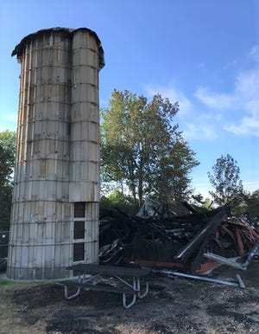
Ten months after the flames that destroyed Canton Township's Civil War-era Cady-Boyer barn were extinguished, plans are rising from the ashes to rebuild a similar structure at Preservation Park, the site of the beloved burned-down gathering place.
"Our tentative plans are to build a more modern structure that has the look and feel of an historic barn," Canton Township Leisure Services Director Greg Hohenberger explained. "We want it to include more modern amenities and we want it to be more ADA (Americans With Disabilities Act) accessible.
"The big thing is we want the new structure to honor what was there before so it's not going to look out of place next to the historic buildings that make up Preservation Park."
Canton Township fire officials confirmed June 11, 2021, that plans to produce a social media post were the original cause of the flames that engulfed and destroyed the barn. The post was supposed to capture images of burning cardboard and smoke bombs, officials said in an update sent out to township employees.
Although the precise cost of rebuilding the barn will not be known until a plan has been cemented, Hohenberger said it will probably run in the neighborhood of $500,000 — an expenditure, he estimated, that should be covered by an insurance reimbursement ($350,000) and roughly $150,000 the township expects to receive as part of a Wayne County parks millage grant.
^^^^^^^^^^^^^^^^^^^^^^^^^^^^^^^^^^^^^^^^^^^^^^^^^^^^^^^^^^^^^^^^^

Hayes exhibit explores how the Civil War is remembered
News-Messenger/News Herald
USA Today

FREMONT — For 160 years, the United States has been uncertain with how best to remember the Civil War.
Each generation has handled the war’s legacy in its own way, often reflecting its own values and experiences in doing so.
While the debate will continue on how this difficult subject should be remembered, the latest special exhibit at the Hayes Presidential Library and Museums will provide the often-overlooked history of how people have chosen and still choose to remember the Civil War.
“Mustering Memory: 160 Years of Saluting the Civil War” opens to the public on April 14.
From the aged veterans who walked on the fields of Gettysburg for its 50th anniversary in 1913 to modern enthusiasts who use their vacation time reliving famous battles or scouring Civil War antique shows, this exhibit offers context on where Civil War memory has been and insights for those interested in engaging with it today.
“How we remember the Civil War has been and continues to be a tough subject. It deals with issues of race and patriotism, as well as history and heritage,” said Kevin Moore, curator of artifacts at Hayes Presidential. “Our hope is that visitors to ‘Mustering Memory’ will leave with a better grasp of how past generations, beginning with the Civil War veterans themselves, have tried to understand and commemorate this pivotal event.”
Artifacts that will be on display include Civil War medals from President Rutherford B. Hayes and First Lady Lucy Hayes, as well as medals from other Civil War veterans. Lucy Hayes’ medal was from the Women’s Relief Corps, and it honored her for her work in tending to wounded soldiers, mending their uniforms and offering other support.
“Mustering Memory” will include items from President Hayes, including his work as president of the Military Order of the Loyal Legion of the United States, an organization that began as a group for Union Civil War veterans. It will feature Civil War manuscripts and artifacts from Hayes Presidential’s collections.
The exhibit also will share information about Civil War reenacting and Civil War artifact and memorabilia collecting.
“People who are into history continue to remember the Civil War in a number of different ways, many of which can be both educational and a lot of fun,” Moore said. “We want to make visitors aware of what activities exist today and point them to resources in case they want to get involved.”
“Mustering Memory” will be open during regular museum hours, which are available at rbhayes.org. Members are admitted free. For nonmembers, access to the exhibit is included with regular admission.
The Hayes Presidential Library and Museums is America’s first presidential library and the forerunner for the federal presidential library system. It is partially funded by the state of Ohio and affiliated with the Ohio History Connection. The Hayes Presidential Library and Museums is located at Spiegel Grove at the corner of Hayes and Buckland avenues.
For information, call 419-332-2081, or visit rbhayes.org.
###################################################

4 Southern counties that seceded from the Confederacy during the Civil War
Team Mighty
Posted On March 02, 2022 11:41:43

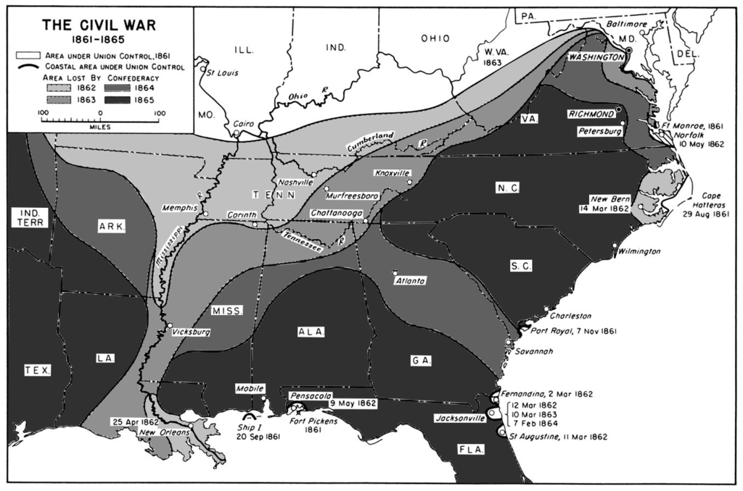
Map which describes the Confederate losses each year throughout the war.
It’s well known that after the election of Abraham Lincoln in 1860, 11 states seceded from the Union to form the Confederate States of America. The subsequent Civil War would rage across the country for almost five years. American history books make southern secession seem like an almost unanimous decision, but it wasn’t as simple as that.
Black Americans volunteered to fight Axis Italy in droves before the US entered World War IIUp Next: The F-14 Tomcat was designed around its engines, radar and missiles
Top Articlesby We Are The MightyREAD MOREREAD MOREThe F-14 Tomcat was designedaround its engines, radarand missiles

Just as there were Americans who supported secession and the southern cause in Union states, there were pro-Union Americans living in the Confederacy. Unlike those who supported secession in the north, however, some anti-Confederate Americans in the south went s ofar as to secede from the Confederacy – and there are a lot of them.
1. The Republic of Winston
The locals living in what we today know as Winston, Cullman and Blount Counties in Alabama didn’t raise crops on large plantations and had no use for slaves. They were mostly poor white farmers, scraping out what food they could manage. When Alabama passed its Ordinance of Secession in 1861, Winston County’s representative refused to sign it and was sent to jail, where he spent most of the war.
Back home, residents refused to support the Confederacy, refused to be drafted into the army and even passed resolutions that stated if the Confederate States could secede from the Union, then a county could secede from the Confederacy. When the Union Army came to Alabama, residents of Winston joined the Union’s 1st Alabama Cavalry.
2. The Free State of Jones
The Confederacy was a great place to be if you were a wealthy, aristocratic, slave-owning landholder. For everyone else, it wasn’t so hot. To support this gentry and the army fighting for its way of life, Confederate tax agents seized a lot of livestock, food, and cash from already-poor farmers. Much of this didn’t even make it to the army.
With terrible conditions back home and a rough life of hunger and disease in the army, rebel troops deserted by the thousands and Jones County, Mississippi became the place to be for deserters. They organized their own government and protection force to keep the tax collectors away. They even wrote a declaration of independence and sent it to Gen. William T. Sherman.
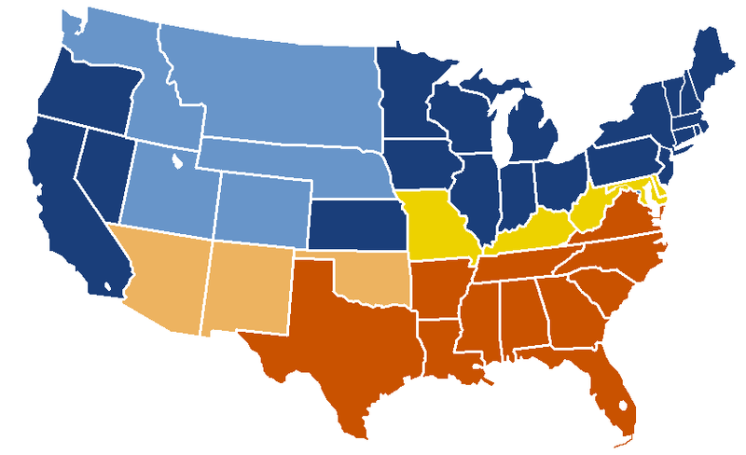US Secession map. The Union vs. the Confederacy.
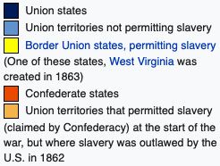
3. The State of Scott
The border areas between Union Kentucky and Confederate Tennessee were filled with people who sided with either cause. Scott County, Tennessee was one of these border areas, but its people were wholly committed to staying in the Union. When Tennessee passed its secession legislation in 1861, Scott County passed a secession law of its own.
Scott County was one of two counties in the states whose economy was not dependent on slavery to keep it afloat. The residents were not about to go to war with the government to preserve a way of life they didn’t want or need. The governor sent 1,700 troops to subdue the county, but locals organized and forced them to retreat.
4. Arkansas Peace Society
Searcy County, Arkansas did not get on board with secession the way the rest of the state did. In the northern part of the state, where Searcy County is located, many of the local remained pro-Union and did not want to see the state secede. To protect themselves from conscription, they formed the Arkansas Peace Society.
Unlike the other members of this list, the Confederacy was successful in destroying this group, but that didn’t mean an end to resistance. Arkansas contributed the second highest number of troops to the Union Army, beaten only by Tennessee – despite having a significantly smaller population.
Books by Bill Teegarden
Alexandria, North Carolina author https://www.google.com/url?rct=j&sa=t&url=https://alexandrialivingmagazine.com/news/civil-war-started-151-years-ago-today/&ct=ga&cd=CAEYACoTMTk4OTU3NzI3ODA4ODY5MjE0NDIaZWM4MTNkOWI2ZjZiZmFjNjpjb206ZW46VVM&usg=AFQjCNH24Ett-4IRtwZLdhaKBjfRHWvU7g
Author Interview https://www.google.com/url?rct=j&sa=t&url=https://networks.h-net.org/node/4113/discussions/6138793/author-interview-judkin-browning-and-timothy-silver-environmental&ct=ga&cd=CAEYSioTMzg1OTA3NTQxNzMzMzEyNjI2NDIaZWM4MTNkOWI2ZjZiZmFjNjpjb206ZW46VVM&usg=AFQjCNGjuJEAc_MylOPGJ4R12A_B2Y2_jQ
Cavalry in the Civil War – short video https://www.google.com/url?rct=j&sa=t&url=https://www.battlefields.org/learn/videos/cavalry-civil-war&ct=ga&cd=CAEYOyoUMTYyNTYwMTE4NDk0MTAxMjc4NTUyGmVjODEzZDliNmY2YmZhYzY6Y29tOmVuOlVT&usg=AFQjCNEL_b21Jc3cjfFRPrP7JvHGbM_PuA
Vermont will do its full duty https://www.google.com/url?rct=j&sa=t&url=https://vtdigger.org/2020/05/03/then-again-vermont-will-do-its-full-duty/&ct=ga&cd=CAEYASoTNTYwMzg5MzM5NDA4NDI2ODcyNzIaZWM4MTNkOWI2ZjZiZmFjNjpjb206ZW46VVM&usg=AFQjCNGP8eAol47c4_cxT0WjYE6CcGZo7w
Museum of Civil War Medicine jumps to adapt virtuallyhttps://www.google.com/url?rct=j&sa=t&url=https://www.fredericknewspost.com/news/continuing_coverage/coronavirus/museum-of-civil-war-medicine-jumps-to-adapt-virtually/article_205fa6bd-fadc-5dfd-877d-204356cabaa9.html&ct=ga&cd=CAEYDCoUMTgyMTAyMzA5NzYyMDI1MTI0NzcyGmJhZmFjYmMyMWE4OWJlYmU6Y29tOmVuOlVT&usg=AFQjCNGZidPOD4iBolnLOSNZYxBGp6mjgg
Reconstruction Videos https://www.google.com/url?rct=j&sa=t&url=https://www.kcet.org/shows/reconstruction-america-after-the-civil-war&ct=ga&cd=CAEYACoUMTUzMDM2NzQ4MTQ2MTg1NjgwNjYyGmJhZmFjYmMyMWE4OWJlYmU6Y29tOmVuOlVT&usg=AFQjCNEK9D0XPZhvaFeGX2U5us7iMpQnyQ
Volatile Times – listen https://www.google.com/url?rct=j&sa=t&url=https://kpfa.org/episode/letters-and-politics-may-6-2020/&ct=ga&cd=CAEYCyoTMzM2NTE3MDczMDc1OTY2MDM1MTIaZWM4MTNkOWI2ZjZiZmFjNjpjb206ZW46VVM&usg=AFQjCNFNpmDzoEK2AQrSpLhS5vHIN9uLSA
Shelby Foote
https://www.google.com/url?rct=j&sa=t&url=https://studycivilwar.wordpress.com/2020/05/11/shelby-footes-the-civil-war-a-narrative-volume-1-chapter-2/&ct=ga&cd=CAEYAyoTMjk2MTMyOTc0MDk2NTQ0NDQ3NTIaZWM4MTNkOWI2ZjZiZmFjNjpjb206ZW46VVM&usg=AFQjCNGc5TvPvD8qEPyMU7DNFNCjRNJmWA

