HARDSCRABBLE
Civil War Round Table of the Mid-Ohio Valley Newsletter
January 2022 – Vol 16

Notes from Nancy Arthur
If you were unable to attend the January gathering of our Round Table to hear Tom McMillan speak on his book Armistead and Hancock, then to hear our schedule of speakers for the coming year, you may not have heard that our trip this year is back to Gettysburg but for a different experience.
We are planning on a 4 day trip, leaving Thursday and going to Chamnbersbug to visit some places many of us have not seen, and on the way to Gettysburg taking the route that Lee left on July 4, 1863.
With that in mind, a couple of new places have opened or are opening soon, in Gettysburg. The train depot, to which Lincoln arrived on November, 1863, to give his Gettysburg Address, is being turned into a museum. There are to be 3 characters from the time period who will give their accounts of the day of his arrival and what it was like to live in the town before, during and after the battle. If you have been to see this special building, you know Lincoln’s Diner sits just across the street and offers a unique dining experience; the front of the diner is a railroad dining car, sitting beside still active tracks. It is not unusual to be eating a delicious omelet and have a train go by so close, you feel the need to lean away.
For anyone with small children, there is a new Children’s Museum on Baltimore Street, that opened just last summer. And a new museum is in the process of construction that will not be just the Civil War time period but the roots of of the town and Adams County in general. Items that have been in storage for years are being uncovered; imagaine the excitement of those doing the unpacking! Especially to someone who enjoys and studies history…..

A website for Gettysburg “buffs”…. https://battleofgettysburgbuff.com/ (copy and paste)

Announcement
Chambersburg Seminar and Tours
Greetings!
We are excited to announce a fantastic way to kick the mid-winter blues! On Saturday, February 19 from 10 a.m. to 4 p.m. we will present a one-day virtual seminar called "Leaders & Leadership of the Civil War." Eric Wittenberg will moderate the program with the following speakers & talks:
- Dr. Chris Mackowski: Stonewall Jackson’s Arresting Leadership Style
- Gordon Rhea: Jeb Stuart: The Man Behind the Mask
- David Powell: William S. Rosecrans and the Spirit of Innovation in 1863
- Dr. Zachery Fry: Martinets and McClellanites: Regulars, Volunteers, and Leadership Challenges in the Union Army
- Dr. Jennifer Murray: General Meade’s Maturation of Command, 1861-1863
- To view the itinerary or to register copy and paste the following https://www.civilwarseminars.org/leaders
The conference will be held virtually via Zoom. Registered guests will receive the Zoom link and the digital map packet by February 14. Speakers will be available LIVE to give their presentations and answer questions. The conference will be recorded and available to view afterward as a pay-per-view option.
Cost is $75 for members, $80 for non-members. We will donate $10 from every registration to Battlefield Preservation. To become a member of Chambersburg Civil War Seminars & Tours, you simply need to attend an event once and you're a member for life.
Kind Regards,
Lark Kennedy, Eric Wittenberg, Susan Wittenberg, Karen Lowry

Stories by Bill Teegarden
The Civil War was the deadliest of all American wars. No one disagrees with that. But how many died has long been a matter of debate.
For more than a century, the most-accepted estimate was about 620,000 dead. A specific figure of 618,222 is often cited, with 360,222 Union deaths and 258,000 Confederate deaths.
This estimate was not an unreasoned guess, but a number that was established after years of research in the late 19th century by Union veterans William F. Fox, Thomas Leonard Livermore and others. Their work involved an exhaustive examination of army documents, muster rolls, cemetery records, census records, pension records and other resources and documents. In 1900, Livermore published a 171-page book of his work, Numbers and Losses in the Civil War in America 1861-1865.

2011 Analysis Raises Estimate
But in 2011, demographic historian Dr. J. David Hacker published “A Census-Based Count of Civil War Dead,” in the scholarly quarterly, Civil War History, reporting that his in-depth study of recently digitized census data concluded that a more accurate estimate of Civil War deaths is about 750,000, with a range from 650.000 to as many as 850,000 dead.
Hacker, an associate professor of history at the University of Minnesota, believed that a fresh, detailed examination of the numbers from the 1850, 1860 and 1870 U.S. census tabulations might reveal a massive reduction for the young male population in 1870 that would reflect the human toll of the war. And that is what he found. Hacker’s research concluded that the normal survival pattern for young American men from 1860 to 1870 was far less—by about 750,000—than it would have been had no war occurred.
Civil War History called Hacker’s findings “among the most consequential pieces” it has ever published. “It even further elevates the significance of the Civil War and makes a dramatic statement about how the war is a central moment in American history,” said Civil War historian Eric Foner.
“The first thing to stress is this is an estimate of the number of men missing in 1870. It is adjusted for possible census undercount and other things,” Hacker tells HISTORY. “It is not an estimate of the number of people who died on the battlefield. And why are these men missing? I think the only reasonable reason they're missing is because of the Civil War.”

Lack of Written Records Present Challenge
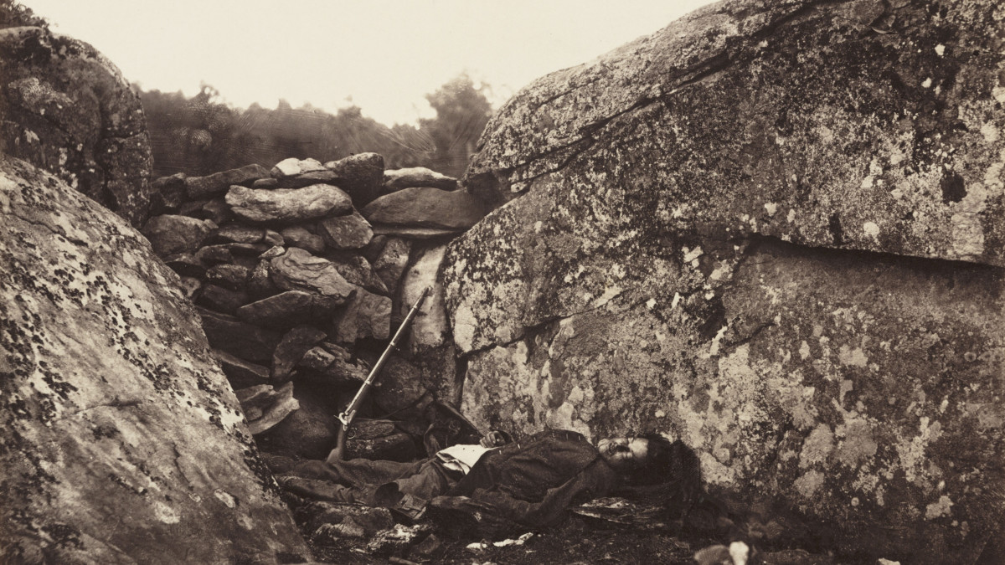
A print of a dead soldier at Devil's Den on the battlefield at Gettysburg, by Alexander Gardener (1821-1882) from a negative produced by Timothy H O'Sullivan (1840-1882). The Devil's Den was the scene of bitter fighting during the second day of the Battle of Gettysburg.
SSPL/Getty Images
Many Civil War historians have believed the 620,000 estimate to be too low, especially on the Confederate side, given the lack of written records and the estimate’s questionable assumption that men in the Confederate army died of disease at the same rate as men in the Union army.
“I think that there's been a long, long belief among historians that the numbers that we've been citing for a century or more are not based on solid data but were in fact, crude estimates that were likely to be underreported,” Hacker says. “And for that reason, I think, the results of my study verified in some people's minds exactly what they had long suspected.”
The American Battlefield Trust, however, says it will continue to cite the estimate of 620,000. It praised Hacker’s initiative, but said his estimated range of 650,000 to 850,000 “is very broad, includes civilian casualties, and is not directly linked to the war years of 1861-1865.”
“They say, ‘How can you publish a number with that big of a possible error range (650,000 to 850,000)?’” Hacker says. “So they’re going to stay with a number that we all know is much more specific. But to me, the 620,000 number has a big error range with it. It’s just not published. We shouldn’t prefer that number just because it does not include the possible error range.”

Deaths Traced by Birth Regions Reveal High Southern Toll
Hacker's analysis did not break down the estimate for Union and Confederate deaths since the census records did not account for that. However, as a 2011 HISTORY.com story details, his method was able to discern patterns for various regions of birth. For example, the analysis concluded that mortality was significantly higher for white males between the ages of 10 and 44 born in the South (13.1 percent) and in the slave-holding border states of Missouri, Kentucky, Maryland and Delaware (12.7 percent) than for those born in the free states and territories (6.1 percent). The data further suggest that 22.6 percent of Southern men who were between the ages of 20 and 24 in 1860 lost their lives because of the war.
Hacker doubts that further research into national census figures will yield a significantly closer or more accurate estimate of Civil War deaths. At the same time, and he and other quantitative historians are excited about a vast new range of opportunities for census that will be possible with the release in 2022 of a massive, comprehensive digitization of all U.S. census records from 1850 to 1940.
“We're looking at a time when there can be some real contributions to historical knowledge using these data that are being released,” he said. “We not only have complete census data on everybody, we have linked slaves to their owners so you can study slaveholding families. We can link people from census to census, so we can see where people were located, where they moved and observe their transition from, say, single marital status to married, or from married to widowed.
“With these new data, we’re going to be able to get a much more fine-grained picture. So there are some real opportunities for understanding the Civil War generation better than we have in the past. And this is a really exciting time to be a quantitative historian of the Civil War.”
BY
BOB ZELLER
Author and photo historian Bob Zeller is the co-founder and president of The Center for Civil War Photography. He has authored or co-authored four books on Civil War photography, including Lincoln in 3-D and The Blue and Gray in Black and White: A History of Civil War Photography.

Books by Bill Teegarden
118th Ohio History https://www.google.com/url?rct=j&sa=t&url=https://www.sidneydailynews.com/news/business/213871/delphos-author-publishes-book-about-civil-war-soldiers-stories&ct=ga&cd=CAEYAyoTOTQ1OTcyMzMxOTkxNDA0OTcyODIaYmFmYWNiYzIxYTg5YmViZTpjb206ZW46VVM&usg=AFQjCNF8qh_4tEwrLZqUOfzjJRDn7OIYjw
Our First Civil War
https://www.google.com/url?rct=j&sa=t&url=https://alcalde.texasexes.org/2021/09/ut-professors-new-book-explores-opposing-sides-of-the-american-revolution/&ct=ga&cd=CAEYAyoTMzEwNjI0MzM1Njc0OTg4MzE2ODIaYmFmYWNiYzIxYTg5YmViZTpjb206ZW46VVM&usg=AFQjCNEIwOVknEu3DbU2kapez8-yaugtwg
“A Holy Baptism of Fire & Blood”
https://www.google.com/url?rct=j&sa=t&url=https://www.wsj.com/articles/a-holy-baptism-of-fire-blood-review-the-civil-wars-biblical-violence-11610752821&ct=ga&cd=CAEYAyoUMTcyOTMyNDg3NTk0OTQyMzMzODAyGmVjODEzZDliNmY2YmZhYzY6Y29tOmVuOlVT&usg=AFQjCNGvlmKzY4qI-lzwienO8h_Qiv9D6A
A Contest if Civilizations
https://www.google.com/url?rct=j&sa=t&url=https://www.cdispatch.com/lifestyles/article.asp%3Faid%3D85900&ct=ga&cd=CAEYAyoTNDE3MzcwOTMxMzA1NTYzNTg1NDIaYmFmYWNiYzIxYTg5YmViZTpjb206ZW46VVM&usg=AFQjCNGdVHK-MHihEd4a0KSF26BBTXJ35w
The Black Civil War Soldier:
https://www.google.com/url?rct=j&sa=t&url=https://www.vogue.com/article/deborah-willis-new-book-salutes-the-black-civil-war-solider&ct=ga&cd=CAEYAioTMzc0MDkxMDY4MzQ0MDE0OTM5MjIaZWM4MTNkOWI2ZjZiZmFjNjpjb206ZW46VVM&usg=AFQjCNHu3OV_CgUNgDAqkNyuue8M2xLOeQ

