HARDSCRABBLE
Civil War Round Table of the Mid-Ohio Valley Newsletter
September 2021 – Vol 14

Notes from Nancy Arthur
If you can’t travel to all the places you read about or would like to see, there is a second best idea: websites. And there are some great ones!

Check out battlefields.org American Battlefield Trust has so far created 23 digital apps to show you around important battlefields. They are GPS friendly and include maps, interpretive assistance, and historic commentary. www.battlefields.org/apps

If you couldn’t get to Gettysburg for the anniversary in July, there are 26 videos posted for you to see many of the sites. These were brought to us by the Adams County Historical Society, Ancestry/Fold 3, Gettysburg Foundation and the Gettysburg National Military Park. Look for them at www.battlefields.org/gettysburg-158-live

And get a 360 battlefield tour of more than 50 Civil War and Revolutionary War hallowed ground, offering panoramic views and points of interest through articles, pictures and videos.
www.battlefields.org/visit/virtual-tours

And finally, the Trust is contributing to a series still in the works called Hear Here. This series started in 2020 and has over 10,000 audio stories narrated by voices like Kevin Costner and Phil Jackson. www.battlefields.org/HearHere

In the October issue of Civil War Times, there is a review of A Thousand May Fall by Brian M. Jordan that has peaked my interest, due to the fact it is close to home. Written about the 107th Ohio, it starts with their training at Camp Cleveland and was made up of ethnic Germans from northeast Ohio. These men fought with the Army of the Potomac under Ambrose Burnside, against Stonewall Jackson at Chancellorsville, on Blocher’s Knoll at Gettysburg, then were shipped off to the swamps of Florida and finished the war on the banks of the Cooper River in South Carolina, near Charleston.

Happy arm chair traveling!

Stories from Bill Teegarden
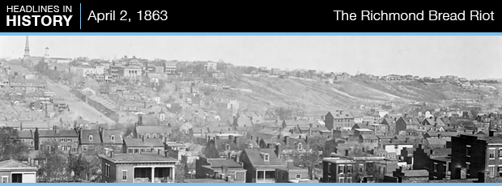
During the Civil War, lack of food, money, and supplies created unbearable conditions for women living in the southern United States. Inflation and the lack of supplies left families reeling. Women especially felt the financial pinch and had difficulty providing food for their families. The situation was further exacerbated when the drought of 1862 impacted the harvest. Meager food supplies became even scarcer. The salt needed for preserving meat was also hard to come by. It was imported from the North and generally unavailable, or too expensive to purchase.
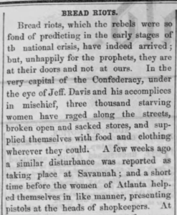The Lancaster Examiner 4.15.1863
Tensions reached a boiling point in the spring of 1863 when civil unrest broke out in cities across the South. The unrest was organized by women, enraged by the exorbitant price of bread. They attacked stores and warehouses, stealing food, clothing, and supplies. The largest of these riots took place in Richmond, Virginia, on April 2, 1863.
In March 1863, a Richmond woman named Mary Jackson began recruiting women to participate in an organized protest. She was the mother of a Confederate soldier and frustrated with the government’s inability to provide aid for her and other women whose men were away fighting. She garnered the support of about 300 women. On the morning of April 2, 1863, Jackson arrived at the market in Richmond. She was a peddler, but that day she brought nothing to sell. Instead, she increased recruitment efforts and began warning men that trouble was brewing. The growing crowd of women began marching towards the governor’s office in Capitol Square, where they were turned away. There are varying reports of what happened next, with some claiming the governor eventually came and met with the women. The angry crowd began marching towards Ninth Street. As the women marched, hundreds began to follow, and the crowd ballooned.
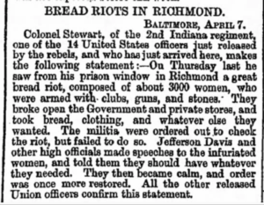Liverpool Mercury 4.20.1863
Armed with guns, hatchets, and household implements, the women began to chant “Bread or Blood!” They attacked grocery stores, warehouses, and other businesses, stealing food, supplies, and even fine jewelry.
Soon, Richmond Mayor Joseph Mayo arrived and read the Riot Act aloud to the mob. They ignored him. Governor John L. Letcher sent for Confederate President Jefferson Davis. He begged the women to disperse, warning that an artillery unit would open fire on the mob. Davis then emptied his pockets, throwing his money to the women. Tensions finally eased, and the crowd disbursed.
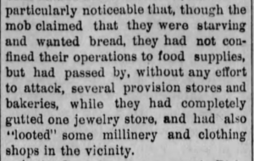Rioters take more than bread – The Chanute Times 5.29.1889
Confederate secretary of war James A. Seddon asked the local press to refrain from publishing news of the incident, fearing it would fuel Union propaganda. Confederate deserters, along with Union prisoners who watched the scene unfold from their cell windows, leaked the story. The New York Times published a front-page account of the riot on April 8th.
Following the riot, more than 60 demonstrators were arrested, including Jackson. The women received varying degrees of punishment. Jackson’s punishment was merely nominal. The City of Richmond increased efforts to provide aid to the poor, restoring a measure of calm. The 1863 bread riots showed just how difficult life had become for women on the home front. If you would like to learn more about the Richmond Bread Riot, search Newspapers.com™ today.

Sacrifice: Remembering the 1st Minnesota at Gettysburg
7
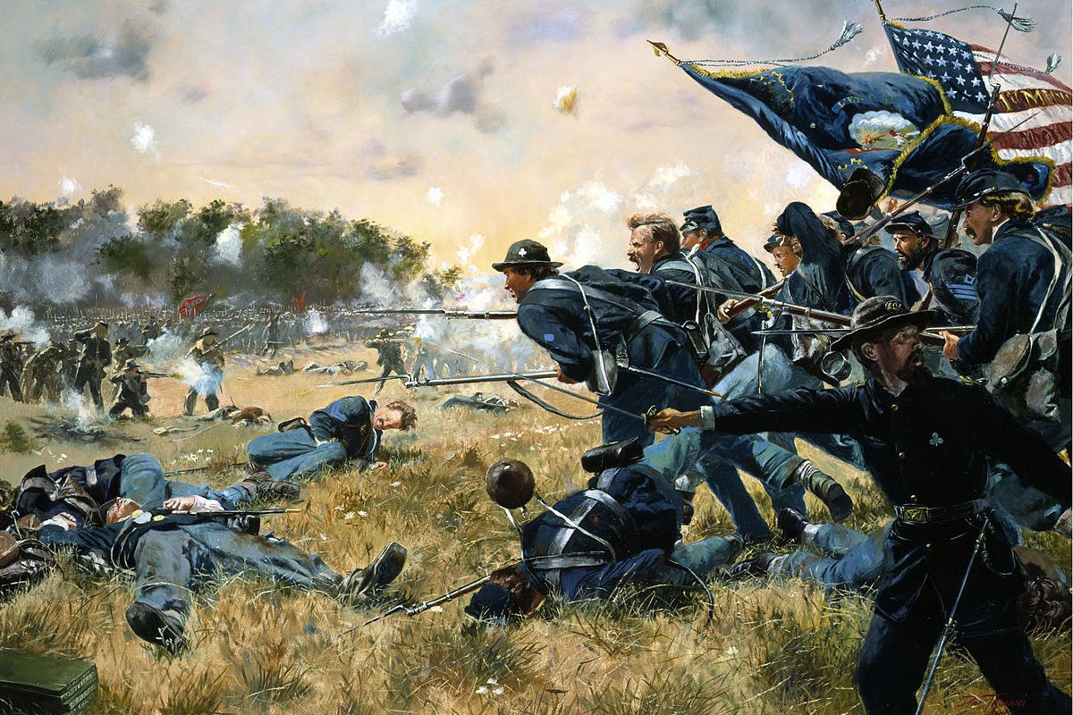
Heroism seldom occurs without a mistake, and it was no different around 4 pm on July 2nd, 1863. Union General Sickles, a political appointee without a military background, advanced his men without authorization to higher ground 1000 meters ahead of his original position, creating a gap in the Union lines. Cemetery Ridge was now vulnerable, and Confederate forces poured into the half-mile-wide opening.
The Union held the veteran troops in reserve. Green troops in the front because green troops run instead of holding their lines. Veterans stand their ground, and no regiment was more veteran than the 1st Minnesota. Alexander Ramsey had volunteered them on April 14th, 1861, shortly after the shelling of Fort Sumter. The men were loggers and farmers, big in stature and rugged by nature, used to wielding the ax, the rifle, and the setting pole. Since the beginning of the war, the regiment had seen lots of action. They had taken heavy casualties at Bull Run and more later at Antietam. On the afternoon of July 2nd—after beginning the war with over one thousand men—they stood midway between Cemetery Ridge and Little Round Top, just 262 strong.
As Sickles’s line collapsed under Confederate attack, it became apparent that the situation was dire. If the enemy managed to get through the gap, they would roll up the Union forces, devastating the Union Army and likely ending the war. Gray uniforms arrived in magnificent waves, hurling death and destruction from rifles and batteries. Union General Hancock had sent for reinforcements, but they would not come for at least five minutes. All he had to plug the gap stood before him. He looked at the regiment.
“My God,” said Hancock. “Are these all the men we have?” They were.
“What regiment is this?”
“The 1st Minnesota,” commanding officer Colonel William Colvill replied.
“Charge those lines,” ordered Hancock.
The regiment was to be sacrificed for an uncertainty. The 1st Minnesota was outnumbered at least 5 to 1. Colonel Colvill turned to his men and ordered them to fix bayonets and “forward, double quick.” Not a single man disobeyed the order. At first, they began moving in two lines, which the regiment held as long as possible under punishing fire before driving straight into the center of the enemy. Their flag fell five times, and each time was picked up again. By the time they reached the enemy, the 1st Minnesota was spread out, fighting individually or in small groups.

Hancock had asked them for five minutes. The 1st Minnesota gave him fifteen. They lost 215 men, 82% of the regiment, including their commander and all but three captains. The General would later say that “No soldiers on any field, in this or any other country, ever displayed grander heroism.” Historians believe that the 1st Minnesota’s charge saved the Union at Gettysburg, and as a result, was one of the crucial moments in winning the Civil War. What remained of the 1st Minnesota was plugged into other units and found themselves at the focal point of Pickett’s Charge.
Each year on this day, I think of those men who were given a suicide mission so that others may live without any guarantee of success and many reasons to expect failure. And to a man, they accepted and charged double time, once more unto the breach. More than a century and a half later, the nation they fought and died for remains deeply imperfect but still here. They make me proud to be from Minnesota. As Lincoln said, “It is rather for us to be here dedicated to the great task remaining before us that from these honored dead we take increased devotion to that cause for which they here gave the last full measure of devotion.“

Coda: Flags and Monuments
In the Minnesota Historical Society’s collection lies a scarred piece of cloth, primarily red, with a blue St. Andrew’s Cross and thirteen white stars. The cloth started its journey in Lynchburg, Virginia, in June 1861, flew at Manassas and throughout the Peninsula Campaign, and on July 1st, 1863, made its way to Gettysburg. The cross on the flag has no historical meaning, chosen only to avoid a potential objection to an upright cross, and the colors are plagiarized.
Marshall Sherman was a house painter by trade and had come to Minnesota in 1849 when the state was still a territory. He was a quiet man and had mustered into the 1st Minnesota at age 37. On July 2nd, Sherman had been stationed on detached duty as a division provost guard and did not see action. On July 3rd, he and the rest of his unit were placed in the middle of the Union line.
The piece of cloth led men who followed a bankrupt idea. Over the course of the war, that number had been up to 600. On July 3rd, the cloth led considerably less of them on a charge up a ridge.
Marshall Sherman was not the first man over the wall. If it was a Minnesotan, then the man was Henry D. O’Brien, who held the colors of the First Minnesota on a staff nearly broken in two by a bullet. O’Brien rushed forward toward the Confederate chargers. His Lieutenant ordered him to come back, but as O’Brien later said with a smile, “I didn’t.” The rest of the Minnesotans reacted on instinct and followed the colors. The two unequivocal facts from that day are the failure of Pickett’s charge and that Marshall Sherman was awarded the Medal of Honor for capturing the 28th Virginia’s colors.
In 1905, Congress passed an act that declared that flags in possession of the War Department at the time be returned to the respective states from which they came. However, the 28th Virginia’s battle flag was not in the War Department’s possession. That does not mean the flag was missing. Since 1867 the flag was almost certainly owned by Marshall Sherman. Eventually, Sherman transferred the flag to the Minnesota Historical Society, who has owned it to the present. The flag resides in a museum where such symbols belong, a relic of history.
++++++++++++++++++++++++++++++++++++++++++++++++++++++++++++++++++

Fort Pulaski, home to American Civil War history
- By PAIGE IMPINK News Correspondent paige@yourtowncrier.com
- Jul 17, 2021
- Visiting old forts that echo the history of our nation is a popular pastime, especially in the summer months. Fort Pulaski, on the Savannah River in Georgia, is a Civil War gem which displays artillery of the era in a rich, natural setting.
- Unlike many forts in the country, at Fort Pulaski visitors can see the scars of battle preserved right on the exterior walls. Cannon balls are lodged in the brick from its defining battle in April of 1862.
- Fort Pulaski is part of the National Park Service. It was designed as a coastal fort to protect Savannah from any attacks by river. As with a number of forts built in the United States in the early 19th century, Fort Pulaski, commissioned by the United States federal government, took 18 years to build and was not completed on time or garrisoned.
- The fort was built on marshy Cockspur Island and had to rely on an elaborate dike system, designed by then Lt. Robert E. Lee, to manage the drainage around the fort. In addition, a 7-foot-deep moat was dug around the perimeter of the fort, and a drawbridge installed, complete with a medieval-era portcullis to keep out any attackers.
- As Georgia seceded from the Union in January of 1861, the state government conferred the fort to the Confederate States of America. Not all residents of Savannah, a rich trading port, were on board with the plan to take over a Federal fort.
- However, once the occupation began, people from all walks of life joined the effort. The fort was the only way to protect the route to and from the Atlantic Ocean from Savannah and if the Union controlled it, the port was at risk of being cut off.
- As it turns out, the takeover was executed by 200 Savannah militiamen demanding the keys to the fort from two caretakers who surrender without issue. Three months later the American Civil War began.
- Unfortunately, the downfall of the fort and the Confederate occupation was new artillery technology. When pressure was put on the port of Savannah via a blockade ordered by President Abraham Lincoln, the Confederate soldiers abandoned nearby Tybee Island.
- The opportunity was seized by the Union army and it was the rifled cannon, capable of firing a spiraling projectile from a distance of more than a mile, that let Union soldiers breach the fort. Long since repaired, restoration efforts at the fort have preserved the evidence of cannon ball damage on two of the Tybee-facing walls.
- The fort today is run by the National Park Service and is a perfect excursion from Savannah. The fort has a visitor center as well as interpretive panels placed around the property. Miles of walking trails complete with sandy paths through the marshes are a fine way to absorb the scenery and imagine the hardship that the Civil War brought to Americans from both sides.

****************************************************************

Cross-dressing and poison ivy: How a renegade North Carolina couple switched sides during Civil War
BY
HAYLEY FOWLER
• THE CHARLOTTE OBSERVER • AUGUST 11, 2021

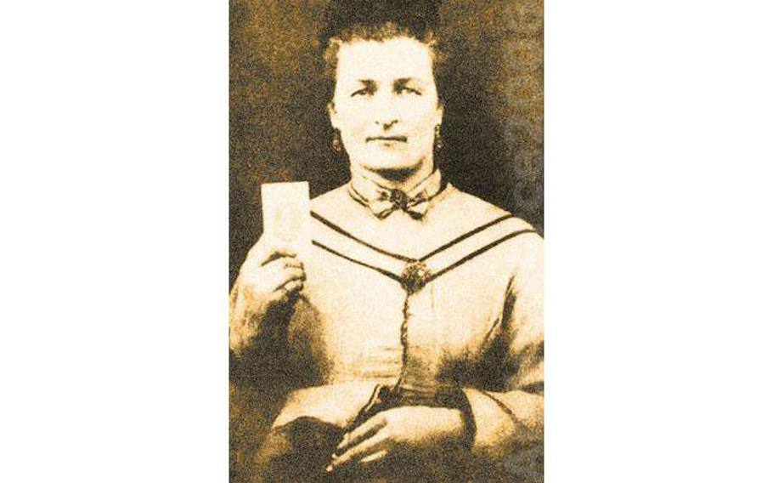
On March 20, 1862, Malinda Blalock disguised herself as a young man and enlisted in the Confederate army. (NC Department of Natural & Cultural Resources Facebook)

(Tribune News Service) — Decades before Bonnie and Clyde terrorized the U.S., there was Keith and Malinda Blalock — a couple of Confederate deserters who wreaked havoc on the mountains of Western North Carolina as Union guerrilla fighters during the Civil War.
Malinda Blalock posed as a man to enlist alongside her husband.
According to historical records, the pair weren’t separated until her death in 1901. Keith Blalock died 108 years ago on Aug. 11, 1913. Their renegade life at the base of Grandfather Mountain is detailed in state records and at the Avery County Historical Museum.
“Murder, robbery and plundering became their calling cards,” the museum said of the Blalocks after they returned from a short-lived stint in the Confederate Army. “And the entire time Malinda was by her husband’s side.”
Malinda, born Sarah Malinda “Linda” Pritchard in Alexander County, met William “Keith” Blalock in a one-room schoolhouse in Watauga County, according to the North Carolina History Project.
Keith was 10 years older, and their families had been feuding for 150 years before the pair married in 1856.
Five years later, the Civil War broke out.
Donning a disguise
Malinda and Keith were Unionists, the N.C. Department of Natural and Cultural Resources said. But Keith’s fear of being drafted prompted him to enlist in the 26th North Carolina Troops for the Confederate Army in March 1862.
His plan was to desert and join Federal troops as his unit moved north, according to the Ohio State University’s eHistory. But he wanted Malinda to be safe amid the town’s secessionists, so he made sure they saw him join with the Confederacy.
His wife, however, had other plans.
Malinda cut her hair short, put on her husband’s clothing and followed him to war by enlisting under the name Sam, the North Carolina History Project said.
She is one of two women known to have served in the Confederate Army and North Carolina’s only female Civil War soldier.
“Sam” was described as a “good looking boy aged 16, weight about 130 pounds, height five feet four inches.” He was thought to be Keith’s little brother.
Historical record differs as to whether Keith knew of his wife’s intentions. According to the Department of Natural and Cultural Resources, the “romantic version” of events is that “Keith looked over at the private walking next to him and did a double-take when he recognized his wife.”
Fellow soldier and Confederate recruiter James Moore was one of the only people who knew Malinda’s secret, The Herald-Dispatch reported. In an article for The Morning Post newspaper in 1900, he wrote that the Blalocks confided in him in Salisbury as they made their way east to Kinston to join their regiment.
Moore had previously commented that Sam “resembles Keith’s wife so much,” and the pair believed he had figured them out.
“They concluded it was best to make me their confidant so I would not tell anyone about it,” Moore wrote in the article. “I never told anyone about it except my brother-in-law, Isaac N. Corpening, who was also in the Company.”
He said no one ever suspected the true identity of Sam Blalock, who “drilled and did the duties of a soldier as any other member of the company.”
Bonnie and Clyde of Western North Carolina
There are conflicting tales as to how the Blalocks came to leave the Confederate Army.
In one version of events as told by the North Carolina History Project, the couple served only one month in the 26th regiment before Malinda was injured in a firefight. She reportedly had to undergo surgery to have a bullet removed from her shoulder, and the surgeon discovered she was a woman.
Keith, wanting to be with his wife after she was discharged, “went into the forest, stripped off his clothes, and rolled around in poison ivy,” the North Carolina History Project said.
His skin became “inflamed and covered with blisters,” and he told doctors it could be a “recurring and highly contagious disease.”
They feared an outbreak, and Keith was discharged.
But according to NCPedia, it was Keith who was first discharged with a poison oak infection after his unit was sent south — not north — and he realized his plans to desert wouldn’t come to fruition. Malinda revealed she was a woman to follow him.
Regardless, the pair returned to Grandfather Mountain, where they were joined by other deserters, according to NCPedia.
Keith began working for the Union Army as a recruiting officer, the Avery County Museum said, and the couple eventually “became the ‘Bonnie and Clyde’ of the western North Carolina mountains terrorizing both Unionists and Confederates.”
The mountains were close to Union supporters across the border in Tennessee, who frequently ransacked the area, according to the museum.
Keith and Malinda Blalock were among those raiders for the Union Army, the North Carolina History Project said.
When the Civil War ended, the couple became farmers in the Linville area, which is now Avery County, according to NCPedia.
They are buried side by side in Montezuma Cemetery in Avery County.
©2021 The Charlotte Observer.
POSTED ON AUGUST 22, 2021

Holy Cow! History: The days of the White House Princess
COLUMNS, TOP STORIES

By J. Mark Powell - InsideSources.com

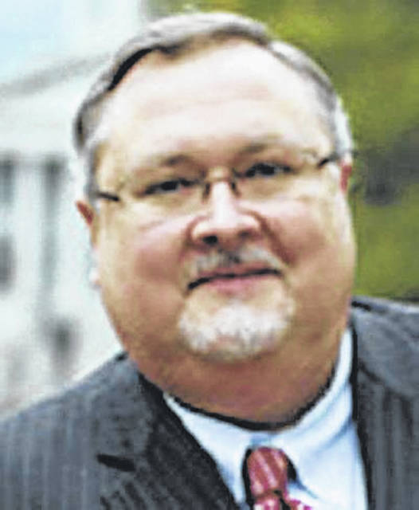
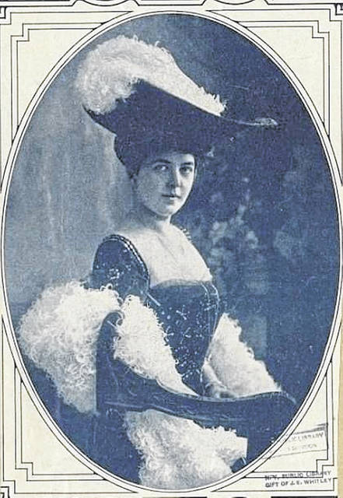
Marrying into the Russian monarchy carried a high price tag for Julia Dent Grant.

Every doting grandfather will tell you his granddaughter is a little princess. Ulysses Grant was no different. The difference between Grant and other grandpas, however, was his granddaughter would become an actual princess.
The president was proud as punch at Julia Dent Grant’s arrival on June 6, 1876. She immediately joined one of America’s most exclusive clubs as one of the dozen or so people born in the White House.
Her father served as President Benjamin Harrison’s ambassador to Austria-Hungary, and Julia toured Europe as fashionable Victorian young ladies were expected to do. During a visit to Cannes, France, she met and fell in love with a dashing Russian diplomat, Prince Mikhail Cantacuzéne. He proposed just two days after meeting Julia. A planned wedding was called off, but later they reunited. Named for her grandmother, also named Julia Dent Grant, she grew up considering the White House all but a second home. Christened in the East Room, she spent her childhood attending parties and events there.
Of her famous grandfather (who died when she was 8) she later recalled, “He held my pudgy, dimpled hand on the palm of his, and we learned to count the dimples and fingers together … he taught me ‘cat-cradle’ with a string.”
Being a Grant had advantages, which included celebrity status. Ulysses Grant was internationally famous — not for serving two terms as President of the United States — but for being the general who had won the American Civil War. That VIP status gave young Julia entrée to the highest echelons of society.
When they finally did get married, in the social capital of Newport, R.I. in Septhad two weddings; a Russian Orthodox ceremony came first, followed by an Episcopalian wedding the next day.
But marrying into the Russian monarchy carried a high price tag. Julia had to move to Russia, where her focus shifted from American republican politics to Romanov royal intrigue. The newlyweds settled in the imperial capital of St. Petersburg, but they also spent time at their extensive estate in Ukraine. They had three children: son Mikhail, daughter Zinaida, and another daughter called Barbara, who was nicknamed Bertha after her great-aunt. (One can only imagine the child explaining that usual name to her Russian playmates. “It’s an American thing. You wouldn’t understand.”)
When World War I began the prince was an aide to Czar Nicholas II, then became a general in the field. He was wounded in 1915 while commanding a 15,000 horseman attack, one of warfare’s last mass cavalry charges.
Then the 1917 Russian Revolution came, followed by Russia’s own Civil War. Everything changed overnight. Julia and her family were forced to flee — first to Finland, then to the U.S.
They settled in Washington. The couple rallied support for a counter-revolution until the Communists murdered Nicholas and his family. That killed their hopes for a Romanov restoration, though they remained active in the Russian expatriate community.
Julia and her prince finally settled in Sarasota, Fla., where he worked in her aunt’s farming and banking operations.
She helped support the family with her writing. Her work appeared in The New York Times, Saturday Evening Post, Woman’s Home Companion, and other leading publications. She also penned three popular memoirs.
Still, the strain of so many ups and downs ultimately took its toll on the marriage. Julia and the prince divorced in 1934. He later remarried; she never did. A countess no more she regained her U.S. citizenship, dropped her old imperial titles, and rebranded herself simply Mrs. Julia Grant Cantacuzéne.
Time eventually caught up with the former noblewoman. She was going blind before she turned 80, though incredibly her vision partially returned in the final two weeks of her life. Her last years were spent enjoying her six grandchildren, 22 great-grandchildren, and three great-great-grandchildren before quietly slipping away in 1975 at age 99.
The life that began in the aftermath of Appomattox stretched into the depths of the Cold War. She had seen governments rise and fall, old dynasties swept away and a new world emerge from their rubble. And throughout it all, she carried herself with dignity and style and wrote about her many remarkable experiences with tender deftness.
You can’t help believing the old general would have been proud of his little princess.
Books by Bill Teegarden
From Leight Murry: My favorite reads in the last couple of months are A Gallant Defense: The Siege of Charleston, 1780 by Carl P Borick, and, The Siege of Charleston, 1861-1965 by E. milby Burton. Respectively, ISBN numbers are 1-57003-487-7 and 0-87249-345-8.
The Devil in Andrew Johnson
https://www.google.com/url?rct=j&sa=t&url=https://www.post-gazette.com/ae/books/2021/09/19/Robert-Levine-Failed-Promise-Reconstruction-Frederick-Douglass-Impeachment-Andrew-Johnson-review/stories/202109190001&ct=ga&cd=CAEYAioTNzk1MDM3NzkxNDU5MDM5NTA4MzIaYmFmYWNiYzIxYTg5YmViZTpjb206ZW46VVM&usg=AFQjCNEfvUnfkHimi-OAluquJtMwvWMn2AThe Devil in Andrew Johnson
Francis “Frannie” Lightburn Cressman
https://www.google.com/url?rct=j&sa=t&url=https://www.wdtv.com/2021/09/19/frances-frannie-lightburn-cressman/&ct=ga&cd=CAEYASoUMTM3NDAzMjg5MjgxMTMzODExNTMyGmJhZmFjYmMyMWE4OWJlYmU6Y29tOmVuOlVT&usg=AFQjCNELuc5r_cniF8FNCQlMn7BRr_87pg
PC Games
https://www.google.com/url?rct=j&sa=t&url=https://www.pcgamesn.com/victoria-3/slavery&ct=ga&cd=CAEYCioUMTQ0OTczNjE5NzE1MTEzOTI0NzIyGmJhZmFjYmMyMWE4OWJlYmU6Y29tOmVuOlVT&usg=AFQjCNGabQRseYM44kgIs1-AqXPKSFE62A

Ohio At Antietam
https://www.google.com/url?rct=j&sa=t&url=https://www.wvxu.org/show/cincinnati-edition/2021-09-07/ohio-at-antietam-daniel-welch&ct=ga&cd=CAEYCCoTMTM5NzU0MjY0MDEwMTkzODE2NjIaYmFmYWNiYzIxYTg5YmViZTpjb206ZW46VVM&usg=AFQjCNHGPs6Ke_ahH_vMW_mncaIPXnrFFg
Battle of Gettysburg Bluff e-newsletter (courtesy of Jeff Danner):
http://battleofgettysburgbuff.com/ This is a neat site.
Our First Civil War
https://www.google.com/url?rct=j&sa=t&url=https://alcalde.texasexes.org/2021/09/ut-professors-new-book-explores-opposing-sides-of-the-american-revolution/&ct=ga&cd=CAEYAyoTMzEwNjI0MzM1Njc0OTg4MzE2ODIaYmFmYWNiYzIxYTg5YmViZTpjb206ZW46VVM&usg=AFQjCNEIwOVknEu3DbU2kapez8-yaugtwg
Travel in West Virginia
https://www.google.com/url?rct=j&sa=t&url=https://wvstateparks.com/visiting-the-new-river-gorge-round-out-your-trip-with-a-visit-to-these-state-parks/&ct=ga&cd=CAEYCCoTMjMyNzEyMjU4Njk2NjU0OTE0NDIaZWM4MTNkOWI2ZjZiZmFjNjpjb206ZW46VVM&usg=AFQjCNHwDEuVVqDAJpdJmfxEDEeQLekNXw

This Guilty Land
https://www.google.com/url?rct=j&sa=t&url=https://www.lrb.co.uk/the-paper/v42/n24/eric-foner/this-guilty-land&ct=ga&cd=CAEYBioTMzY3NTEzOTYzMDkwMTY5Mjg1NTIaYmFmYWNiYzIxYTg5YmViZTpjb206ZW46VVM&usg=AFQjCNGpA8PqxSsjpvdlcjHde9kQf6boGQ
Civil War Photo Sleuth
https://www.google.com/url?rct=j&sa=t&url=https://theroanokestar.com/2020/12/10/va-tech-professors-photo-sleuth-software-helps-investigate-150-year-mystery-of-john-wilkes-booth/&ct=ga&cd=CAEYDyoTMTcxNDgxMTI5NTM2NTAzNjc4MzIaYmFmYWNiYzIxYTg5YmViZTpjb206ZW46VVM&usg=AFQjCNFOqn0-zEOIDz5zq-Ou7xFZyhf40w
Midnight Rising – John Brown and more books
https://www.google.com/url?rct=j&sa=t&url=https://www.amazon.com/Black-African-Americans-Military-History/s%3Frh%3Dn%253A4867%252Cp_n_feature_four_browse-bin%253A9336647011&ct=ga&cd=CAEYNSoTMTcxNDgxMTI5NTM2NTAzNjc4MzIaYmFmYWNiYzIxYTg5YmViZTpjb206ZW46VVM&usg=AFQjCNEMw15MUBushXmhqX_CmclI19yO2Q
John Avery Benton
https://www.google.com/url?rct=j&sa=t&url=https://fcnp.com/2020/12/15/life-of-bentons-relative-civil-war-veteran-explored-in-latest-biography/&ct=ga&cd=CAEYAioUMTQxMzc0MTE2Mjk3MzIwMzgyOTAyGmVjODEzZDliNmY2YmZhYzY6Y29tOmVuOlVT&usg=AFQjCNEpup-cuap2Lk14zGWZi4xlnUNUeA

We Met By Chance
https://www.google.com/url?rct=j&sa=t&url=https://patch.com/virginia/fairfaxcity/calendar/event/20210104/955106/masters-monday-chuck-mauro-we-once-met-by-chance&ct=ga&cd=CAEYACoTMjkzODE5NDMyMzU1Nzg3Mjg1NjIaYmFmYWNiYzIxYTg5YmViZTpjb206ZW46VVM&usg=AFQjCNFwrwmqfh_8604KAk-r_NxlBIgtUw
Lincoln’s Lie
https://www.google.com/url?rct=j&sa=t&url=https://will.illinois.edu/21stshow/story/presidents-day-lincolns-lie-by-elizabeth-mitchell-the-presidents-vs-the-press-by-harold-holzer&ct=ga&cd=CAEYCSoUMTc1MzQxMTcyNDAyMjA3ODQ0ODQyGmVjODEzZDliNmY2YmZhYzY6Y29tOmVuOlVT&usg=AFQjCNFymCJ0C0hCiD07dSJ0ajUPB2UWcg
The Last Battleground
https://www.google.com/url?rct=j&sa=t&url=https://www.starnewsonline.com/story/news/2021/01/03/brunswick-civil-war-round-table-historian-philip-gerard/4047667001/&ct=ga&cd=CAEYASoUMTc2NzM5NjYwNzI2NTA1OTg1MDIyGmVjODEzZDliNmY2YmZhYzY6Y29tOmVuOlVT&usg=AFQjCNH41RiEKrn1WHpMpVqjV4TQW8LEzQ
Historical Author – Bob O’Conner
https://www.google.com/url?rct=j&sa=t&url=https://www.journal-news.net/journal-news/local-author-publishes-his-18th-book/article_76233780-2b19-55fa-ad31-ac6acce2893c.html&ct=ga&cd=CAEYCSoUMTY3MTk3NTkwNTQ0MTMzNTcwODAyGmJhZmFjYmMyMWE4OWJlYmU6Y29tOmVuOlVT&usg=AFQjCNG9czPK5p5gxqOnSRroY32F37GnEg
___________________+++++++++++++++++___________________

