HARDSCRABBLE
Civil War Round Table of the Mid-Ohio Valley Newsletter
June 2020 – Vol 2

Story by Bill Teegarden (Scott is immersed in starting up The Castle but I hope to have him back in full force in August)

WILMINGTON, N.C. (WTVD) -- One of the most important African American leaders of the late 1800s was born in North Carolina, but his accomplishments and influence vanished from history for 100 years.
Abraham Galloway was a spy, an insurgent, a statesman, a fierce advocate of the working class and a warrior against oppression and tyranny.
"When he did speaking tours in the North, he didn't introduce Frederick Douglass as the main speaker of the night. Frederick Douglass introduced him as the main speaker of the night," historian Dr. David Cecelski said.
Yet today, Frederick Douglass is a household name and central figure of study in American history, while Abraham Galloway is hardly known.
When Galloway died in 1870, approximately 6,000 people attended his funeral. Newspapers at the time reported that it was the largest funeral in North Carolina history.
"Everybody knew who Abraham Galloway was at that point," Cecelski said.
Galloway was a war hero. He was a nationally known speaker. He was one of the first African Americans elected to serve in the North Carolina General Assembly. But check North Carolina history books, museums and classrooms from the 1900s into the 2000s and you will find hardly a whisper of one of the state's most influential sons.
"What happened--and it's a central part of North Carolina history--is that beginning in the 1890s early part of the 1900s, we get a new vision of what our past was like. In a way it was kind of the vision of North Carolina history that I grew up with," Cecelski said. "Docile black people, happy slaves--in that vision of our history, there's no room for a man like Abraham Galloway. He was a proud African American insurgent. Brilliant. Who fought like one of the great guerilla leaders of world history for the freedom of his people."
Galloway was a hard man to please; he was fearless. He was known for always having two pistols in his belt where everybody could see them, and he would challenge people that crossed him to duels in the street. But he was also a man with a sarcastic sense of humor, who loved to laugh loudly and often.
'He laughed loud and often:' The life philosophy of Abraham Galloway
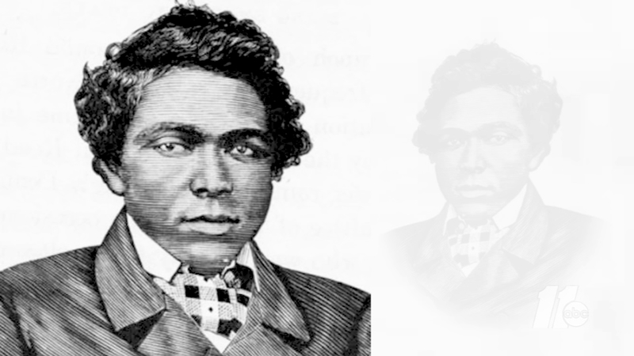
'He laughed loud and often': The life philosophy of Abraham Galloway

Cecelski was researching a book when he kept running across stories about a man who seemed larger than life: a 19th century James Bond.
"I almost couldn't believe (the stories)," Cecelski said. "They were so not like what I was taught about the history of slavery, not like what I was taught about the history of the Civil War, not like what I was taught about African American history."
Galloway was born in 1837 in what is now Southport, North Carolina. His mother was enslaved; his father was a white man. He grew up in a world where he had to learn spy skills just to survive.
"Union generals later said this about Galloway and other African American spies: They said it is as if they were born to be spies," Cecelski said. "They had developed that -- just living through slavery gave them the most basic skills they needed. The ability to put up a false face. You know, to take on-to blend into surroundings, to conceal themselves."
At the age of 19, Galloway escaped to the North hidden on a ship. He worked for a while going back into the South and helping other enslaved people escape to the North.
As the Civil War began, the Union Army realized it needed better military intelligence inside the South. Abraham Galloway was the perfect type of spy they needed.
He spent his mid-20s setting up a network of spies in the South, passing information to the Union Army, and even going hundreds of miles into Confederate territory to rescue his mother.
During this time, Galloway goes from being a sort of master spy to being a leading African American political leader.
He created the first Civil Rights groups in the South during the war. He led a delegation of African American men from the South to the White House to pressure President Abraham Lincoln into promising political equality and full citizenship to African Americans if the Union wins the Civil War.
"And basically they succeed in that," Cecelski said. "It may not have been everything they wanted after the war. It may not have been every goal accomplished, but they brought millions of people out of enslavement. And from the beginning-and this was eye-opening for me-it was southern blacks, men and women like Galloway, who were leading that push. It wasn't white abolitionist up North, it wasn't freed black people from the North, it was people who were fighting in the trenches in little places like Kinston and Durham and around the South. People like Galloway who risked their lives day in and day out. "
In 1868, Galloway was elected state Senator in North Carolina as part of the group of first African Americans representatives.
"In the General Assembly he worked for labor rights, issues familiar to us today: minimum wages, regulate hours of work. He introduced the first amendments for women's suffrage," Cecelski said.
The man born into enslavement, who had been forbidden to learn to read or write, was now one of the most influential men in North Carolina.
But his life ended abruptly. He died at the age of 33 from fever and jaundice.
"If we can miss Abraham Galloway -- and nobody knew who he was 10 years ago, 20 years ago -- who knows what else we've missed," Cecelski said. "I think, particularly for young people, for students, the excitement and importance of that kind of historical discovery awaits them. And I don't just mean, I mean, yes, with African American history, but also all kinds of things. In many ways we have been denied much of the best parts of our past and places and things that happened that we can draw strength from, inspiration from, get a better vision of who we are as we try to fashion a future in this crazy new world that we're in."
Despite being erased from history for nearly 100 years, Galloway's life story is now making its way back into history books. Wilmington recently put up a historical marker near where he lived. His story can also be found in the North Carolina Museum of History.
To learn more about Abraham Galloway, consider reading Cecelski's book The Fire of Freedom.

Books and More by Bill Teegarden
"Civil War Northern Virginia 1861" and "Mosby's Raids in Civil War Northern Virginia," published by History Press, author William S. Connery
Confederate General William “Extra Billy” Smith by Scott Mingus (author of 19 other Civil War books)
The Valley of the Shadow –virginia.edu an electronic archive of two communities in the American Civil War--Augusta County, Virginia, and Franklin County.
Administrations of Lunacy: Racism and the Haunting of American Psychiatry at the Milledgeville Asylum Mab Segrest
Ulysses S. Grant Popular biographies, by Ronald C. White’s American Ulysses (2016) and Ron Chernow’s Grant (2017)
“Wild Rose,” by Ann Blackman
“News of the World” & “Simon the Fiddler” by Paulette Jiles
Tufts Digital Collections and Archives has partnered with the Medford Historical Society and Museum to protect, preserve, and improve access to a treasured collection of thousands of Civil War photographs.
Life of Pauline Cushman: the Celebrated Union Spy and Scout by Ferdinand Sarmiento
Congress at War: How Republican Reformers Fought the Civil War, Defied Lincoln, Ended Slavery, and Remade America, Fergus Bordewich’s
Armies of Deliverance: A New History of the Civil War by Elizabeth R. Varon
The Civil War Story of Michigan’s Anishinaabe Sharpshooters by Sally M. Walker
In Their Letters – In Their Words – Illinois Civil War Soldiers Write Home, by Mark Flotow.
The Civil War Dead and American Modernity. By Ian Frederick Finseth.
“The Real Horse Soldiers: Benjamin Grierson's Epic 1863 Civil War Raid Through Mississippi”by Timothy B. Smith
“The Civil War in the West,”by Earl H. Hess
“The Overland Campaign — Battle of Cold Harbor” by Gordon Rhea (and 6 other books on the Wilderness Campaign
Raising the White Flag: How Surrender Defined the American Civil War by Angela Zombek
“So Much to Say” is an account of the Civil War experience of Robert Bradbury, a Union corporal in Battery D, the First Pennsylvania Light Artillery. By Jonathan Noyalas, and Charles Givens
The entirety of Marvel Comics’ Civil War series. – seriously
“Faith and Fury: The Rise of Catholicism During the Civil War” by Father Charles P. Connor.
Not Even Past: The Stories We Keep Telling about the Civil War, by Cody Marrs

Comment: 1) The Newsletter came about because I asked the question “Why Don’t We Have One”? And was told that no one raised their hand. I thought it strange that we were working on setting up a website but somehow had overlooked having a newsletter – which seems to be a given for Civil War Round Tables.
2) The Roundtable is looking for a book cart (bookcase on wheels) for our library. We have a collection of books from Dick Feil and now Norm Pape. If you have one, we have a home for it @ our regular meeting location – St Luke’s Episcopal Church. Let Leight know……

