HARDSCRABBLE
Civil War Round Table of the Mid-Ohio Valley Newsletter
December2020 – Vol 5

My apologies to you for failing to “proof” my changes that were intended to make my book selections easier to read. I did not know that what I “saw’ in my original to Leight would not carry through in the final copy. I realized the error of my ways when Leight sent out the November Newsletter and by then it was too late. What I found out later was that your computer retains the back-end link/connection but fails to pass it on in a document. Hence a quick introduction to the use of Hyperlink and taking a deep breath that this month’s newsletter should work for you as I intended. Sorry about that… Bill
-
Notes from Nancy Arthur
David Duncan, new president of American Battlefield Trust
Jim Lighthizer, longtime president of the American Battlefield Trust, has retired from this position, giving way to David Duncan, after serving for 20 years. His vision was to preserve battlefield grounds around the country to both honor our ancestors and inspire future generations.

Duncan says “I study history because I enjoy it; I work in historic preservation because I believe it is vital to the future of our nation.”

If you get the opportunity, look him up; he feels this preservation work is essential and is the “forever” business for passing on to the next generation.

The ABT is the country’s foremost historic land preservation group and is vital for history education.

Some of the recent purchases / saves are:
Cedar Creek, Va; Chattanooga, Tn; Fredericksburg, Va; Perryville, Ky; Ream’s Station, Va; Shepherdstown, Va.

And for a wide variety of videos on innumerable historical topics, go to

Youtube.com/americanbattlefieldtrust

A few that caught my eye were :
The Revolutionary War; Southern Campaign
David Duncan, new president of American Battlefield Trust
And for a wide variety of videos on innumerable historical topics, go to

Youtube.com/americanbattlefieldtrust

One that caught my eye was :
The Revolutionary War; Southern Campaign

Greetings from Shenandoah University's McCormick Civil War Institute. I hope this finds you well. As promised in June, due to the popularity of our online sessions, MCWI will be running an online winter seminar in January. These three sessions (please see below for additional detailed information about topics) will be held on Monday, January 4, Thursday, January 7, and Monday, January 11. Each session will begin at 7 p.m. EST.

Shenandoah University's McCormick Civil War Institute Online Winter Seminar with Jonathan A. Noyalas

**Monday, January 4: "Worth a Whole Brigade": Rebecca Wright, Tom Laws, and Union Victory in the Shenandoah

**Thursday, January 7: "Its Thrill Will Never Die": Sheridan's Ride in War & Memory

**Monday, January 11: "It is Natural That Each Comrade Should Think His Corps the Best": Sheridan's Veterans Refight the 1864 Shenandoah Campaign

Prof. Jonathan A. Noyalas
Director, Shenandoah University's McCormick CWI
Davis Hall 115
1460 University Drive
Winchester, VA 22601
NOTE: In order to register please email jnoyalas01@su.edu with your name and state of residence no later than December 20. All sessions will occur via Zoom with the Zoom link for the first session being sent out MCWI is again pleased to offer these sessions for free, however, donations to support this and our other myriad efforts are greatly appreciated. Donations can be made via checks payable to "Shenandoah University" with "McCormick CWI" in the memo line. Donations can be mailed to:

======================================

Story’s by Bill Teegarden: This month I selected a number of short stories for sharing.

A brief history of black names, from Perlie to Latasha

Originally published in

By Trevon Logan
Hazel C. Youngberg Distinguished Professor of Economics, The Ohio State University
Black names have changed over the centuries. fizkes/Shutterstock.com
Most people recognize that there are first names given almost exclusively by black Americans to their children, such as Jamal and Latasha.
While fodder for comedians and social commentary, many have assumed that these distinctively black names are a modern phenomenon. My research shows that’s not true.
Long before there was Jamal and Latasha, there was Booker and Perlie. The names have changed, but my colleagues and I traced the use of distinctive black names to the earliest history of the United States.
As scholars of history, demographics and economics, we found that there is nothing new about black names.

Black names aren’t new
Many scholars believe that distinctively black names emerged from the civil rights movement, perhaps attributable to the Black Power movement and the later black cultural movement of the 1990s as a way to affirm and embrace black culture. Before this time, the argument goes, blacks and whites had similar naming patterns.
Historical evidence does not support this belief.
Until a few years ago, the story of black names depended almost exclusively on data from the 1960s onward. New data, such as the digitization of census and newly available birth and death records from historical periods, allows us to analyze the history of black names in more detail.
We used federal census records and death certificates from the late 1800s in Illinois, Alabama and North Carolina to see if there were names that were held almost exclusively by blacks and not whites in the past. We found that there were indeed.
For example, in the 1920 census, 99% of all men with the first name of Booker were black, as were 80% of all men named Perlie or its variations. We found that the fraction of blacks holding a distinctively black name in the early 1900s is comparable to the fraction holding a distinctively black name at the end of the 20th century, around 3%.

What were the black names back then?
We were interested to learn that the black names of the late 1800s and early 1900s are not the same black names that we recognize today.
The historical names that stand out are largely biblical such as Elijah, Isaac, Isaiah, Moses and Abraham, and names that seem to designate empowerment such as Prince, King and Freeman.
These names are quite different from black names today such as Tyrone, Darnell and Kareem, which grew in popularity during the civil rights movement.
Once we knew black names were used long before the civil rights era, we wondered how black names emerged and what they represented. To find out, we turned to the antebellum era – the time before the Civil War – to see if the historical black names existed before the emancipation of slaves.
Since the census didn’t record the names of enslaved Africans, this led to a search of records of names from slave markets and ship manifests.
Using these new data sources, we found that names like Alonzo, Israel, Presley and Titus were popular both before and after emancipation among blacks. We also learned found that roughly 3% of black Americans had black names in the antebellum period – about the same percentage as did in the period after the Civil War.
But what was most striking is the trend over time during enslavement. We found that the share of black Americans with black names increased over the antebellum era while the share of white Americans with these same names declined, from more than 3% at the time of the American Revolution to less than 1% by 1860.
By the eve of the Civil War, the racial naming pattern we found for the late 1800s was an entrenched feature in the U.S.
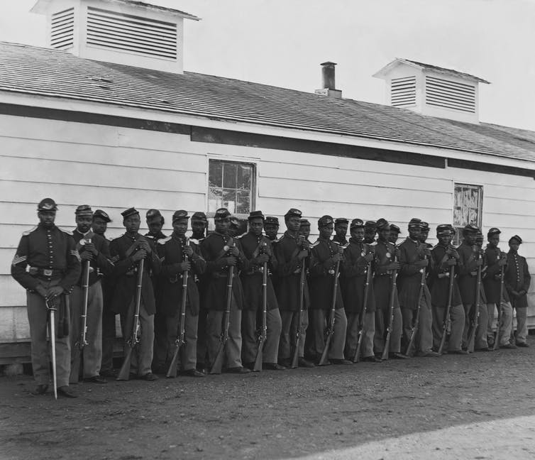
Company E was the fourth U.S. Colored Infantry during the Civil War. Everett Historical/Shutterstock.com

Why is this important?
Black names tell us something about the development of black culture, and the steps whites were taking to distance themselves from it.
Scholars of African American cultural history, such as Lawrence W. Levine, Herbert Gutman and Ralph Ellison, have long held that the development of African American culture involves both family and social ties among people from various ethnic groups in the African diaspora.
In other words, people from various parts of Africa came together to form black culture as we recognize it today. One way of passing that culture on is through given names, since surnames were stolen during enslavement.
How this culture developed and persisted in a chattel slavery system is a unique historical development. As enslavement continued through the 1800s, African American culture included naming practices that were national in scope by the time of emancipation, and intimately related to the slave trade.
Since none of these black names are of African origin, they are a distinct African American cultural practice which began during enslavement in the U.S.
As the country continues to grapple with the wide-ranging effects of enslavement in the nation’s history, we cannot – and should not – forget that enslavement played a critical role in the development of black culture as we understand it today.
-

Union gunboats didn’t just attack rebel military sites – they went after civilian property, too
30Jan, 2020
By Robert Gudmestad
Editor’s note: Robert Gudmestad, professor of history at Colorado State University, wrote this piece for The Conversation in January 2020. Colorado State is a contributing institution to The Conversation, an independent collaboration between editors and academics that provides informed news analysis and commentary to the general public. See the entire list of contributing faculty and their articles here.
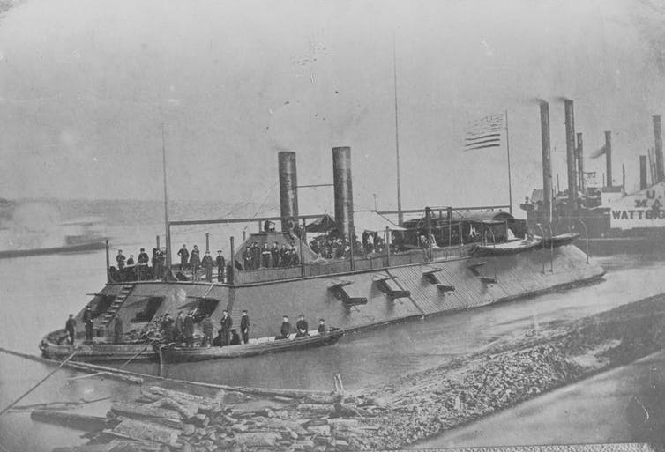The USS Cairo pulls up to the banks of the Mississippi River in 1862. U.S. Naval History and Heritage Command
During the American Civil War, huge metal monsters roamed the Mississippi River. Called ironclads, these boats were about 50 yards long, carried 75 tons of armor on their hulls and decks, sported up to 13 guns, and had crews numbering up to 250 men.
The seven city-class ironclads, sometimes called the turtles, were the most recognizable boats in the fleet, but northern laborers also converted a few existing steamboats into armored vessels.
The Union used this cutting-edge naval technology to attack Confederate forts at places like Tennessee’s Fort Henry and Island No. 10, and Vicksburg, Mississippi.
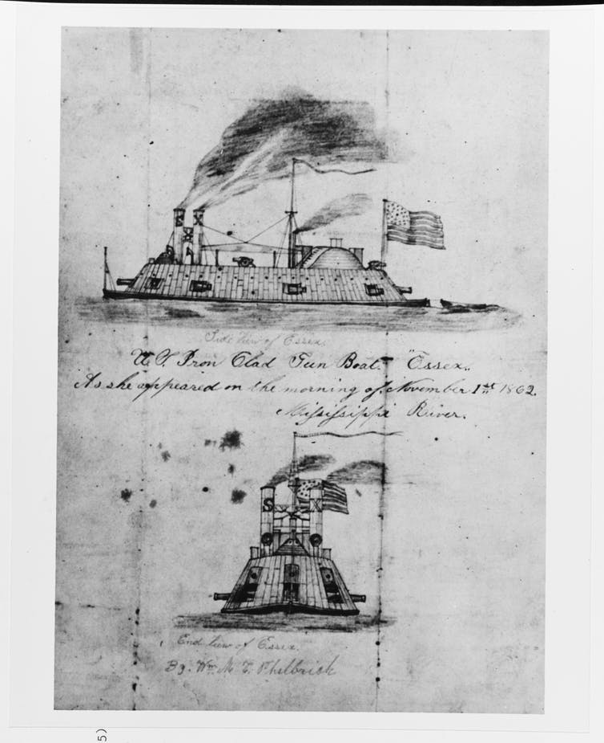The USS Essex operating on the Mississippi River on Nov. 1, 1862, as drawn by William M.C. Philbrick, a crew member of a nearby Navy ship. U.S. Naval History and Heritage Command
But these conventional battles are only one part of the larger story of the Union’s Mississippi River Squadron.

Piecing together fragments
As a Civil War historian who has been researching the Union’s river navy for seven years, I have learned that the fleet was important in ways beyond its attacks on southern forts. It protected Union transports and supply boats from Confederate ambushes. In the process, the Union navy waged a nasty war against southerners who supported the insurgents.
The evidence for this unconventional war is hidden in the shadows of the archives. Bits and pieces of information are littered throughout the Official Records of the Union and Confederate Navies, materials in the National Archives, collections of sailors’ letters and diaries, and post-war accounts.
Piecing together this fragmentary material, I created a database of 559 separate episodes where gunboats attacked a target, southerners shot at a federal boat, or there was a mutual fight. I then worked with my university’s mapping experts to analyze the data using computers.
As the resulting map makes clear, combat between Union gunboats and southerners occurred across the Civil War’s western theater but was also clustered in a few important areas. My research also reframes our understanding of the Civil War away from well-known battles to a constant, grinding war that sucked in thousands of civilians.

Confederates seek loot and supplies
This irregular guerrilla war was an improvisation that began in earnest in the summer of 1862. By that point, Union ironclads and speedy rams had squashed the measly Confederate River Defense Fleet at Memphis. As northern armies began to march overland toward Vicksburg and elsewhere, they depended on steamboats for supplies.
The Confederates created mobile ambush squads that were conglomerations of artillery and cavalry and sent them to the shores of the Mississippi River and its tributaries to attack Union supply boats and the ironclad gunboats that protected them.
One of these ambush groups was a mixture of about 250 men from the Third Maryland Artillery and a squadron of Texas cavalry. They had four cannons, including one christened “Black Bess.” On May 3, 1863, they captured the Minnesota, a steamer carrying US$40,000 worth of Union supplies.
Hungry Confederates swarmed aboard to find “flour, bacon, potatoes, pickles of all sorts, sugar, coffee, rice, ginger, syrup, cheese, butter, oranges, lemons, preserves, canned oysters, whiskey, wines, musquito [sic] nets, clothing, stationery, tobacco, etc. etc.” After wolfing down “a luxurious dinner,” a member of the artillery remembered how the rebels shared their extra food with sympathetic civilians in the area.
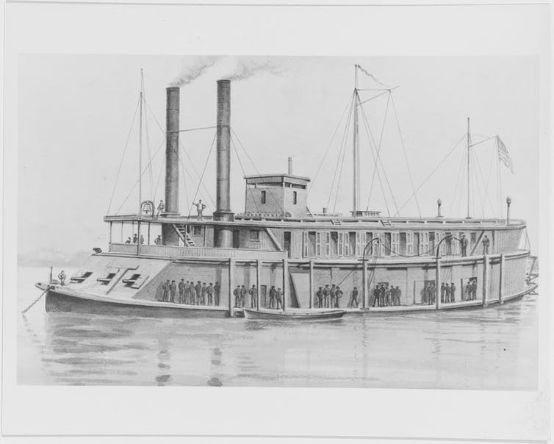The USS Rattler, a so-called ‘tinclad’ gunboat made by putting armor on a rivergoing steamboat. U.S. Naval
History and Heritage Command

Union fights back
Union commanders realized that their ironclads clustered their men into a few boats, so they improvised and created a fleet of tinclads, also known as “mosquitoes.” These boats were lightly armored, had a crew of about 70 men, carried six to eight light cannons and could go just about anywhere because they had a draft of 30 inches of water.
By the end of 1862, the Union put 17 tinclads into action and fitted out 74 by the time Robert E. Lee surrendered in 1865.
The crews of the tinclads and the other gunboats waged a deadly game of whack-a-mole along the western rivers. Whenever rebels popped up and attacked a boat, the fleet tried to smite it.
This reactive strategy failed because rebels could quickly retreat into the southern countryside, so Admiral David Dixon Porter devised a new strategy.
He gave Union commanders the authority to confiscate or destroy civilian property, including food, animals, cotton, buildings and personal property. Porter intended to starve rebels by depriving the men and their horses of food. He also hoped to inflict enough punishment on civilians that they would withdraw their support from the insurgents.

Punishment turns to plunder
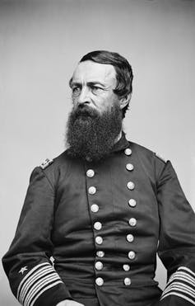U.S. Navy Admiral David Dixon Porter. Mathew Brady/Restored by Adam Cuerden/Library of Congress Prints and Photographs Division/Wikimedia Commons
Union sailors were quick to carry out Porter’s orders. For instance, when Confederate-aligned guerrillas near Helena, Arkansas, killed one sailor from the USS Cairo and nearly captured another, revenge was swift. Union sailor George Yost, who was a 14-year-old cabin boy, reported that 40 sailors from the boat landed at a nearby plantation and burned “up all the houses barns and everything combustible near the scene of the assassination.”
But such punitive attacks often became plundering sprees. When the USS Cincinnati stopped at a plantation on the Mississippi River in March 1863, sailors went ashore and, after chasing away the owner, took 150 chickens, 600 pounds of bacon, a bull, some geese and a couple of guinea hens.
According to a sailor whose letters are in the Buffalo History Museum, they also helped themselves to bed clothes, pictures, crockery, “&c. &c. &c. &c. &c. &c.” – a clear implication that they took all kinds of personal possessions.
This strategy of exhaustion produced indifferent results. The Mississippi River Squadron was not able to quash resistance. Many civilians stayed loyal to the Confederacy and supported guerrillas until the war ended.
And since the boats only patrolled the water, they could not occupy the land and drive out the rebels. But the river navy provided enough protection to Union supply lines to ensure victory over the Confederate army. The Union’s Mississippi River Squadron didn’t have to win its war; it merely had to prevent the rebels from winning theirs.
^^^^^^^^^^^^^^^^^^^^
I was reading some Civil War history the other day and came across a bit of history not many folks ever knew about or remembered. I know for a fact, I knew very little of this man, who by doing his job could have changed history.
In the early 1860’s, Washington, D.C., was the center-point of the Union Army’s war effort. The war had turned a small city into a major capitol.
Lincoln had been elected and became president on Mar. 4, 1861. His recent election served to be the driving force for the outbreak of the American Civil War. Although, Lincoln’s biggest political ambition was to preserve the Union at all cost.
In 1863, Lincoln was instrumental in passing the Emancipation Proclamation which freed 20,000 slaves. Then the Thirteenth Amendment made slavery unconstitutional in the U.S.
Then in 1864, Lincoln won re-election, mostly because of northern victories in the south.
On April 9, 1865, General Lee surrendered his Northern Virginia Army to General Grant at Appomattox. Before the month ended the Civil War was over, giving the north the victory.
All during the war, Lincoln had been a hands-on president. If one of his generals wasn’t doing enough, he was replaced by someone who possibly could.
During Lincoln’s presidency, he preferred not to have many bodyguards around. I wonder if that would be the case in today’s society. Why, in his last term, someone took a shot at him while he walked alone in the gardens of the White House. The bullet went through the top of Lincoln’s hat, but he wasn’t injured.
Then on April 14, 1865, Lincoln, his wife and another couple, decided to take in a play at Ford’s Theater in Washington. The play was called, “Our American Cousins.”
What Lincoln didn’t know was that a local actor by the name of John Wilkes Booth and his fellow conspirators had plans to assassinate the president, the vice president (Johnson) and Sec. of State (Seward) that very night.
As the president entered the president’s box, only one guard was posted at the door. The Metropolitan Police Department had detailed four officers to guard the president but only one was stationed at the door that fateful night. That man was John Frederick Parker.
Let me tell you a little about Parker. He was born in Winchester, Virginia, on May 19, 1830. His father was a butcher but later became a police officer.
As time went by, his son John moved to Washington, D.C., and became a carpenter. It wasn’t long before John got married and he and wife had three children.
When the Washington Metropolitan Police Force was organized in 1861, John left the carpentry business and became one of the 150 officers that were hired.
As a police officer, Parker’s record was spotted to say the least. He was brought up before the police board for several transgressions. These charges included conduct unbecoming to a police officer, visiting a house of prostitution, firing a pistol through a window, being drunk on duty, asleep on duty
and using foul language. At times, Parker was reprimanded; at other times, the charges were dismissed but at no time was he fired. Despite his record, Parker was assigned to be one of the four officers who became Mr. Lincoln’s presidential guards. This sounds a little fishy to me.
On the night of April 14, 1865, John Parker reported to the White House at 7 p.m. (three hours late). He was told to go to Ford’s Theater and wait for the president.
After Lincoln and his guest arrived and were seated, Parker took up his position in a small passageway just outside the closed state box door.
As the play went along, Parker got bored and could only hear the play. To better see the play and hear it better, Parker left his post and found a seat in another open box.
At the play’s intermission, Parker not only left the president unguarded but went with some of his friends to a saloon next to Ford’s Theater. Some say that Lincoln excused Parker but no record was found to that order. As John Wilkes Booth entered the state box to kill President Lincoln, Parker was nowhere to be seen.
Early the next morning after everyone learned of Lincoln’s death, Washington was in chaos. Vice President Johnson was spared but Secretary of State Seward had been badly injured. All of the Union Army and the local police departments were trying their best to track down John Wilkes Booth and anyone else in the conspiracy to kill Lincoln.
On May 3, 1865, John Parker was cleared of the neglect of duty charge. A transcript of the case was never kept and the complaint was dropped. Parker never got over that fateful night — he left his post but was still assigned to work security at the White House.
Mrs. Lincoln told Parker that she would always think that he was responsible for President Lincoln’s death.
Parker stayed on the police force until 1868 when he was fired for sleeping on the job. He died in Washington, D.C., of pneumonia on June 28, 1890, and was buried in an unmarked grave at Glenwood Cemetery. His widow and their three children are buried next to him. There are no images of John Parker and his grave was left unmarked to signify his contribution to the president’s death.
In closing this story, I wonder by leaving our post in life, how many people we affect and how it might change history as was the case of John Frederick Parker.
J.A. Bolton is author of “Just Passing Time,” co-author of “Just Passing Time Together,” member of Anson County Writer’s Club, Anson and Richmond County Historical Societies and Story Spinners in Laurinburg. Contact him at ja@jabolton.com
Books by Bill Teegarden
Kentucky by Heart
Frederick Douglass: Prophet of Freedom
God's Almost Chosen Peoples
Books To Read In Your Down Time
Civil War Game-Changers
The Civil War: Random Observations
Coffeeland
When It Was Grand: The Radical Republican History
Picolata Road - Historical Fiction
Horace Greeley: Print, Politics & Failure

