HARDSCRABBLE
Civil War Round Table of the Mid-Ohio Valley Newsletter
October 2020 – Vol 4

Story by Jerrie Berentz

A TRAGIC WEEK

Charles (Charley) Beman Gates and Ephraim Cutler Dawes were members of the same family, not by birth, but by marriage. Charley’s sister Mary Beman Gates was married to Ephraim’s brother, Rufus Dawes. Their lives were intertwined by family, community, church, the war, and tragically by the events of the week on May 23rd, 1864.

All photos from <juliacutlerjournal.blogspot.com>:

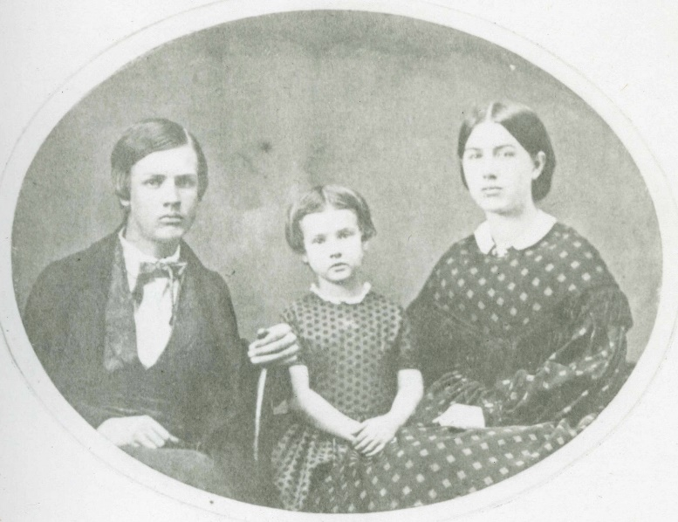
Charley, Betsey, and Mary Gates

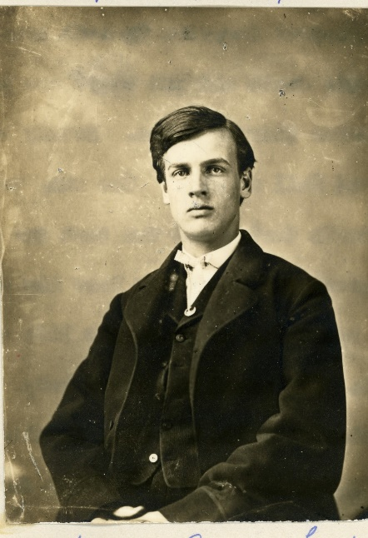
Charles Beman Gates

Charles B. Gates was the son of Beman and Betsey (Shipman) Gates, brother of Betsey (Gates) Mills, and Mary (Gates) Dawes. He was a student at Marietta College and was known as an amiable, affectionate young man. He was filled with an intense desire to enlist perhaps best described by his brother-in-law Lt. Colonel Rufus Dawes in a letter to his wife, Mary Gates Dawes.
“Gaines’ Farm, June 6th, 1864
He (Charley) was not prepared for the stern hardships of war, but when I was at Marietta, I saw that he was full of zealous ardor to act a part in the great historic drama. He said to me, ‘You belong to the ‘Iron Brigade’; how do you think I feel to take no part in the war, and be in the same family?”
He did however, eventually enlist in the 148th Ohio Infantry and tragically died as a result of injuries resulting from a train accident outside of Marietta as they were heading to the front lines in Virginia.
The following is a transcribed excerpt about his death from The Female Missionary Sewing Circle Journal 1858-1867 from the archives of the First Congregational Church, Marietta, Ohio.

”Charles B. Gates left Marietta as lieut in the hundred days service on the 23rd of May last. An accident occurred on the railroad, a short time after leaving Harmar, resulting in the sudden & terrible death of three young men. The bodies of two were sent back to Marietta & the company went on their way, silent and thoughtful, on reaching Harper’s Ferry. There was no provision made for them, & many were exposed, by lying in the ground, in the rain.
Charles was taken sick on Friday, with what the physicians supposed to be lung fever-but they were not alarmed about him, until about midnight on Monday when he became suddenly worse - symptoms of gangrene appeared, and then they first learned that he had been injured at the time of the accident at starting, but had concealed it, fearing they would not allow him to go on with the regiment.
His parents were notified by telegraph of the change for the worse, but were unable to reach Harper’s Ferry, until 19 hours after his death, when decomposition had progressed so far that they could not even look upon his face.
He was very anxious to see his parents, once more before he died, but when the cars came in at noon, & they were not on board, he gave up the expectation of seeing them again in the flesh, feeling assured that he could not live till their arrival.
When first made aware of his danger, he was not alarmed, but said at once,
“Tell them at home that I am ready to go-I am as happy as I can be.” A chaplain was sent for who prayed with him, and he responded at the close, “Amen, Amen.” He told the chaplain that he was not afraid to die and he believed that Christ would save him.
In January, he wrote to a friend, “I believe that I am a Christian and that God is my God. For some time I have been thinking of uniting with the church, I had made up my mind to do so at once, but I fear that I may bring disgrace rather than honor upon the name we wish to advance. I am willing to give up all & do the Christian work, whether I join the church or not.”
He was anxious to make a public profession of his faith, but his sister being abroad, that best he defer it, and then in May, he was prevented to do so. Death came to him, before his wish was gratified.
But he was ready for the messenger. We sh(oul)d naturally think he would have regretted leaving home, when he found that he must be in a strange place, with none of the kindred near him, but not a word of the kind escaped him. He said it was his duty to serve his country, & he was not sorry that he went with the regiment. His mind wandered a little at the last, & he was at home with his sisters, or at college with his companions, then all was right again, & with loving messages for the dear ones at home, and with unshaken faith in his Redeemer, he yielded up his precious life without a struggle, on the evening of the 31st of May, at the untimely age of 19 ½ years.”

Also dying as a result of the train crash were Pvt. Jeremiah Stuckley, and two civilians Alexander S. Nugent and John McKinney, both schoolmates who decided to accompany their friends in the 148th down to Belpre. Five others in the regiment were also injured besides Charley.
Rufus Dawes spoke of Charley’s death in his letter to his wife, Mary. “Of tall and manly figure, he (Charley) was a splendid youth, and he was of warm and noble impulse, and of pure and lofty character. As I lay in the works at Cold Harbor, I saw William Jackson come running toward us. He dodged from tree to tree, and crawled upon the ground to escape the fire of the rebel sharpshooters. A letter had come from Washington directed to be delivered “quickly.” It said: “Charley died at Harper’s Ferry on Tuesday.”
Charles Gates’ funeral was held at the First Congregational Church in Marietta on June 3, 1864. Rufus’ aunt, Julia Cutler, noted in her diary, “We went to the house and went with the family. (Marietta College) Pres. Andrews made a very good address & Mr. Wickes (First Congregational Church minister) prayed. The funeral was very numerously attended.”

That same week Ephraim Dawes was fighting in the Atlanta Campaign in an engagement known as the Battle of Dallas. On May 28, 1864 in the midst of battle he was struck by a minie ball on the lower side of his left jaw. He was horribly wounded as his lower lip and chin were torn away and he lost almost all his lower teeth and experienced a tongue injury as well. He endured an agonizing wagon train/railroad trip to a hospital in Nashville experiencing extreme pain and bleeding as well as great difficulty eating and sleeping. On June 6th he was given leave to travel back to Ohio. He suffered from his wounds for months but on September 24th, 1864, Dr. George Blackwell reconstructed his jaw in an hour and a half surgery that Ephraim endured awake as the chloroform was not effective. His brother Rufus, back home after his discharge from his service with the 6th Wisconsin Infantry, was there throughout during the surgery holding Ephraim’s hands. One of the physicians observing later told Rufus that “a man who could endure what Major Dawes had that day would bear burning at the stake.” A month later a more limited surgery completed the reconstruction and he finally was restored to health.

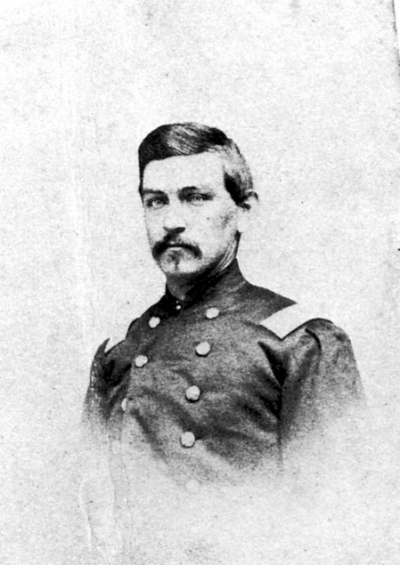
Ephraim Cutler Dawes before his wounding

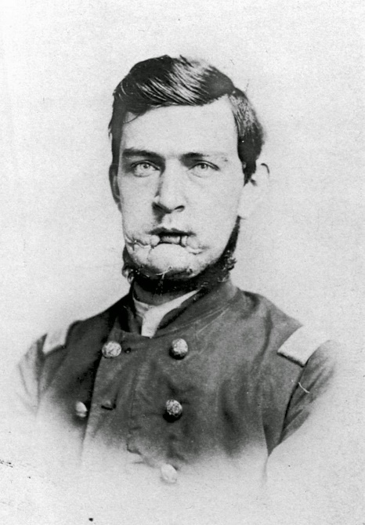
Ephraim Cutler Dawes after surgery

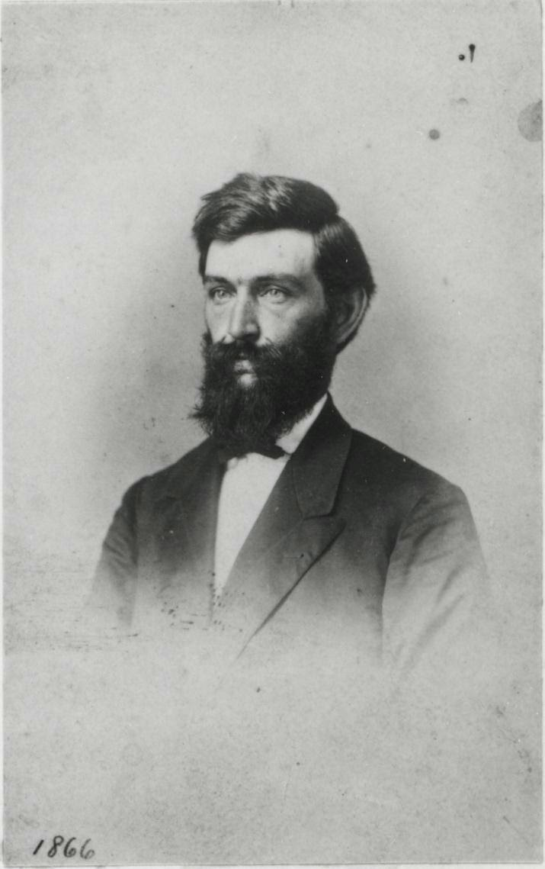
Ephraim Dawes in 1866

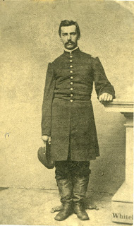
Rufus R. Dawes, brother of Ephraim & brother-in-law of Charley

This was a strong family. And in spite of experiencing these devastating tragedies in the same week, they endured. They continued their service to their country, community and to each other. Ephraim healed, became known as a gifted speaker and writer, and married, but had no children. Rufus and Mary named their first child after Charley—Charles Gates Dawes. He later became a General in World War I, Vice-President of the United States and a winner of a Nobel Peace Prize. Charley’s unbreakable spirit and drive to serve his country and Ephraim’s quiet endurance and commitment to overcome obstacles in his later life are examples that must not be forgotten!

*******************************

Books by Bill Teegarden

Bombshell: the Curious War of a Union Gunboat by Thomas McGraw

They Were Her Property by Stephanie Jones-Rogers

The Field of Blood: Violence in Congress by Joanne B. Freeman

Incitements in the Life of a Slave Girl by Harriett Jacobs

Little Women by Louisa May Alcott

Leaves of Grass by Walt Whitman

The Conjure Woman by Charles Chesnut

Benito Cereno by Herman Melville

The Three Corned War by Megan Kate

A Clearing in the Distance by Witold Rybezynski

Olmsted’s American by Lee Hall

Emotional Gettysburg by Bruce Mowday

Natures Civil War: Common Soldiers and the Environment in 1862 Virginia by Katy Shively

………………………………………………….

Review of The Twentieth Maine by Nancy Arthur

I'm reading The Twentieth Maine by John J. Pullen, a fascinating writing of their story from enlistment to end of the war. There is a couple of chapters about their time in Gettysburg, which is what is so famous, but the rest of their story is interesting, as well. Maybe not the fighting until Fredericksburg, because they were untrained, but the writer tells human interest stories of several of the members of the 20th.
For example, I found out recently that Joshua Chamberlain had 2 brothers with him; Tom (don't call me Lawrence) and John, who served as a chaplain and helped the medics. They were all 3 on LRT when Joshua uttered the line " It could be a hard day for Mother" and sent his brothers in different directions.

