HARDSCRABBLE
Civil War Round Table of the Mid-Ohio Valley Newsletter
January 2021 – Vol 6

Notes from Nancy Arthur
An article in The Civil War Monitor lists the best Civil War books of all time. Personally, I haven’t read many that are bad, as long as I’m learning. The list was written by Civil War historians, getting their opinions on a number of topics, such as best and worst commanders, best films, most influential women, turning points of battles, etc.

The #1 book listed was Battle Cry of Freedom by James McPherson, which is currently sitting on a table in my living room, to be read when the Christmas details are completed!

Some others on the list are The Life of Johnny Reb and The Life of Billy Yank by Bell I. Wiley, Personal Memoirs of U.S. Grant (very good), by Grant himself, The Lost Cause by Edward Pollard, A stillness at Appomattox by Bruce Catton. And of course, The Killer Angels.

The list goes on; we all have our favorites and are always looking for more. When we can meet again, we hope to have a library put together. Something Bill has been looking for is a rolling book cart or perhaps a bookcase that we could use after installing casters. Let us know if any of you could help with this donation.

With long winter evenings ahead, give some time to exploring some of these:
American Battlefield Trust – find a wealth of information on The Revolutionary War, The War of 1812 and The Civil War. You will find an overview of each, a list of specific battles to read about, explore by topic, view maps, and so much more.

And as mentioned last month, YouTube has so many videos to watch; Garry Adelman never fails to entertain.

Or go local to The Castle’s website: The Castle Historic House Museum to view educational talks on a variety of subjects.

And, then share with us what you are reading and watching!

Merry Christmas to all of you reading this and wishing us all a BETTER New Year!

Keeping local…. this from Leight Murray
Providing fresh perspectives on America's defining event
Skip to content
- Home
- About Us
- Contributors
- 2021 Symposium
- Publications
- Podcast
- Speakers
- Battlefield Tours
- Contact Us
← When a Monument Cherrypicks Its History
Incendiaries on the B&O: The Burning of the Fish Creek Spans During the Jones-Imboden Raid (Part II) →

Incendiaries on the B&O: The Burning of the Fish Creek Spans During the Jones-Imboden Raid (Part I)
Posted on December 15, 2020 by Jon-Erik Gilot
Civil War cavalry raids often rank among the most romantic of Civil War tales. This often has to do with the characters most often associated, with names like Stuart, Morgan, Mosby, Rosser, Gilmor and others. These raids would be recalled in song and verse and were often recorded by civilians in places like Missouri, Ohio, West Virginia, and Indiana as the time when the war literally came to their doorstep.
Another hallmark of cavalry raids were local civilians and home guard troops working either in concert with or to impede the progress of the raiding party. Raids were by their nature quick-moving operations, with the pursuers often running to either catch up or close off an avenue of escape. Civilians and home guard troops would sometimes find themselves as the only or the last line of defense to protect a city, railroad, or river crossing, or conversely, as party to the destruction of bridges, railroads, or materials of war. These actions could have reverberations beyond their immediate neighborhood. Having grown up along the path of Morgan’s Raid in eastern Ohio, where home guard units successfully hemmed in Morgan’s command from several Ohio River crossings, these types of stories have always captured my attention. We’ll look at one such story today.
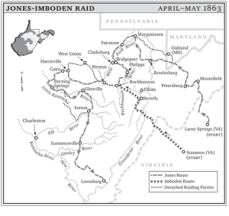
Map showing routes of Jones-Imboden Raid (WV Encyclopedia)
The Jones-Imboden Raid ranks among my favorites in Civil War historiography. Lasting from April 20 – May 25, 1863 and covering some 1,100 miles between the two columns, the raid has not received the attention or notoriety of its peers. Its commanders, William E. “Grumble” Jones and John D. Imboden, don’t exude the romantic notions of the likes of Stuart, Mosby, or Morgan. And to be sure, the raid occurred at a time when there was a lot going on, including the battles of Chancellorsville, VA, and Jackson, MS; the Vicksburg Campaign; the sacking of Lawrence, KS; and more.
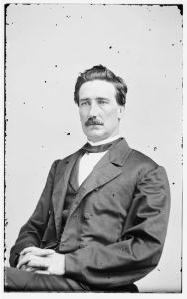
Brigadier General John D. Imboden (LC)
The brainchild of Imboden and Captain John Hanson McNeill, the raid was envisioned as a means of crippling the Baltimore & Ohio Railroad in Maryland and western (soon to be West) Virginia by destroying bridges, viaducts, and tunnels along Abraham Lincoln’s vital lifeline to the west. Imboden and Jones would also plan to scatter several small Federal garrisons, gather needed horses and cattle, enlist new recruits that were disaffected with the West Virginia statehood movement, and threaten the burgeoning government forming at Wheeling and its coming elections. The raid would combine efforts from multiple Confederate departments and nearly 5,000 troops of several commands.
The reach of the Jones-Imboden Raid was just incredible, with Jones taking a northerly route and Imboden southerly. Jones would reach as far northwest as Morgantown, (West) Virginia – even sending riders into the southwestern corner of Pennsylvania to gather horses – before turning south to Fairmont. After a brisk fight at Fairmont the raid achieved one of its most significant feats in the destruction of the B&O bridge across the Monongahela River on April 29, 1863, the longest and most expensive iron span on the B&O main line. The raid would continue for another three weeks and reach even farther southwest to Burning Springs, near Parkersburg on the Ohio River, where Jones destroyed an oil works and some 12 – 15,000 barrels of oil.
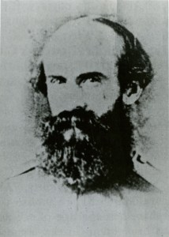
Brigadier General William E. “Grumble” Jones (WVRHC)
All told the raid resulted in the damage or destruction of an astounding 26 B&O bridges, dozens of miles of track damaged, two engines and at least twenty cars destroyed, company buildings and water stations ransacked, and many miles of compromised telegraph lines. According to the B&O’s annual report for 1863, expenses for the year ballooned more than $500,000 from 1862 and nearly $700,000 from 1861, due in large part to the damage inflicted from the raid.[1]
While reviewing the B&O annual reports – which are wonderful reading, by the way – I was surprised to find noted that three bridges had been burned on the main line at Church’s Fork and Cappo Fork, a full 30 miles west of Fairmont, where Jones defeated some 500 Federal troops and home guards before continuing south. Perhaps riders moving west on the B&O in search of horses had burned the bridges behind them, I thought. However, if that were the case, they would surely have passed several far more important bridges at Mannington and Farmington. Why spare those in favor of these smaller, seemingly out-of-the-way spans farther out the line?
While neglected in favor of the more contested stretches of the Baltimore & Ohio, the main line past Fairmont was actually a critical stretch of the line between the Monongahela and Ohio rivers. Confederate troops understood this earlier in the war when they burned two B&O bridges over Buffalo Creek at Mannington in May 1861, precipitating George B. McClellan’s invasion of western Virginia. The landmark study The New World in 1859 notes that after passing Glover’s Gap and its 350 foot long tunnel, “the line descends by Church’s Fork of Fish Creek…passing the ‘Burton’ station, the route continues down a stream to the crossing of a tributary called “Cappo Fork,” 4 miles from Glovers Gap. The road now becomes winding, and in the next 4 miles you cross the creek 8 times.”[2] One Federal soldier traveling through this stretch of the B&O just a few months after the raid termed it “the worst, crooked railroad and roughest country that you can imagine. In fact, it is nothing but one continuous hollow…”[3]
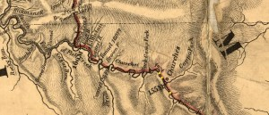
Section of 1850 B&O map showing the Fish Creek district, west of Fairmont. The burned bridges at Church’s and Cappo forks have been highlighted (LC)
With so many water crossings and tunnels in so short a distance, this stretch of the line served as a bottleneck for moving troops and material. As a result of the raid’s apparent reach to this section of the B&O, two Federal commanders more accustomed to commanding armies in the field would instead be called on to secure these critical spans in a backwaters area of the war. The effects of their burning would continue to smolder after their repair…
To Be Continued…

If the above excerpt piqued your interest try the library for a book: "Where It All Began" by Allen McKain the story of the people and the places where the oil and gas industry began here in Parkersburg/Marietta.

This from Bill Teegarden

The American Scion Who Secured British Neutrality in the U.S. Civil War

The journal pages of Charles Francis Adams, the son of one president and the grandson of another, illuminate the life and politics of Victorian England
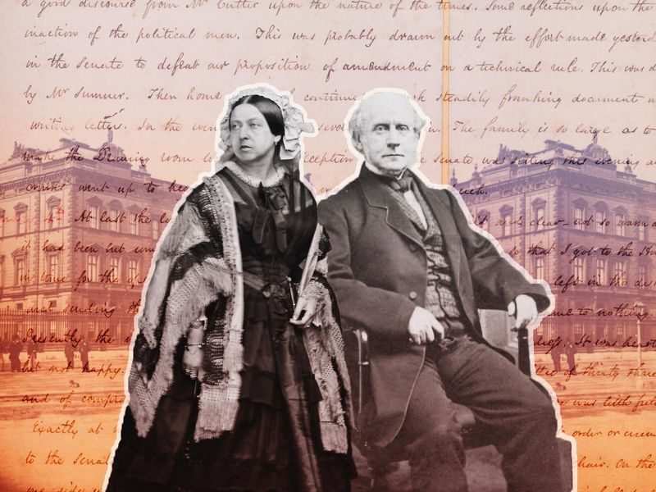Charles, the son and grandson of American presidents, carved out a second home in England, succeeding in his main diplomatic mission: securing British neutrality in the Civil War. (Photos via Getty Center, Massachusetts Historical Society and public domain / Photo illustration by Meilan Solly)
Charles, the son and grandson of American presidents, carved out a second home in England, succeeding in his main diplomatic mission: securing British neutrality in the Civil War. (Photos via Getty Center, Massachusetts Historical Society and public domain / Photo illustration by Meilan Solly)
By Sara Georgini
SMITHSONIANMAG.COM
JANUARY 16, 2020
What do you wear to meet the queen of England? Torn between a crisp navy-and-gold lace suit or a severe black morning coat, Charles Francis Adams fretted over his first day of work. He was more comfortable in plain clothes, but worried that he would look like a proper English butler in all black.
So the 55-year-old American statesman erred on the side of history in the spring of 1861, dressing for his new London audience in full color. It was starchy and hot, but Adams had to make a good first impression. To a degree, the fate of his nation’s Civil War hinged on his royal interview. Which way would the world turn: North or South?
Leafing through Adams’ recently digitized diaries, spanning the period from 1861 to 1865, we can watch how Charles, the son and grandson of American presidents, carved out a second home in England, negotiating his place in Victorian London, and succeeding in his main diplomatic mission: securing British neutrality in the war.
His diary “remains unique because his view of the war operates on two levels,” says Sara Martin, editor in chief of The Adams Papers editorial project, based at the Massachusetts Historical Society. “First, he was a father whose son was a soldier, so he experienced the war as a parent. Second, as the U.S. minister to the Court of St. James, Adams was tasked with mitigating foreign engagement in the domestic conflict. Thus, his diary places the war in a global context.”
Beyond that, a curious and cosmopolitan Charles comes through in the diaries as he soaks up English culture and befriends foreign peers. His wife, Abigail Brown Brooks Adams, emerges as a highly regarded hostess. His growing children dabble in journalism and sample European culture. From tempestuous politics to glamorous parties, Charles and his family tasted the best and worst of the capital city.
While previous foreign ministers had met with the British monarch to present their formal diplomatic credentials at St. James’ Palace, the protocols had changed by Charles’ day. His first audience with Queen Victoria took place in Buckingham Palace, which she established as her home base in the city and carefully renovated to project her trademark vision of domestic serenity.
As he wrote in his journal on May 16, 1861, Charles found Victoria “dignified and yet gracious.” In other pages, he writes about forming an influential friendship with her husband, Prince Albert. Meanwhile, the livelihood of both Charles’ nation and his soldier son were in constant, grinding doubt.
Charles, Jr., a Massachusetts cavalryman, reported frequently to his father on the war’s bloody consequences. His detailed letters, often written on picket in the Carolinas, were passed around the legation and parsed for clues. Diplomatic duty and paternal heartache blended together in the pages of his father’s diary. The severity of his wartime mission was never far from the senior Charles’ mind.
Charles’ interleaved his diary with newspaper articles, photographs and political pamphlets he collected to build his case. He kept up a “cordial relationship with Lord [John] Russell, the foreign secretary, and other conservative elites who were ready to recognize the Confederacy. He helped the Lincoln administration to allay crises like the Trent Affair,” says historian Manisha Sinha.
A political insider at home, Adams had to work hard to convince British peers that the American Civil War had global implications. He opposed slavery on moral grounds, watching as “secession fever” grew throughout the 1850s, and lamenting the nation’s disunion. The Confederate bombardment of Fort Sumter in Charleston, South Carolina, on April 12, 1861, marked a clear turning point. Adams turned to his journal for solace, writing:
“My fear now is that the breach is complete. Perhaps this is not in the end to be regretted so much, as the Slave States always have been troublesome and dictatorial partners. But I had always hoped that slavery might be driven back to the cotton region, and there left to work out its mission. We must now rely upon a consolidated action among ourselves. The peaceful solution of the problem has failed. Mr Lincoln has plunged us into a war.”
A student of diplomatic history, Adams perceived that the unfolding conflict would riple through the globe. Any intervention from the powerful British Navy would radically alter the outcome, so he pursued neutrality once at his post in London.
“The rest of the world, mainly Europe, seemed to have accepted the ‘fact’ of Confederate independence and it would take Union victories, the emancipation policy of the Lincoln administration, and all the expertise of American diplomats to avert diplomatic recognition of the Confederacy,” adds Sinha. “In Britain, Adams noted that the sympathy of the working classes was with the Union but that of the upper classes with the Confederacy. He astutely notes that the bonds of cotton tied Britain to the slave states as ‘consumers’ and ‘producers.’”
Within two years, Charles scored a major diplomatic victory, persuading the ministry to halt the progress of Confederate ironclad ships built in Liverpool. His act stemmed a tide of British support for the South, just as a ring of Confederate agents pressured them for aid.
Apart from his diplomatic success, Charles’ neat, daily entries offer a unique tour of Victorian London, taking readers from palaces to slums at a stately clip. He made pilgrimages big and small, revisiting family haunts and documenting new architecture.
One of Charles’ first stops upon arriving in London was at No. 8 (now No. 9) Grosvenor Square, which served as the first American legation in Great Britain. His grandfather John Adams leased it shortly after his arrival in the summer of 1785. Shortly after he reached London in 1861, Charles inspected a number of possible homes in Bloomsbury’s posh Russell Square, as well as in Grosvenor Square. “The prices are enormous too,” Charles wrote of his ventures in London real estate. For 700 guineas, he settled on a house at 21 Grafton Street in the Mayfair district, an area that became known as a diplomatic enclave.
Although Charles thought he was a “pretty monotonous” writer, he liked the sound of his diary ticking along like “a second Conscience.” He used it to jot down weather statistics, political events, family news, social outings, and personal observations. On and off, when his diplomatic duties felt fairly calm, Adams made what he called a set of “journeyings” through English culture. He hunted and catalogued the work of architect Christopher Wren (1632-1723), who rebuilt London’s religious landscape after the Great Fire of 1666. Charles never aimed to become a professional architect, but during his time in London he realized that beauty was holy to him.
With sons Henry and Brooks in tow, Charles worked his way through most of Wren’s 52 churches. He was less fond of the crowds crawling through the parks. Italian opera blared by his office, interrupting his long dispatches to Lincoln. One thing he noticed right away was that gin shops threw open their doors early on the Sabbath. “Think of this on a Sunday in New England,” Adams wrote incredulously. Eager to experience the full range of London, he took to the streets.
Charles was intrigued by the colorful slew of cultural offerings—museums, zoos, libraries, learned societies, department stores, theatre—that he passed on his way to and from work. And he possessed a third-generation diplomat’s knack for using religion to read foreign culture. Adams reveled in his first trip to attend services at Westminster Abbey. In a rare burst of praise, he called it “the quietest and pleasantest day I have passed in London,” taking special note of the Poets’ Corner.
He strolled over to the House of Commons—he had visited Parliament once or twice as a young boy—and returned with plenty to say. “The hall contrasts singularly with that of the House at Washington,” Adams wrote. “It is much more plain and so small in size as not to accommodate the members when the attendance is very full. They sat tonight packed in the seats as people do in a popular meeting, though not by any means all were there.”
Three days after Christmas 1862, he made an emotional trip to the Church of All Hallows Barking, located in the shadow of the Tower. He knelt, weeping, at the altar where his parents John Quincy and Louisa Catherine Adams wed in 1797. “Here am I, their only surviving son plodding my weary way through days of natural tribulation, in the performance of an arduous trust, in the land which witnessed the outset of their career,” he observed.
In lighter moments, Charles joined the visitors mobbing the world’s oldest zoo, opened in 1828 and then known as “the zoological gardens in Regent’s Park.” The whole Adams family enjoyed a few professional perks, too. Charles and son Henry toured through the fossils and natural history treasures at the British Museum. “The collection is enormous, and it grows at a rate to make it difficult to keep up with it in space. Indeed it threatens to be too large for utility,” Adams wrote. Charles’ diary is filled with repeat visits to “the South Kensington museum” (founded in 1852, later the Victoria & Albert Museum). He singled out as his favorites the art of John Singleton Copley, William Hogarth, and J. M. W. Turner. “On the whole the collection is valuable and suggestive,” Adams wrote. “Three hours fatigued me and I went home to find my weekly despatches had arrived, and letters from my sons which absorbed me completely.”
Like any newcomer, Adams scored some of his best London “finds” when he got lost. His accidental ramble into the Seven Dials neighborhood—then poor and troubled, now a dynamic and artsy neighborhood—was especially illuminating. Any reader of Charles Dickens will recognize the scenes that Adams painted, connecting England’s prospects to the future of its poorest inhabitants. “All the best that these young people can hope to arrive at in England is perhaps domestic service, and hard labour, whilst the worst is only to be learned in the history of the region of th[e] Seven Dials, the work houses and the prisons,” Adams wrote. “Here is the painful idea of a city of three millions of people.”
On an April morning in London, 1865, as the end of the Civil War neared, news of Richmond’s fall set the American minister aglow, imagining how this story might appear in the books he loved to read. “Marvellous indeed is the history,” he wrote. “Nothing in the records of the past exceeds it for the magnitude of the interests at Stake, and the heroism that has been developed.”
Charles, who loathed the pomp and “geegaws” of diplomatic ceremony, resigned his post in 1868 and returned home. His mission was complete. Charles, who published editions of the writings of Abigail, John, and John Quincy Adams, turned next to building the Stone Library in Quincy, Massachusetts.
“He took to diary writing early,” the younger Adams noted with an historian’s appreciative gleam, “and he took to it bad.”
Sara Georgini is series editor for The Papers of John Adams, part of The Adams Papers editorial project at the Massachusetts Historical Society. She is the author of Household Gods: The Religious Lives of the Adams Family.
Read more from this author | Follow @sarageorgini

Books by Bill Teegarden
Interpreting The Civil War
Who Was Varina Howell Davis
Woodrow Wilson Tries to Cancel Back Progress
Photographic Atlas of Civil War Injuries
The Statute Silence in Savannah
Historian Disputes Claim of Fake History During Reconstruction
The War For Missouri
Daughters of Union Veterans of the Civil War
Home and Away: Transfixed by the War
Carrying The Colors

