HARDSCRABBLE
Civil War Round Table of the Mid-Ohio Valley Newsletter
July 2023 – Vol 24

Notes from Nancy Arthur

In the upcoming months, you will be hearing more and more about the fall trip to South Carolina. In respects to that trip, I'm finding all kinds of information on sites to see while there.

From an article in the latest Hallowed Ground magazine titled Lost and Found, written by Jennifer Howard and Sarah Nell Blackwell, the writers describe the battle of Camden, South Carolina. On August 16, 1780, Lord Cornwallis had over 2,000 troops and the Colonials, under Major General Horatio Gates, with 3,500 Patriots, collided about 8 miles outside of Camden. Early morning, they regrouped across a space of about 200 yards in a pine forest. Even though Gates had more men, a large majority of them were untested in battle.

James Legg, public archeologist for the S.C. Institute of Archeology and Anthropology, says "The American Army was destroyed for the second time in four years". He has spent years on the battlefield and doing research.

Many died but we don't have numbers for a total. It is estimated that about 900 died and another 1,000 were captured and sent to prison ships. Burials were crude, if at all; many were left on the ground, while some buried were in group graves, a mere inches of dirt on top. The British lost 68 to death and 245 wounded, with 11 missing.

Fortunately, the landscape is much the same, with little paving or building.
Several organizations have worked over the years on preservation, with the results of all 770 acres are now protected.

Legg paints a picture of a "featureless" battlefield. Research in the early 2,000's produced musket balls, lead shot, articles of clothing, such as buttons, all within 6 to 18 inches of the topsoil. All artifacts were mapped and catalogued.

Page 1 of 10

The SCIAA and the S. C. Dept. of Natural Resources worked with the Richland County Coroner's Office to exhume the bodies. Rare it is to find bodies from the Revolutionary War. The remains of twelve Continentals, one Loyalist Militiaman, and one British soldier were removed from the site with tender care, then after careful study, granted a brief informal ceremony. The coffins were handcrafted by local theologian and minister Phillip Hultgren, who learned woodworking from his Swedish-born grandfather. The nails were forged by Jack Hurley, a retired professor from the University of Memphis and a self- taught blacksmith.
May they finally rest in peace.

Next time, I'll tell you about the creation of national cemeteries after the battle is over. Stay tuned!

Stories by Bill Teegarden

Singular vs. Plural: How Wars Shape Imagined Sovereignty
June 5, 2023 APSR, Journals, Public Scholarship Program 0
In the APSA Public Scholarship Program, graduate students in political science produce summaries of new research in the American Political Science Review. This piece, written by Karra McCray, covers the new article by Melissa Lee, Nan Zhang, and Tilmann Herchenröder, “From Pluribus to Unum? The Civil War and Imagined Sovereignty in Nineteenth-Century America”.
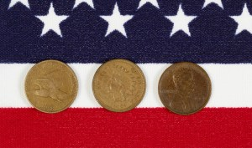Generally, when people think of sovereignty, supreme authority, or power, they think about kings, queens, or a formal institution that makes and enforces laws. Wars typically serve as critical events to enforce such sovereignty, but how?
In their newly published APSR article, Melissa Lee, Nan Zhang, and Tilmann Herchenröder investigate how war shapes the popular imagination of sovereignty. To this end, this paper argues that institutions alone do not make the state. Instead, the authors contend that for sovereign authority to be effective, it must be recognized and accepted by those they govern.
The authors propose two potential ways wars could influence the public perception of sovereignty – valence and reversal. The valence perspective centers on entrepreneurs and leaders who promote ideas that give meaning to war and help the public understand the sacrifices the conflict demands. In the aftermath of loss, the reversal perspective predicts that dissatisfaction and the humiliation of defeat will inspire a new search for meaning that embraces the victor’s ideals and allows new principles to emerge.
Applying these mechanisms to the case of the American civil war and the competing visions about sovereign authority between the North and the South, the authors hypothesize that, in a valence pathway, the Civil War should strengthen popular attachments to a national concept of sovereignty in the North, especially among Republican supporters. After a defeat, a reversal pathway should increase attachments to a national idea of sovereignty in the South.
To test the hypotheses, the authors utilize a strategy that calculates the shift of the term “United States” from a plural to a singular noun as a proxy for the popular imagination of sovereignty. The plural usage of the word infers that Americans view the US as having multiple sovereignties embedded within the several states, and a singular use indicates that Americans view the US as a single national sovereignty.
“This article is important because it shows that the violence of war and the institutional change that occurs as a result do not imply that ideational change will follow.”The authors analyzed local newspapers from 1800-99 in states that participated in the war. The authors found no significant difference between Northern and Southern newspapers in singular and plural language patterns before the war. After the war began, the transition from plural to singular occurred faster in the North, suggesting that the war promoted a greater adoption of national sovereignty in the North in the popular imagination.
Beyond local newspapers, the authors also examined the partisan identification and language patterns of individual US congressional members’ speeches from 1851-99. They found a consistent partisan gap in adopting singular usage following the war. Supporting the valence hypothesis, imagined sovereignty was heavily concentrated among Northern Republicans who used the civil war to advance their ideals about a singular national sovereignty. No evidence of the reversal hypothesis was found.
This article is important because it shows that the violence of war and the institutional change that occurs as a result do not imply that ideational change will follow. Political leaders and ideological entrepreneurs play a significant role in mediating the impact of war on sovereignty and social and political change more broadly.

War of Words – revolver with Marc DeSantis
A ‘revolver’ is a pistol in which individual bullets are contained inside separate chambers within a rotating cylinder. As the cylinder revolves, a new bullet is placed before the hammer for firing.
The origin of this meaning – a revolving pistol firearm – isn’t clear. It may have come from none other than the weapon’s American inventor: Samuel Colt. Whatever its derivation, its enhanced firepower made it a success. ‘Revolver’ entered the American lexicon.
‘There are probably in Texas about as many revolvers as male adults,’ wrote one correspondent for The New York Times in 1854.
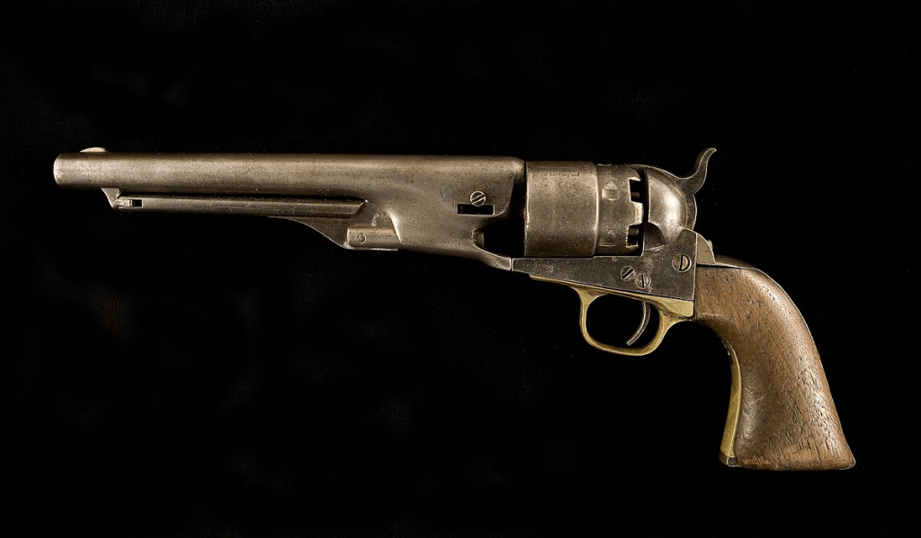Model 1860 Colt army revolver of Col. Charles G. Stifel of the 5th Regiment, United States Reserve Corps and the 5th Missouri Infantry Volunteers during the Civil War. IMAGE: Wikimedia Commons
During the American Civil War (1861-1865), the revolver eclipsed the traditional sabre among cavalry. The firepower advantage of revolvers was undeniable. ‘Not a damned revolver in the crowd!’, laughed doomed Union officer Major Andrew Vern Emen Johnston on 27 September 1864, near Centralia, Missouri, just before his unit of 115 infantrymen, armed with single-shot muskets, was annihilated by just 80 Confederate irregular cavalry.
The weapon’s invention story holds that the idea for the revolver had come in 1830 when Colt, then aged 16, voyaged aboard the sailing ship Corvo to India, where he remained for several weeks. Colt then headed home to America the following year, and started whittling a revolving pistol, the idea coming from either the Corvo’s wheel, or perhaps its windlass.
Many models of revolver were used by both sides during the American Civil War. Representative was the ubiquitous Colt Model 1860 Army, of which the Union (US) Army bought almost 130,000 units. Weighing more than two and a half pounds, and chambered in .44 calibre, it carried six rounds. A weapon containing six chambers was also known as a ‘six-shooter’.
^^^^^^^^^^^^^^^^^^^^^^^^^^^^^^^^^^^^^^^^^^^^^^

Granville P. Moody, a Methodist minister in Columbus, became a Union colonel in Civil War
Ed Lentz
Special to The Columbus Dispatch
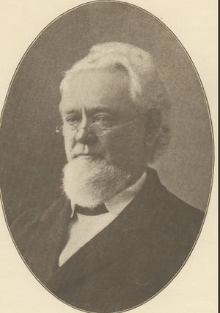
Religion came early into central Ohio in the years after the American Revolution. Frontier Franklinton was founded in 1797. By 1806, a Presbyterian minister named James Hoge received the call and established a church in central Ohio.
The Methodists were not far behind.
The more newly formed evangelical churches of the Methodists and Baptists saw a chance to grow in the “West.”
The Methodist church was established in central Ohio with the gathering of four people in a cabin in the state's new capital of Columbus, which was founded in 1812. Methodist ministers had been invited to the town since its founding, and by 1813, the first congregation of four members met. They included George McCormick and his wife, George B. Harvey and Jane Armstrong, who was soon to be George's wife. It was later said to be the first marriage solemnized in Columbus. In short order they were soon joined by a free African American named Moses Freeman.

A later history said of the Methodist Church in Columbus: “At first its growth was slow and feeble. The early Methodists were a humble folk. They were very poor, were burdened with debt, and did not hold social rank…”
But in time, due to the evangelical outreach of its circuit-riding ministers, the church in Columbus, and across Ohio, grew in influence. It was to this established town of Columbus that a new pastor came in 1845. His name was Granville P. Moody and it was a name to be remembered.
A later history described him in some detail. “He was of Puritan stock, born in Portland, Maine, January 2, 1812…He settled in Muskingum County, Ohio, when eighteen years old, and engaged in mercantile pursuits. While teaching in a Methodist Sabbath school, he was converted…He joined the Ohio Methodist Conference in 1833.”
The Methodists had been given a lot for a church on the north side of Town Street between High and 3rd Streets (now a part of the site of John F. Wolfe Columbus Commons) by the Proprietors of Columbus. Other denominations had been given other lots. The Methodists began with a small, one-room church, and built, built and rebuilt as the congregation grew larger. By 1845, there was a brick church of some size on the lot. It was to this church that Granville Moody came as pastor.
“He served it two years, from the fall of 1845 to that of 1847. He had great success and reported a membership of 644 the first year and 600 the second year. Encouraged by this growth, the society felt strong enough to divide. William Neil gave them a lot on the west side of High Street between Gay and Long Streets … on which Wesley Chapel was built. The location was then considered the northern part of the city. A colony of 190 members went out of Town Street” to this new site.
After leaving Columbus in 1847, Granville Moody continued to grow in influence and position in the Methodist Church in Ohio and the Midwest. And then came the Civil War.
At the outbreak of the war, Gov. William Dennison offered Moody command of the 74th Ohio Volunteer Infantry, whose duty soon became guarding several thousand Confederate prisoners at the Camp Chase Confederate Prison Camp five miles west of Columbus. Moody was considered to be a firm, but fair, administrator.
When the rebels later learned that he was leaving, they promised him the same treatment if he were to become a prisoner of the Confederacy. “Should Colonel Moody, at any time become a prisoner of our [Confederate] government, we hereby earnestly request for him the highest consideration and treatment, as a proper acknowledgment of his kindness and care for us.” But some wondered how well he might fight.
The doubters soon found out.
Col. Mooody led the 74th Ohio into the Battle at Stones River (Dec. 31, 1862- Jan. 2, 1863) near Murfreesboro, Tennessee. A later account noted that “his horse was shot from under him, he took a bullet in his right calf and he narrowly escaped a fatal wound when one or more bullets shattered a revolver he carried in his right breast pocket, more bullets shredded his uniform so much that one man called him the 'ragged colonel.'"
As a practicing Methodist minister, Moody continued to preach to his men and others while in uniform in the Union Army. But as one account put it, “the rigors of campaign and camp took a toll on the 50-year-old Moody and prompted his resignation in May, 1863. It was accepted with regret.”
Moody continued to preach and serve as a Methodist minister through the rest of the Civil War and after. The “Fighting Parson” closed a long career of service to church and society with his death in 1887 in Mt. Pleasant, Iowa. He was buried nearby. His autobiography, "A Life’s Retrospect," was published posthumously in 1890.

Antiques: The story of Waltham, the great American watch company
Mike Rivkin
Special to The Desert Sun
0:29
0:54
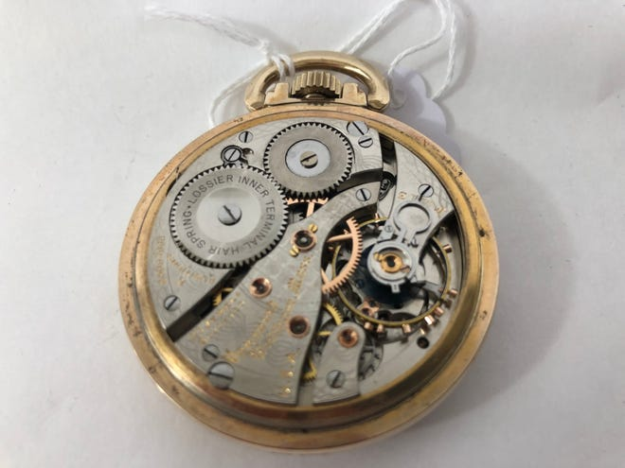
If there's a Big 3 in high-end watches these days — i.e., names that most people would recognize — it would most likely include Rolex, Omega and Longines. At least in our gallery, those are the brands people ask for the most. And if I had to assemble a similar list of American makers, it would feature Bulova, Elgin, Hamilton and Waltham. Among these latter firms, we've already reviewed the first three in previous columns, but Waltham remains unexplored.
Founded in 1850, the Waltham Watch Company was a giant of American timekeeping for more than 100 years. A review of its history is overdue.
If a time machine could take you back to the mid-19th century, you would quickly see that the Industrial Revolution was well advanced. Smoke-belching factories were nearly everywhere, spitting out products made by machine that heretofore had been crafted entirely by hand. Clocks were among those products now being mass-produced, and it wasn't long before watchmaker Aaron Dennison figured that he could do the same with pocket watches. He, along with several partners, raised $20,000, and in 1849, the American Horological Company was formed. The Waltham name soon followed.
The company's first decade was a rocky one. Despite some significant innovations, its inaugural model was slow to sell, and the firm steadily lost money. An economic slowdown in 1856 didn't help, and a year later, it was bankrupt. Nonetheless, new owners with more experience emerged, and the Civil War proved to be an unexpected boon. Synchronized timekeeping of military maneuvers in the field was now possible, prompting many soldiers to seek out suitable watches. By war's end, Waltham's inexpensive "William Ellery" model had become nearly ubiquitous among Union troops.
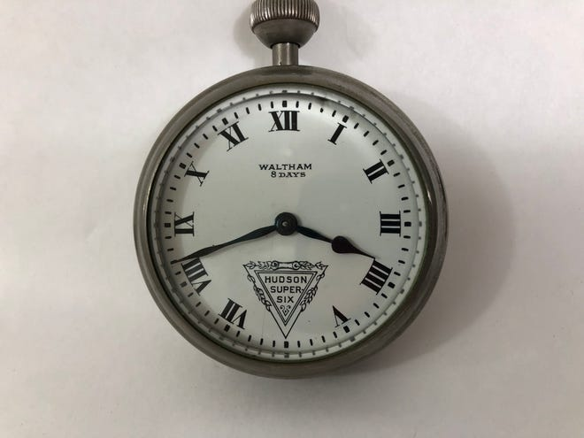
Not long thereafter, another spur to Waltham's business took place with the 1869 completion of the transcontinental railroad. Accurate timepieces were needed to keep trains running on time and avoid catastrophic accidents, and here again, Waltham rose to the occasion. Throughout the last quarter of the 19th century, Waltham was a principal supplier of chronometers to the railroad industry, both in America and dozens of other countries. Its "railroad-grade" pocket watches included a range of features that made them easy to read and hard to misuse, enabling an entire industry to grow safely and profitably. It was the best of times.
With the dawn of a new century, however, things took a turn for the worse. Economic uncertainties, poor management, and a lack of innovation prompted a steady decline that even a short-term boom in wartime production couldn't reverse. Despite making substantial contributions to both world war efforts, Waltham never regained its commercial footing. Restructuring followed restructuring until a 1950 bankruptcy brought with it a revolving door of new owners. It took 30 more years, but the original firm finally closed for good in 1981. Nonetheless, its Vanguard and other premium models remain among the finest of all American-made watches. If you're looking for a quality timepiece with authentic USA roots, you can hardly do better.

Books by Bill Teegarden
To OPEN HYPERLINKS with PC -place cursor on Subject line, hold down Control and Left Click mouse / with Smart Phone – touch with finger or stylus

Gun Makers Preserve Union
The Lion of Roundtop
Bates Walk Across America
Benjamin Franklin Butler Reexamined

Choctaw Confederates

Our First Civil War

The War after the War

The Lincoln Memorial

On The Make

The Battle of Jackson, MS

Kane County

Precious in His Sight

Animal Histories of the Civil War Era

