HARDSCRABBLE
Civil War Round Table of the Mid-Ohio Valley Newsletter
December 2023 – Vol 25

Notes from Nancy Arthur
Why is history important?
History is often thought of as boring, but we hear if we don’t learn about it, we are doomed to repeat it. History is who we are, where we’ve been and where we are going.
Medicine, art, music all have history, as well as what we think about when we hear the word…the founding of our country, the wars in which we’ve fought, the people we have memorized their names, etc.
History has been interesting to me since junior high, due to the method used by Mr. Cifaldi, my history teacher. He told us stories, not just had us memorize dates, places and names. I enjoy the tie in from one event or person to another, relations of who knew whom. Fascinating!
History helps us become better citizens, learning how political parties have worked since this country’s founding.
History can help us form our values; reading about difficult decisions made by people over the years can help us learn courage and perseverance. We can learn about wars and diseases that have affected us in the past and teach us to look for warning signs.
As you read and learn about history, it will help you to learn about mistakes made throughout the year, so that corrections can be made. And as you read and study, check your sources, to be sure if the information is reliable and fact, or just the writer’s opinion.
History that is preserved is the foundation for future generations and history inspires and encourages leaders to take us into the future.
This is the main reason behind the Mid-Ohio Valley Civil War Round Table’s existence. Consider getting involved, whether it is with the Youth Day, sponsored in part by Campus Martius Museum and this Round Table, or attending bi-monthly meetings, with speakers who talk about events from the past that still influence this country today.
Stories by Bill Teegarden

Some Civil War Soldiers' Wounds Glowed in the Dark?

As the story goes, they noticed their wounds emitting a so-called "angel's glow."
According to Timothy B. Smith, a history lecturer at the University of Tennessee at Martin, the Battle of Shiloh was the first big battle in the American Civil War.
“20,000 dead in two days of fighting," he told Snopes. "I always say, America took a collective gasp at Shiloh.”
Before he was a history lecturer, Smith worked at the Shiloh National Military Park as a ranger. He’s published multiple books about the battle. But before a 2001 news report from the U.S. agriculture department, he had never heard of a long-held story about wounds that faintly glowed in the dark — a phenomenon that's become known as "angel's glow."
The tale begins in April 1862. Just under a year into the war, Union Army Maj. Gen. Ulysses S. Grant was already making great progress. He had captured two forts on the northern Tennessee border in February, before spending March advancing towards Corinth, Mississippi, a critical railway junction for the Confederates. Now, Grant set up camp on the banks of the Tennessee River, about 20 miles outside of Corinth, to wait for more troops to join him.
Before they arrived, however, the Confederates attacked Grant's site, and, as the fighting began, this irony became evident: The closest settlement, Shiloh, took its name from the Bible, and that name is sometimes translated to mean “place of peace.” Over the next two days, though, the fighting was intense and devastating.
According to researchers who discovered an explanation for the "angel's glow," the story of the glowing wounds goes like this: As the fighting on the first day at Shiloh ended and the Confederates pushed the Union troops back towards the Tennessee River, wounded soldiers noticed something remarkable — some of their wounds were supposedly faintly glowing in the dark. Even more, when the soldiers received medical aid at a field hospital, those with the alleged glowing wounds ended up having a higher chance of survival and faster recoveries than those without. Because of the glowing wounds' allegedly miraculous properties, the soldiers called them the “angel’s glow.”
That possible explanation for the "phenomenon" wouldn’t come until a Maryland high schooler whose mother researched phosphorescent bacteria visited the battlefield. He wondered if the bacteria his mother was studying could have caused the purported glow, and he experimented with a friend to find out, entering their project into the Intel International Science and Engineering Fair. Their findings suggested that the bacteria, P. luminescens, could have been in the soil where the battle occurred, and it was possible that it made its way from the dirt into soldiers' wounds — producing the glow. According to the theory, P. luminescens, which has a symbiotic relationship with a parasitic worm called a nematode, killed off other small organisms that might have caused an infection, allowing both creatures to reproduce unchallenged. For their findings, the students were awarded first prize in the fair.
(Snopes could not independently corroborate the details of that story, including whether the alleged science-fair project existed at all.) At first glance, the high schoolers' theory appears to be a convincing solution, complete with science to back it up. However, Civil War historians have come to a different conclusion. For them, the most credible sources of information are those written soon after an event and authored by someone who witnessed it firsthand. Smith said there are over 2,000 such sources for the Battle of Shiloh, but none mention glowing wounds.
“It would be weird to see somebody glowing in the dark,” Smith said. “And amidst all those sources, there’s not one contemporary account of the phenomenon.”
Smith found it strange that he couldn't find any sources at Shiloh reporting it and looked to other battlefields to see if he could find references to the phenomenon elsewhere. However, his eventual conclusion was that "angel's glow" never actually happened, and whoever invented the story (likely the high schoolers) chose Shiloh as a site because of its notoriety.
“In a lot of ways, Shiloh is sort of like the Western Gettysburg. Everyone writes about the Eastern Theater, and Gettysburg has become the mecca of Civil War folklore. If there is one battle from the Western Theater like that, it would be Shiloh,” he said. “And if this happened at Shiloh, it would have happened elsewhere too, and I haven’t seen accounts there either.”
Smith said just because there aren’t any written records about the alleged phenomenon doesn’t mean it didn’t happen. But humanity’s morbid fascination with blood and guts and a clever scientific solution form a compelling reason why people might believe the angel's glow ever occurred in the first place.
+++++++++++++++++++++++++++++++++++++++++++++++++

Why Are There Two Virginias?
In 1863, West Virginia seceded from the rest of the state. The issues between the two sides of Virginia, however, ran deeper than the Civil War.
Oct 19, 2023 • By Madison Whipple, BA History w/ Spanish minor
Article Four, section three of the United States Constitution clearly states that to form a state separate from an existing state, the new state must have the consent not only of the federal government but also of the state it wants to leave. This was the uphill battle that the Virginians who lived in the western part of the state faced in the way of their secession. On June 20th, 1863, however, West Virginia was born. This article will discuss the reasons behind the split of the two states.

The settlers who inhabited tidewater Virginia, that is, land along the James River that flowed into the Chesapeake Bay, were, in large part, English. By 1700, five percent of Virginia’s entire population had taken control of the finances and politics of the colony. These were the landed gentry who had already built large tobacco plantations and were beginning to import enslaved people from Africa to work the land. Their trade was incredibly lucrative, as tobacco caught on in England and no one could get enough of the colonial plant.

While the eastern part of Virginia was well-settled by the 18th century, the land west of the Blue Ridge Mountains was, for the most part, empty. The colony of Virginia had established a treaty with the Iroquois in 1722, recognizing the sovereignty of the lands west of the Blue Ridge. Several tribes used the land for skirmishes throughout the years, but none ever settled there besides a few small Shawnee and Iroquois groups.
The relative emptiness of the westernmost part of Virginia was a haven for religious refugees who came into the region through Philadelphia. Most of these immigrants were from Germany and were escaping persecution in their home countries. While William Penn’s colony provided them with the freedom they sought, they found that if they moved further southwest, into the region west of the Blue Ridge, they could more readily afford the land.

After the French and Indian War, however, many Scots-Irish immigrants moved into the mountains, as they were deeply disenchanted with the English government and wanted a more individual lifestyle. The soil in the Blue Ridge region did not yield to large plantations, so many of the immigrants raised livestock and sold them to markets north of Virginia.
Religion west of the Blue Ridge Mountains was also different from that of tidewater Virginia. While those who lived along the coast were mostly loyal to England and practiced in the Anglican Church, the mountain settlers were from different Protestant persuasions–mostly Presbyterianism and Anabaptism. Their loyalties aligned more strongly with Virginia’s neighbors to the north, Pennsylvania and Maryland, as with their economic activity. Thus, the western Virginians had virtually no connections to the tidewater elite, and did not, from the start, feel connected to the eastern half of Virginia.
While George Washington himself lived in western Virginia for a time and sought to improve economic and political loyalties to the East, growing unrest was already brewing. People in western Virginia were calling for a separate state soon after the American Revolution, claiming that the state of Virginia did virtually nothing to support their political and economic interests in the state.

The Westerners had just cause for this feeling. By 1816, the Virginia Board of Public Works had been established and financed 40 to 60 percent of public works projects in the state, including turnpikes, railroads, and canals. However, the board hardly ever approved projects that would improve transportation and infrastructure in the West; instead, it focused on connecting farming towns in the East with market cities in the East, which furthered the economy of the elite built on slave labor.
This was reflected in the General Assembly in Richmond, where the western counties of Virginia were grossly under-represented. The Staunton Convention, which convened in 1816, found that only a third of the population eligible to serve as representatives (white males) lived in the eastern part of the state, but effectively controlled the state legislature, with the majority of seats in both the House of Delegates and the state Senate.
Political parties also did not matter in the control of Virginia, as both the Whigs and the Democrats tended to finance projects that only benefited the eastern half of the state. Western Virginians were, in short, kept at arm’s length by the rest of the state. They were not a part of the mercantile economy and thus were not important to eastern interests.
Some attempts at representational improvement were made before the Civil War, with the 1830 amendment of the Virginia Constitution allowing the Board of Public Works to finance more projects west of the Blue Ridge Mountains but disallowing voting rights to those who did not own a certain amount of property. This created a dilemma in western Virginia, as many tracts of land were owned by easterners and worked by westerners.
The new Virginia Constitution of 1850 eased restrictions on voting rights in the western part of the state, allowing more men to vote in state elections, but disallowing the western counties from ever holding a majority in the legislature. This was ensured by the design of voting districts, whose boundaries were drawn by eastern legislators. The design of voting districts saw to it that western Virginia would never hold more than 66 seats (43%) in the 152-seat House of Delegates and no more than 19 seats (38%) in the 50-member state Senate.

Taxation of Virginia & West Virginia

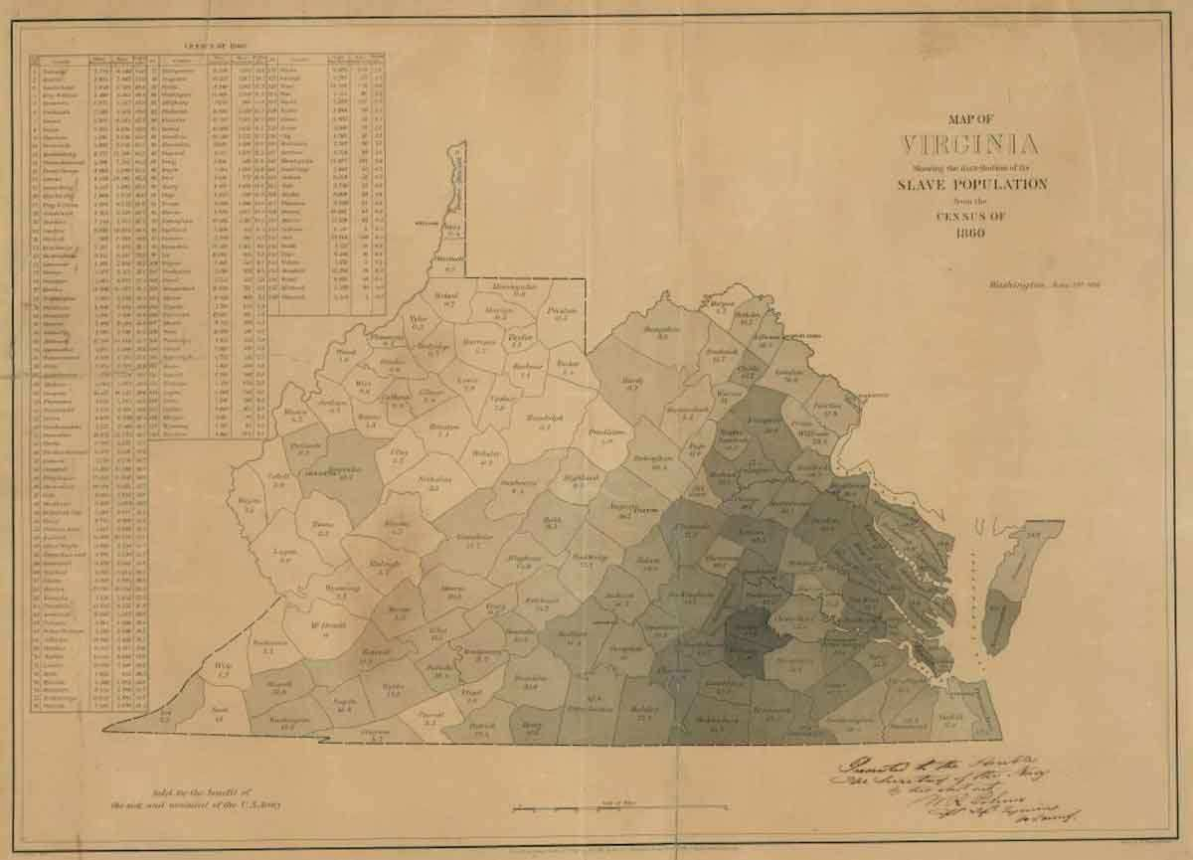
The American Revolutionary refrain of “taxation without representation” also applied in Virginia during its many Constitutional iterations of the 19th century. Special treatment was given to eastern Virginians in the legislature through laws pertaining to property taxes. In short, tax breaks were given to slave owners in Virginia which almost wholly benefitted the eastern part of the state.
Political agriculture and enslaved labor were common in the eastern part of the state but not in the western. More well-off families of western Virginia did own enslaved people, but not nearly to the scale of eastern Virginia. The economic interests of the East, therefore, relied on slavery, and the state legislators fostered this economy through laws easing taxes on the eastern planters.

The state’s tax laws of 1850 stated that all property and land should be taxed at a percentage of its actual value, except for enslaved people. Enslaved laborers under 12 years old were not subject to tax, and those over 12 were only taxed to the flat value of $300 when often the price for buying enslaved people was closer to $2000.

Western Virginians’ land and properties were taxed at a percentage of their actual value, which made the taxation level of the region disproportionate to that of the eastern half. The eastern economy boomed, and plantation owners could absolutely afford to pay more in taxes, but their representatives in the state legislature instead put the impetus for tax revenue on western Virginians.

Slavery was a contentious issue in Virginia long before the Civil War, but not always regarding the morality of it. Most of the western half of Virginia didn’t enslave people because they didn’t have large enough tracts of land or enough money to justify it. Morally, many western Virginians were not opposed to slavery.

The 550,000 enslaved people, who composed a third of Virginia’s population in 1860, were located mostly in the eastern part of the state. They served as the unpaid labor force for several hundred tobacco, corn, and wheat plantations and later could be loaned to help in the coal and salt industries. The state of Virginia disallowed descendants of enslaved people they bought from becoming free, and thus the system of slavery was ever-sustained by the natural growth of population. By the time of the Civil War, eastern Virginia was incredibly reliant on enslaved labor, which was likely the main reason for the state’s secession.

In western Virginia, although most did not oppose slavery, some were vehemently against it. Descendants of Quakers and the new Methodist Church of Virginia highly opposed the practice of slavery as immoral. In 1857, a Massachusetts man named Eli Thayer established an abolitionist settlement in western Virginia, which was intended to prove that paid labor provided just as much, if not more, success as enslaved labor.

Another abolitionist used western Virginia as a stage for demonstrating the immorality of slavery in 1859. John Brown, a Connecticut-born abolitionist, was in favor of violent resistance to the institution, taking a Biblical viewpoint that those who enslaved others were deeply sinful. Brown’s raid of the United States Armory and Arsenal in Harpers Ferry, Virginia, was a failed attempt to right the wrongs of slavery in the South.

Brown hoped for an enslaved uprising following his capture of the arsenal, but it never came, largely due to the fact that the presence of enslaved people was scarce in western Virginia. Regardless, the name Harper’s Ferry and the whole of western Virginia was thereafter juxtaposed against the thriving slave economy of the eastern half of the state.
In April 1861, the Richmond Convention voted to secede from the United States. The delegates from western Virginia, for the most part, voted to stay in the Union, but the majority of easterners in the state legislature overrode their votes. A month later, a referendum was held to vote on secession by way of democratic voting. Of the western counties of Virginia, over 30,000 people voted against secession, while only around 19,000 people voted to ratify secession.

This referendum, due to the political power of the east, was little more than a show of democratic process, as the decision was all but made. The eastern state representatives had already decided that they would secede, and this was the last straw for western Virginians.
Immediately following the referendum, the Wheeling Convention met to discuss another secession: that of West Virginia from Virginia. The delegates from western Virginia began discussing the separation of the two states, tired of the way that the eastern portion of the state assumed they spoke in the interests of the entire state. In convening in Wheeling, the western delegates made it very clear that they saw Richmond and the government of Virginia as null and void.

West Virginia, although it was a slave state, wanted to be a part of the Union, and wanted to promote an idea of constitutional secession, rather than traitorous secession like that of Virginia’s.
There was, however, a problem with West Virginia’s plan to secede. They had to make the federal government see that secession from the now Confederate state was legitimate. President Lincoln and the United States Congress were hesitant to allow the secession of a new state, fearing that this would translate into the administration’s tacit acceptance of the Confederacy as legal.

Two large obstacles stood in the way of West Virginia joining the Union: their identity as a southern state and as a slave state. Thus, the western provisional government fostered an ever-growing majority of Unionist sentiment in the region in an attempt to prove that a southern state joining the Union would help the Federal Government’s cause. They sought this within the Unionist portion of Virginia’s government, mainly made up of westerners, which called itself the Restored Government of Virginia.
The Restored Government legitimized and approved West Virginia’s plan to leave the state, and soon the Federal Government saw that an ally within the South would be helpful to their cause in the war. After the approval of the Restored Virginia Government in 1862, which had found West Virginia’s Unionist aims to be the majority opinion, based on a referendum, the Lincoln administration accepted the state’s bid to join the Union on December 31, 1862.

The acceptance of West Virginia was conditional on implementing a policy of gradual abolition for the population of enslaved people who lived in the state, but from 1863 onward, Lincoln’s government had a stronghold in the South, which provided them with loyalist support and strategic posturing for the rest of the Civil War.
On June 20, 1863, West Virginia was officially admitted into the Union as the 35th state.

After the Civil War, the governments of West Virginia and Virginia engaged in several disputes, some of which have lasted until the modern day.

Virginia and West Virginia had to deal with their previously shared debt in some way. West Virginia’s constitution allowed for the assumption of some of Virginia’s debt, mostly from public works projects, but negotiations were fruitless, and eventually, Virginia agreed to take on two-thirds of its debt, leaving the final part to West Virginia. In 1915, the Supreme Court ruled that West Virginia owed Virginia approximately $12.4 million, the first installment of which was not paid until 1939.
Virginia began a Supreme Court case against West Virginia in 1866 over the transfer of two counties from Virginia to West Virginia. Virginia claimed that the absence of several hundred Confederate soldiers during the vote to transfer nullified the action, as the former soldiers refused to acknowledge the shift. However, the Supreme Court ruled in favor of West Virginia in 1871, and the counties were never disputed again.

Some form or another of this transfer has existed throughout the history of West Virginia, and several skirmishes over the boundary have lasted hundreds of years. In 1991, both states commissioned a land survey that would establish the actual border.

In addition to border disputes, in 2011, three counties in the eastern panhandle of West Virginia entered into serious discussions about rejoining Virginia, as the counties perceived that they had been neglected by the West Virginian government. The counties did not leave, but talks of rejoining either one side or the other have endured; as recently as 2020, West Virginia Governor Jim Justice announced that incorporation into West Virginia was available for counties that disapproved of Virginia’s newly Democratic-controlled state government.
Thus, the disputes between Virginia and West Virginia continue today, and it is unclear if the problems will ever cease. It is, however, certain that many political, ideological, and economic conditions led to the split between the two Virginias.

________________________________________________________________________________________________________________

Books by Bill Teegarden
To OPEN HYPERLINKS with PC -place cursor on Subject line, hold down Control and Left Click mouse / with Smart Phone – touch with finger or stylus
Ends of War - Caroline Janney
Ways & Means - Roger Lowenstein
The Cambridge Companion
The Door of No Return - Kwame Alexander
Out of Time: William Collins and The Andersonville Raiders
My Last Skirt - Matt Donnelly

The Families Civil War - Holly A. Pinheiro Jr

A Holy Baptism of Fire - Dr. James P. Boyd

The Great What If's - Chris Mackowski and Brian Matthew Jordan

Replanting A Slave Society - Patrick Luck

