|  |  |
| --- | --- |
|  | **HARDSCRABBLE**  Civil War Round Table of the Mid-Ohio Valley Newsletter  April 2021 – Vol 9 |

Notes from Nancy Arthur

When I think of the Revolutionary War, I think of New England – Bunker Hill,

Lexington – of course Philadelphia and New Jersey, New York. I know the war was

fought farther south but I didn’t know that an estimated one third of all combat

action was in South Carolina. John W. Gordon, author of South Carolina and the

American Revolution, divides the state into three areas: the British Nave, the

Cherokees in the western part of the state and loyalists to the King.

His research shows more battles were fought in South Carolina than any of the

other colonies. He is counting battles between Native Americans, back country

settlers, Continentals and British regulars.

From Fort Sullivan to Charleston, and battles of King’s Mountain and Cowpens,

the assorted troops from South Carolina defeated the mighty world power of the

British Army when other areas of the country were at a stalemate in the war.

In 1775, Peter Manigault was the richest man in America and a citizen of South

Carolina, based on per capita wealth. In addition, eight of the next top ten men of

wealth were also from the state. These men had no interest in fighting with the

mother country but after the French and Indian War was over, the Brits wanted to

be paid back for their efforts in winning. To that means, they began to tax the

Americans, then the tea party occurred and we all know how that ended. When

Massachusetts was hit with severe sanctions, the other states met to decide a

plan of action, thinking rightfully so, their turn could be next.

Some of these South Carolina sites, especially Cowpens and Camden, are on the

agenda for the November bus trip. Watch for further details!

Notes from Bill Teegarden

The National Museum United States Army is celebrating Civil War Week (April 5-9) with daily virtual offerings across a wide range of topics – see below.

##### Explore Military Leadership of the Civil War

Join us and examine Civil War military leadership through a series of virtual events including presentations by top historians, a curator discussion of select Museum artifacts, and educational activities.

Choose what interests you and register to attend one, or all, of the scheduled events. All events are virtual, FREE and open to the public.

**SCHEDULE OF EVENTS**

NMUSA Image  
***Monday, April 5, 2021***  
**History Talk – “Meade: The Price of Victory”**

**SCHEDULE OF EVENTS**

John Selby of Roanoke College examines Union general George Meade. Meade’s performance during his two-year tenure as commander of the Army of the Potomac was overshadowed by his successor: Ulysses S. Grant. Selby characterizes Meade as a more active, thoughtful, and enterprising commander than has been assumed, bringing him into focus as one of the war’s more effective Union generals. A member of the faculty of Roanoke College since 1986, Selby is well-known in the Roanoke Valley for the history tours he leads for students and adults.  
[Register for History Talk – “Meade: The Price of Victory”](http://tickets.thenmusa.org/info.aspx?activityID=20201034)

***Tuesday, April 6, 2021***  
**History Talk – “U.S. Grant at Appomattox: Ending the Union’s War of Deliverance”**  
**7:00 – 8:00 pm (EDT)**

**Battle Brief – “Battle of the Wilderness”**  
**12:00 – 1:00 pm (EDT)**

Take a look at the hard-fought Battle of the Wilderness in early May 1864 – the first face-off between generals Grant and Lee in war-torn Virginia.  
[Register for Battle Brief – “Battle of the Wilderness”](https://tickets.thenmusa.org/info.aspx?ActivityID=20201043)

***Wednesday, April 7, 2021***  
**Field Trip – “The Soldier’s Load”**  
**10:00 – 10:45 am (EDT)*****Wednesday, April 7, 2021***

**History Talk – “Robert E. Lee, Stonewall Jackson, and Confederate Strategy in the East, 1862-1863”**  
**7:00 to 8:00 pm (EDT)**

***Thursday, April 8, 2021Thursday, April 8, 2021***

**History Talk – “The Military Career of Ambrose Burnside”**  
**7:00 – 8:00 pm (EDT)**

***Friday, April 9, 2021***  
**Gallery Talk – “Preserving the Nation”**  
**12:15 – 12:45 pm (EDT)**

**OPINION**

# As it Were: Independence was guiding spirit of Lottie Moon

**Ed Lentz**

Guest Columnist

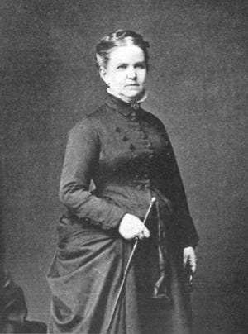

The American Civil War was a defining event in American history.

The conflict involved most of the American population in one way or another for four years. Yet in that world of more than a century and a half ago, gender roles were well defined.

Millions of men joined the military as others labored in the farms, mines and factories that provided the food, goods and guns needed by the armies. Many women minded the homes and staffed the hostelries, hospitals and camps.

Few Americans were bold enough to disregard these traditional roles.

And then there was Lottie Moon.

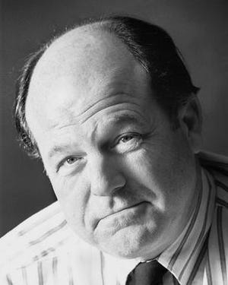

Cynthia Charlotte “Lottie” Moon was born Aug. 10, 1829, and was the first daughter of Dr. and Mrs. Robert Moon of Danville, Virginia. The doctor was a firm believer in the views of Thomas Jefferson that slaves should be emancipated. So he did just that when he moved his growing family to Oxford, Ohio, in 1834.

**More:**[As It Were: Polish patriot Thaddeus Kosciusko left mark in central Ohio despite never living here](https://www.thisweeknews.com/story/opinion/2021/03/08/were-polish-patriot-thaddeus-kosciusko-left-mark-central-ohio-despite-never-living-here/4628758001/)

**More:**[As It Were: Union Station was desirable depot for growing city of Columbus](https://www.thisweeknews.com/story/opinion/2021/03/02/were-union-station-desirable-depot-growing-city-columbus/6878914002/)

Lottie Moon grew up in the town that was the home of Miami University with three brothers and two sisters. The family home, which later became the home of the college president, still stands across from the main entrance to the campus.

Moon was an independent girl and grew up doing quite well at riding, shooting and, more importantly, acting. Attractive and popular, she was courted and became engaged to a young lieutenant from Indiana named Ambrose Burnside.

On her wedding day June 21, 1849, Moon asserted her independence. Asked by the minister whether she was prepared to wed Burnside, she paused, shrugged, said “No, Siree, Bobby!” and ran down the aisle. Six months later, she married a young attorney named John Clark and moved to his home in nearby Jones Station.

Clark’s sympathies were with the South as America moved closer to conflict. So, too, were the views of most of the Moon family. After the death of Dr. Moon in 1856, Lottie stayed in Ohio, but her mother moved the rest of the family to Shelby County, Tennessee. Eventually, all three of Lottie’s brothers would fight for the Confederacy while her mother and sisters worked in Memphis hospitals.

In the meantime, she and her husband concealed their loyalties to the South and became active in clandestine organizations like the Knights of the Golden Circle. With the outbreak of the Civil War, their home became a base station for supplies and a way station for rebel soldiers and Confederate spies. One of those spies was Lottie Moon herself.

Her husband once remarked that she was the “smartest woman in the world.” She soon set out to do her best to prove him right. Her exploits during the Civil War became the stuff of legend. In October 1862, she attended a meeting of Confederate agents in Toronto, Canada, and returned to America with a forged British passport.

Passing herself as a titled noblewoman, Moon approached War Secretary Edwin Stanton for a pass to Virginia, saying she had come from England “to take the waters.” Stanton obliged and permitted her to accompany him on a visit to the front lines with President Abraham Lincoln.

Riding with the two men, she eventually feigned sleep, and Lincoln and Stanton talked war policy. Leaving the coach and riding to Richmond, Moon told Confederate President Jefferson Davis all that she had learned. Finding he had been duped, an outraged Stanton placed a reward on her head – $10,000 dead or alive.

It never was collected.

Moon evaded discovery and capture and for some time acted as a courier and spy for the South.

She regularly visited the massive Union Army base at Camp Chase in Columbus and acted as something of a postmistress for men held at the prison camp. At one time she simultaneously was engaged to no less than 12 Confederate soldiers. She later noted that she simply wanted them to die happy.

Traveling as an Irish washerwoman, she was stopped by Union soldiers at Cincinnati and taken to their commanding officer.

Her attempt to pass as an Irish woman failed when she was recognized by the man who was now Gen. Ambrose Burnside. Despite the loss of a bride, he still was a friend of Moon and her family.

Instead of having her hanged, Burnside said she could remain free if she promised to stay away from espionage and remain in residence at the fashionable Burnet House hotel in Cincinnati for the rest of the war. She agreed and did just that.

After the war, Moon and her husband moved to England, where she became a roving reporter for American and British newspapers and later was the author of two popular novels.

Lottie Moon, who died in 1895, was one of the ones who got away.

Local historian and author Ed Lentz writes the As It Were column for ThisWeek Community News.

=============================================

# Perryville: Scene of the Great Civil War Mule School

* By Jere Garrett HSCC
* Jul 26, 2020

[[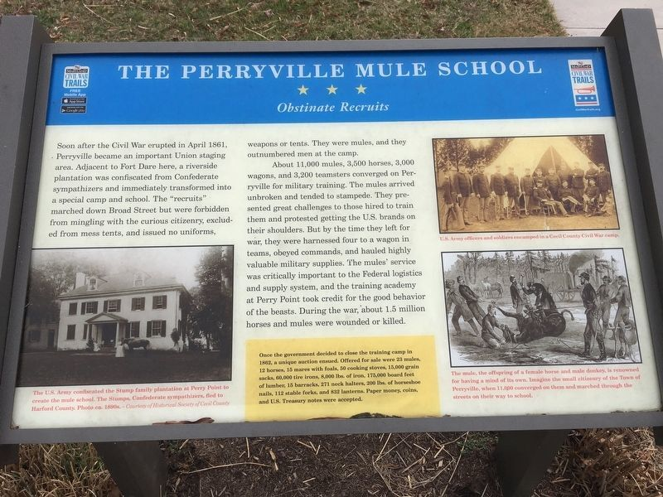](https://www.cecildaily.com/content/tncms/live/#1)](https://www.cecildaily.com/content/tncms/live/" \l "1)

This sign, part of The Civil War Trails signage, tells visitors about the “Obstinate Recruits” at the mule school located at Perry Point.

* HSCC PROVIDED PHOTO

[[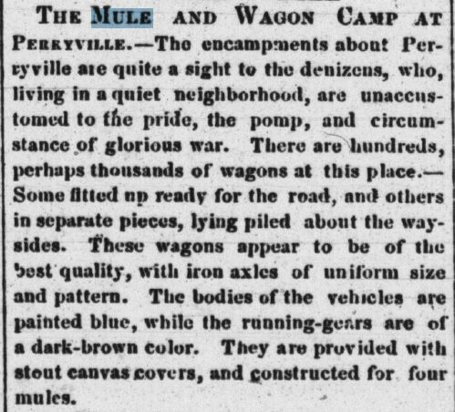](https://www.cecildaily.com/content/tncms/live/#2)](https://www.cecildaily.com/content/tncms/live/" \l "2)

Cecil Whig mini-article about the arrival of the mule camp to Perryville.

* HSCC PROVIDED PHOTO
* *This article originally appeared in the old Historical Society of Cecil County Bulletin. Jere Garrett is the author of Muffled Drums and Mustard Spoons, a book about the Civil War in Cecil County.*
* The population of Perryville mushroomed in 1861 when the government established a camp of instruction on the banks of the Susquehanna River. Just as quickly, it decreased the next year when the larger portion of the camp moved south to be closer to the action. The camp was situated on Perry Point, but the papers invariably referred to its location as Perryville.

Over 2,000 troops, many recruited from Pennsylvania, assembled at Col. Dare’s camp at Perryville in the spring of 1861. They were quartered in railroad buildings. Nobody crossed the line in either direction without Dare’s written permission. All supplies were plentiful – except uniforms. Among some companies, remarked the Whig, dress was as varied as the men themselves.

Perryville residents were ruffled by the activity that surrounded their town. The Whig crowed, “At present, it is the great mule school of the country.” There were hundreds of wagons in the neighborhood. Some were ready to roll, while others lay in pieces piled on the roadsides. Their iron axles were uniform in size and pattern. The wagon bodies were painted blue, and the running gears were dark brown. They were fitted with sturdy canvas covers and required a team of four mules.

As wagons were fitted up, they were pulled onto the perimeter of a plat of a couple of acres. Several hundred mules grazed within each of these “wheeled fences”. An estimated 1200 to 1500 mules were in such enclosures around Perryville. The Whig mentioned one minor problem: all the mules were green (unbroken) and presented somewhat of a challenge to the persons responsible for breaking them.

There were 25 wagons to a train, with four mules and a driver for each wagon. Every train had its own train master and assistant. A soon as the trains were ready, they moved out to make room for others Droves of mules, branded on the shoulder with “U.S.”, were constantly on the move around Perryville.

Those local residents who were not pleased with the encampment in their neighborhood were no doubt disgruntled to read the Whig’s observation: “The camp, as yet, is only in a state of formation, and many more men and animals are expected to be placed on the ground in a short time.”

When the government first took over Perry Point, its owner, John Stump II was forced to leave his homestead. With his family he moved to Harford County. When they returned after the war, the Stumps found that Union soldiers had ripped the staircase out of their mansion and used it for firewood. The whole farm was in disrepair, but many of the former slaves stayed on voluntarily as hired hands. In time, the farming operation resumed.

In 1861, when 1600 troops of the 11th and 14th Regiments of US Infantry prepared to winter near Perryville, a Cecil Democrat correspondent reported on his visit to the encampment.

“The Government depot at Perryville is now the most important in the country. It contains 11,000 mules, 3,500 horses, 3,000 wagons, and 3,200 teamsters with quantities of hay, oats, and corn of not less value than one million five hundred thousand dollars. The total property cannot be less than five million dollars. These animals and articles are in charge of the 14th regiment of regulars, 800 strong, under command of Major Giddings, and part of the eleventh regiment of regulars, comprising 150 in all, including teamsters and soldiers, about 4,500 men. The tents are pitched on the brink of the Susquehanna River; sentries are posted on all the adjacent roads, and the most perfect military discipline prevails within the precincts of the camp. To guard the mules and horses is a most difficult duty. Notwithstanding all precautions, stampedes frequently occur and the animals are given to mortality. About 2 horses and 2 mules are dying every day. Uncle Sam has been pretty extensively swindled in the matter of these beasts. Major Van Vliet of the Quartermaster General’s Department, visited Perryville on Wednesday and witnessed the battalion drill of the 14th regiment. The latter is said to be one of the best Regiments in the service of the Government. Captain O’Connel is acting drill master.”

Breaking mules was an arduous task, but the animals had at least one advantage over horses where swampy terrain was involved. Mules were not susceptible to thrush, the foot disease that had disabled horses. The army leaned that on Burnside’s infamous “mad march.”

Cecil Countians took note in mid-November as a government mule train of 30 wagons passed through Elkton enroute from Perryville to Snow Hill, where it served as a transport for troops in that area.

Quartermaster Sauyelle advertised in 1862 for 200 teamsters. The pay was $25 a month, but only experienced drivers willing to go where ordered needed to apply. Recently some had refused to comply when ordered to join Burnside’s expedition.

Some merchants, of course, prospered from the increased traffic in the area, but other residents were understandably upset when the normal pace of their lives was changed by an influx of strangers.

Finally, the Government moved the wagons, ambulances and mules early in 1862. The Cecil Democrat reported on March 29 that while depots were established farther south to meet the needs of the moving army, the camp of instruction would remain in Perryville.

In spite of the man-made changes going on in and around the little town, some natural phenomena remained constant. The Cecil Whig reported a sure sign of spring in Perryville – 11,000 shad from different fisheries. They sold at ten and fifteen dollars per hundred.

Now that the mule school was pulling out, the Government disposed of a considerable amount of property at auction on May 26, 1862. A partial list gives some idea of the logistical problems encountered by a 19th century army: 23 mules; 12 horses; 15 mares with foals; 50 cooking and heating stoves; 15,000 grain sacks; 60,000 old tire irons; 8,000 lbs old tire iron; 175,000 feet assorted lumber; 15 barracks; 271 neck halters; 200 lbs horse shoe nails; 112 stable forks; 82 lanterns.

Terms: Cash, in coin or US Treasury notes. Symmes Gardner, Captain and Assistant Quartermaster, US Army Auctioneer, Samuel Burns

Some residents breathed a sigh of relief when the mule school closed; nevertheless, their lives had changed profoundly and irrevocably.

# *******************************************************************Confederate Statues Were Never Really About Preserving History

By [Ryan Best](https://fivethirtyeight.com/contributors/ryan-best/)

[Confederate Statues](https://www.google.com/url?rct=j&sa=t&url=https://projects.fivethirtyeight.com/confederate-statues/&ct=ga&cd=CAEYACoTOTUxNzk0MTE2NTM2Njg2MDg1MzIaYmFmYWNiYzIxYTg5YmViZTpjb206ZW46VVM&usg=AFQjCNFOl8DBMXkYfoid2o2Rkkm9yLwgFw)

^^^^^^^^^^^^^^^^^^^^^^^^^^^^^^^^^^^^^^^^^^^^^^^^^^^^^^^^^^^^^^^^^^^^^

# **A symbolic cacophony’: As monuments come down, the unraveling of the rebel flag continues**

By

[**Rex Springston**](https://www.virginiamercury.com/author/rex-springston/)

When Confederate monuments go down, they go down fast.

The rebel flag, on the other hand, has been pulled apart, thread by thread, for years. And now it’s unraveling fast.

The best-known Confederate symbol, the flag is disappearing from public places —[think NASCAR](https://www.espn.com/racing/nascar/story/_/id/29344050/nascar-sees-confederate-flags-fly-talladega-superspeedway) — and could even be endangered in contemplative settings like cemeteries and battlefields, experts say.

“One index to watch will be book covers,” said historian John Coski of Richmond. “Will publishers of books about the Civil War and the Confederacy use Confederate flags on covers, as they have done for decades?

“Another (thing to look for) will be flag displays at Civil War sites and in cemeteries: Will parks and cemeteries prohibit or avoid Confederate flags?”

Indeed, Hollywood Cemetery in Richmond is home to thousands of Confederate graves. Usually the place is a sea of rebel flags, but last week they were gone.

The Sons of Confederate Veterans, a heritage group with about 3,000 members in Virginia, maintains the rebel flags in Hollywood. Andrew Bennett Morehead, a Virginia spokesman for the group, said the flags were removed in early July so they wouldn’t attract vandals who might damage graves.

Morehead said it’s his understanding that the removal will be temporary. A staff member in Hollywood’s office said she also understood the removal to be temporary.

As for the flag’s diminishing presence in general, Morehead said: “It’s cowering to … domestic terrorists inciting riots.”

Working out of the American Civil War Museum in Richmond, Coski is one of the country’s top experts on the flag. He is the author of “The Confederate Battle Flag: America’s Most Embattled Emblem.”

Many see the flag as a symbol of slavery and racism — the banner of the Confederacy’s effort to break from the U.S. and create a separate slave-holding republic. Supporters say the flag is an emblem of independence and southern heritage.

The flag is all those things, Coski said. The trouble is, many people on each side of the debate don’t want to understand their opponents, he added. “They just want their perceptions to rule over all others.”

Protests and public support for racial justice have spread across the country since May 25, when George Floyd died under the knee of a Minneapolis police officer. These events are creating the biggest wave against public displays of the Confederate flag since the 2015 killing of nine black people in Charleston, S.C., by a white supremacist[who posed with the flag](https://www.nytimes.com/2015/06/21/us/dylann-storm-roof-photos-website-charleston-church-shooting.html).

“If you had asked me two years ago if Stonewall Jackson’s statue (in Richmond) would be removed anytime soon, the answer would have been ‘no,’ “ said Adam W. Dean, a University of Lynchburg historian. “The same is true with the Mississippi flag decision,” which [removed the Confederate emblem from that state’s flag.](https://www.virginiamercury.com/2020/07/06/how-sports-and-the-baptists-pushed-the-confederate-banner-off-mississippis-state-flag/)

The push to scrub public spaces of the rebel flag will probably expand to places like cemeteries, said Dean, who specializes in slavery, the Civil War and Reconstruction.

“I think the flag will not be a public symbol for much longer. It, of course, will still be of historical interest and part of museums. … I believe that the practice of putting Confederate battle flags at graves in Hollywood Cemetery will start to fade away, perhaps disappearing in 10 years.”

The flag has gotten a lot of attention the past few weeks. President Donald [Trump defended it](https://www.cbsnews.com/video/trump-says-flying-confederate-flag-is-a-freedom-of-speech-issue/#x). The [Pentagon banned](https://apnews.com/f55584c87592eb48ebe958ded3d89b53) it from military bases.  Even the General Lee — the “Dukes of Hazzard” car with a rebel flag on top — came in for renewed criticism and support.

[“The car is innocent,”](http://abcnewsradioonline.com/entertainment-news/the-car-is-innocent-dukes-of-hazzard-stars-sound-off-on-gene.html) said Tom Wopat, one of the stars of the TV series.

But is the Confederate flag really innocent? Here are some facts about its past, present and future:

## It’s not what you think it is**.**

The flag we all know is rectangular with a blue, star-studded, diagonal cross on a field of red. It is often called the Confederate battle flag.

But it is not *the* Confederate flag. It is one of several flags the South flew during the Civil War, Coski said.

It is not even *the* Confederate battle flag. It’s one of dozens the rebels flew in combat.

Many people say Confederate Gen. Robert E. Lee’s army fought under the flag, but that is almost certainly false, Coski said. Lee’s army carried a similar flag, but it was square.

Late in the war, the rectangular banner became the battle flag of the Confederacy’s other major force, the Army of Tennessee in the western theater of the war. It was also the second Navy Jack, the flag flown from Confederate ships.

[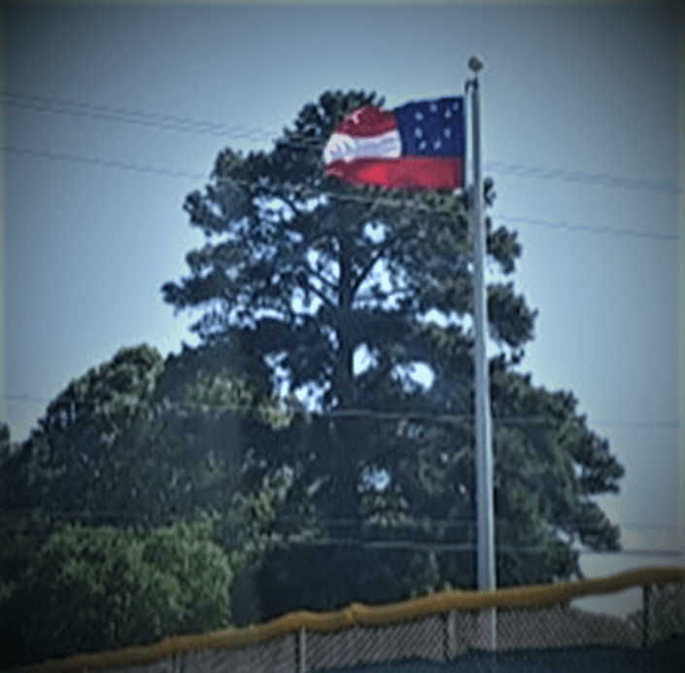](https://www.virginiamercury.com/wp-content/uploads/2020/07/stars_bars_freeman.png)Someone hoisted the “Stars and Bars” Confederate flag over a baseball field at Douglas Freeman High School in Henrico last month. (NBC 12)

It is not the “Stars and Bars,” as the first national flag of the Confederacy was known, named for its resemblance to the U.S. flag, the Stars and Stripes.

The battle flag was never the official flag of the Confederacy. Rather, there were three national, or official, flags.

The rectangular flag was rejected as the national flag, but the square version was incorporated into the cantons, or corners, of the second and third national flags.

After the Civil War, it was the rectangular flag that caught on with the public.

## The flag became synonymous with segregation.

Some Northerners retained an animosity toward the Confederate flag after the war. But as years went by and Southerners fought bravely alongside Northerners in the Spanish-American War and World War I, the flag gained some national acceptance — from Whites.

The flag kept a fairly low profile well into the 20th century, popping up at southern Memorial Day observations and Confederate veterans’ parades.

“Occasional northern and African-American voices questioned the wisdom of displaying a flag they associated with disunity or treason,” Coski said.

The Ku Klux Klan is often linked with the rebel flag — indeed, former Confederates founded the Klan —  but the white-supremacy organization didn’t take up the flag until the 1930s and ‘40s, Coski said.

The flag burst into prominence in 1948 when the so-called Dixiecrat Party displayed it as a symbol of segregation. White supremacists also wielded the flag during the Civil Rights era of the 1950s and ‘60s.

Beginning in the 1950s, young Whites took up the flag in a fad that swept the South and North. The flag came to represent Confederate heritage, racism, the South and rebellion.

“By the mid-1960s, the Confederate flag was a symbolic cacophony,” Coski said.

Those discordant notes continue today.

Some people still claim the flag solely represents southern heritage, but it’s impossible to separate the flag from the Confederacy’s quest to protect slavery, said Dean.

“There is a narrative out there, even among educated people, that the battle flag was at one point ‘pure’ until it was ‘co-opted’ by the Ku Klux Klan and white supremacists,” Dean said by email. “This is just not true considering the centrality of slavery to secession and the Civil War.”

## The flag has been taking fire for a long time.

For a native Virginian it’s hard to believe how far the flag has fallen. You used to find it on the occasional front-yard flagpole, children’s Johnny Reb caps, beach towels, shot glasses. It jumped out at you in roadside convenience stores and Virginia Beach swimsuit shops. A gray-haired, cartoon Confederate saying, “Forget, Hell!” appeared on cigarette lighters and novelties.

The flag still pops up in the occasional rural yard. But it’s definitely harder to find than it used to be.

Another former “Dukes of Hazzard” star, Ben “Cooter” Jones of Portsmouth, [reflected on criticism](https://www.foxnews.com/entertainment/dukes-hazzard-congressman-ben-jones-confederate-battle-flag-not-symbolic-racism) of the flag a few days ago. “This thing that you talk about didn’t happen until about 15 or 20 years ago,” he said.

That’s not true. Legal and political challenges began in the 1960s, Coski said. “The flag has been in retreat for decades.”

According to a [Quinnipiac University poll](https://www.politico.com/news/2020/07/18/trump-confederate-flag-battle-368607) released this month, 56 percent of those questioned associate the Confederate flag with racism. Thirty-five percent see it more as a symbol of southern pride.

A major turning point for the emblem came in 2015 when a white gunman killed nine people in a Black church in Charleston, S.C. Photos emerged of killer [Dylann Roof posing](https://www.nytimes.com/2015/06/21/us/dylann-storm-roof-photos-website-charleston-church-shooting.html) with Confederate flags.

Among other reactions, [South Carolina removed the Confederate flag](https://www.nytimes.com/2019/12/07/us/Nikki-Haley-confederate-flag.html) from its statehouse, and retailers including [Walmart banished the flag](https://www.washingtonpost.com/news/morning-mix/wp/2015/06/23/as-walmart-goes-so-goes-the-nation-or-vice-versa/).

Coski said the Charleston tragedy hastened the flag’s abandonment by much of Middle America.

“I think that, after 2015, many Americans who revered and heretofore defended the flag publicly looked in the mirror and saw Dylann Roof staring back at them.”

Dean, the Lynchburg historian, said, “I think that the (current) Black Lives Matter protests and larger movement have been the biggest tipping point (for the Confederate flag) since Charleston.”

“Due to education efforts over the past 30 years and current activism, people are finally understanding what the Confederacy was about and asking, ‘Why are its symbols continuing to be venerated in public?’”

[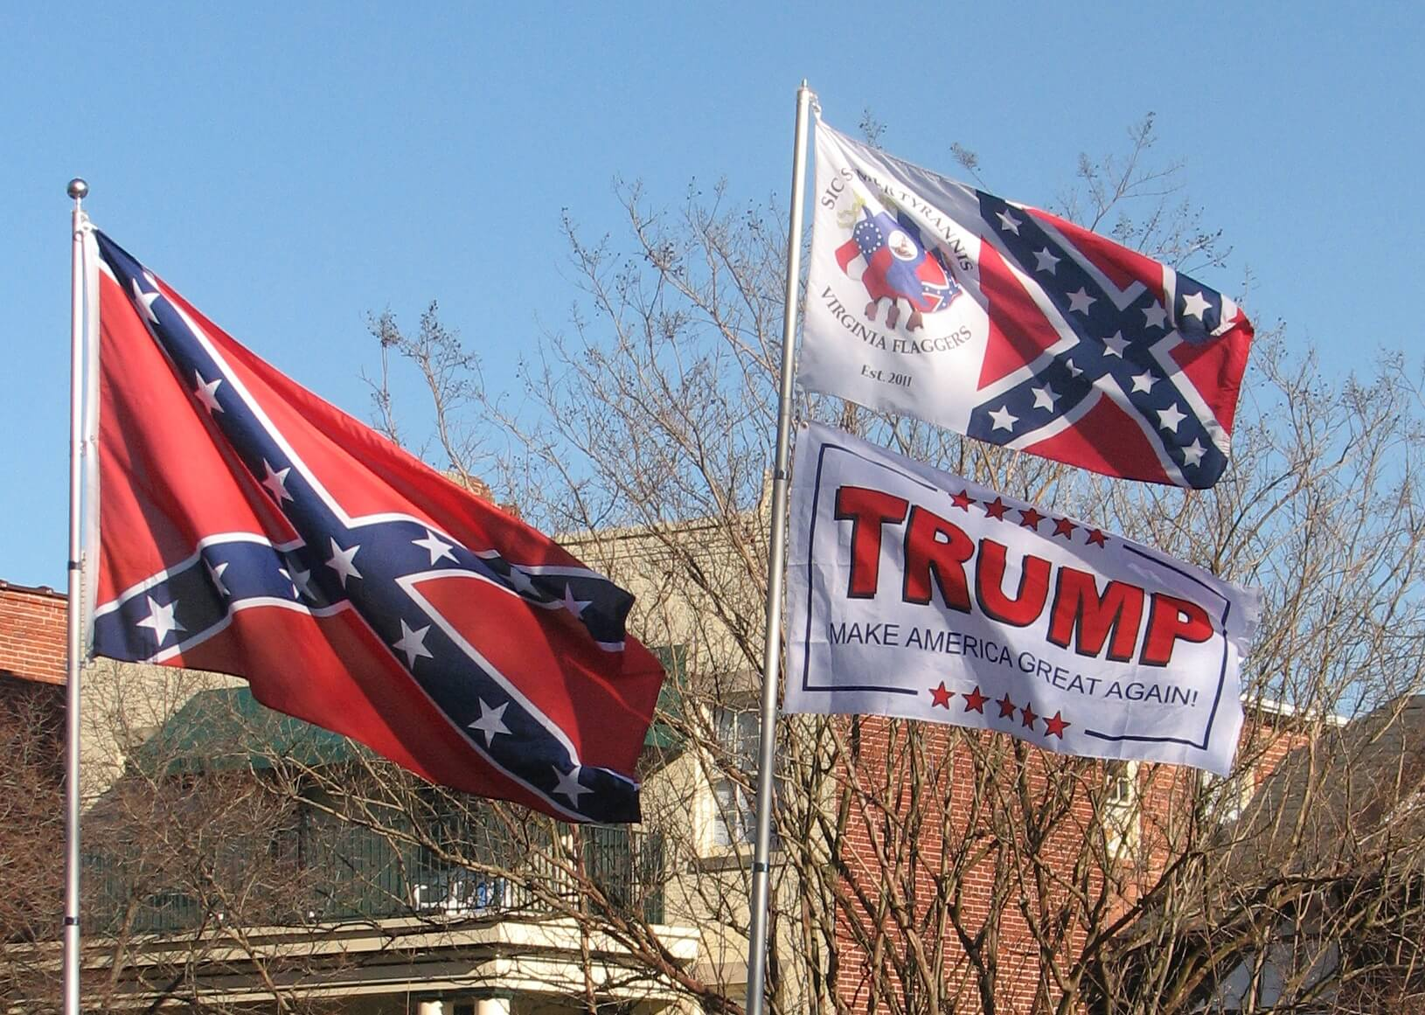](https://www.virginiamercury.com/wp-content/uploads/2019/02/ConfederateTRump_REX.jpg)The Virginia Flaggers hoisted rebel battle flags on Boulevard in Richmond in 2019. (Rex Springston/ For the Virginia Mercury)

## The flag still has a hard core of support**.**

John Whiting, who sells vintage paper items at Antique Village in Hanover County, said demand exploded for old postcards and magazines bearing the Confederate flag when Richmond’s rebel monuments started coming down this summer.

“It’s hotter than ever,” Whiting said of the flag. “Demand increases with volatile times. …People are buying them — I hear this explanation over and over again — before they are no longer available.”

President Donald [Trump defended the flag](https://www.cbsnews.com/video/trump-says-flying-confederate-flag-is-a-freedom-of-speech-issue/#x) to CBS News.

“Well, people love it,” he said, “and I know people that like the Confederate flag, and they’re not thinking about slavery. … I just think it’s freedom of speech, whether it’s Confederate flags or Black Lives Matter or anything else you want to talk about.”

A group called the Virginia Flaggers has put up Confederate flags in recent years on private property near major highways. In 2011, members began flying rebel flags regularly in front of the Virginia Museum of Fine Arts in Richmond to protest the museum’s removal of flags from the nearby Confederate Memorial Chapel.

The [Flaggers’ Facebook page](https://www.facebook.com/pg/The-Virginia-Flaggers-378823865585630/about/) says: “Flaggers speak for those who have no voice. …Our enemies are those who worship ignorance, historical revisionism and Political Correctness.”

[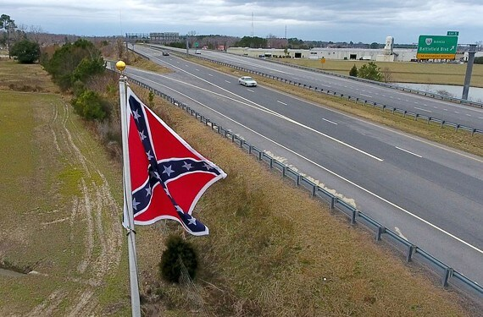](https://www.virginiamercury.com/wp-content/uploads/2020/07/confederate_flag.jpg)An 8-foot by 8-foot Confederate Battle flag was put up in 2017 along the Chesapeake Expressway by The Virginia Flaggers. (Style Weekly)

The group claims to have hundreds of followers. But the page recently listed [no future events](https://www.facebook.com/pg/The-Virginia-Flaggers-378823865585630/events/?ref=page_internal), and the Flaggers appear to have paused their museum protests.

“The last time we recall seeing the Virginia Flaggers protesting near (the museum) was in mid-May,” said Amy Peck, a museum spokesperson. “We don’t know whether the group has ended their protests.”

The Flaggers did not respond to messages seeking comment.

## These colors do fade

Coski, the flag-book author, said, “We’re moving toward a world in which the primary users of the Confederate flag are heritage groups” such as the Sons of Confederate Veterans, which uses flags mainly at private events, and the Flaggers, who “insist on putting big flags in people’s faces.”

“I think the flag’s  presence will decline to almost nothing, but never reach nothing,” Coski said. “That pattern has been clear for years.”

How does Coski feel personally about the incredible shrinking Confederate flag?

“I’ve not thought about it,” he said. “After studying  the flag for almost 30 years, I think I’ll be seeing it in my sleep even if I no longer see it in the wider world.”

++++++++++++++++++++++++++++++++++++++++++++++++++++++++++++

Books by Bill Teegarden

|  |  |  |  |  |  |  |  |
| --- | --- | --- | --- | --- | --- | --- | --- |
| |  |  |  |  |  |  |  | | --- | --- | --- | --- | --- | --- | --- | | |  |  |  |  |  |  | | --- | --- | --- | --- | --- | --- | | |  |  | | --- | --- | | |  | | --- | | of Note | |  |  |  |  | | --- | --- | --- | | |  | | --- | |  | | **James M. Dalzell, “Private Dalzell: His Autobiography, Poems and Comic War Papers” (Cincinnati, OH: Robert Clarke & Co., 1888).**  *\*Throughout 2021 the* | | | | |
| |  |  |  |  |  |  |  |  | | --- | --- | --- | --- | --- | --- | --- | --- | | |  |  |  |  |  |  |  | | --- | --- | --- | --- | --- | --- | --- | | |  |  |  |  |  |  | | --- | --- | --- | --- | --- | --- | | |  |  |  |  |  | | --- | --- | --- | --- | --- | | *\*Throughout 2021 the “Publication of Note” portion of the newsletter will highlight some of our director’s favorite histories and reminiscences published in the immediate decades following the Civil War.*  From his home in Caldwell, Ohio, slightly more than two decades after the Civil War’s end, James Dalzell fulfilled a promise he made to the “public” and published his autobiography. By the time of the book’s publication, Dalzell had been elected to various political posts in Ohio including prosecuting attorney for Noble County and member of the Buckeye State’s House of Representatives.   |  |  |  |  | | --- | --- | --- | --- | | |  |  |  | | --- | --- | --- | | |  |  | | --- | --- | | |  | | --- | |  | |   Courtesy of Bill Grant | | | | | | |

[Heather Cox Richardson](https://www.google.com/url?rct=j&sa=t&url=https://www.amazon.com/Civil-War-Heather-Cox-Richardson/s%3Frh%3Dn%253A4868%252Cp_lbr_one_browse-bin%253AHeather%2BCox%2BRichardson&ct=ga&cd=CAEYSCoUMTMxMDgxNjA0MzM1MjE0MTY0NDkyGmVjODEzZDliNmY2YmZhYzY6Y29tOmVuOlVT&usg=AFQjCNHnIkCZyKjnkcuIDGEO8A4tceRdFg)

[Kentucky By Heart](https://www.google.com/url?rct=j&sa=t&url=https://www.nkytribune.com/2020/06/kentucky-by-heart-amid-horrors-of-racial-intolerance-in-post-civil-war-ky-some-stood-and-said-no-more/&ct=ga&cd=CAEYCCoUMTM5MzIzOTk2MjgwMjgyNzAzMjEyGmVjODEzZDliNmY2YmZhYzY6Y29tOmVuOlVT&usg=AFQjCNExptGd7q93XkJfYvI5njwnnzXaMg)

[David Blight](https://www.google.com/url?rct=j&sa=t&url=https://mynorth.com/2020/06/pulitzer-winning-biographer-david-blight-at-national-writers-series/&ct=ga&cd=CAEYBCoTNTgzNTIyMzQ4NjgzNTMyMDMzMzIaYmFmYWNiYzIxYTg5YmViZTpjb206ZW46VVM&usg=AFQjCNG9WlSyV84M_JqY0t00qXGY23E-cA)

[Religion During the Civil War](https://www.google.com/url?rct=j&sa=t&url=https://www.albanyherald.com/features/creede-hinshaw-book-offers-a-fascinating-glance-at-religion-during-civil-war/article_91aa0684-bc63-11ea-87c6-0360af1bb5f1.html&ct=ga&cd=CAEYCSoTMzY2MzExMDgwMTYxNTU3OTE2MDIaZWM4MTNkOWI2ZjZiZmFjNjpjb206ZW46VVM&usg=AFQjCNEL5bnSuJCPc5vf5zRuBry0zxieBQ)

[Abraham Lincoln Books](https://www.google.com/url?rct=j&sa=t&url=https://www.lansingcitypulse.com/stories/dedria-a-humphries-barker-and-her-abraham-lincoln-books,14838&ct=ga&cd=CAEYCCoTODM5NzIzNTU5Njg3NTY0MzEzMzIaZWM4MTNkOWI2ZjZiZmFjNjpjb206ZW46VVM&usg=AFQjCNF6zJ0i7O-ZAe-syWH9deMg6LHfbw)

[William Faulkner](https://www.google.com/url?rct=j&sa=t&url=https://www.theatlantic.com/magazine/archive/2020/09/michael-gorra-william-faulkner/614206/&ct=ga&cd=CAEYASoUMTI5MzI4MjkyNjAyODc1NDczMzkyGmJhZmFjYmMyMWE4OWJlYmU6Y29tOmVuOlVT&usg=AFQjCNHazJePDkMth52cPALN2_vtJBmhjQ)

[Naval History](https://www.google.com/url?rct=j&sa=t&url=https://www.kentstateuniversitypress.com/category/subject/naval-history/&ct=ga&cd=CAEYTyoUMTc2MjU3NDgwOTI5Njk5NjkyMjUyGmVjODEzZDliNmY2YmZhYzY6Y29tOmVuOlVT&usg=AFQjCNGIKURfkiXmtysq_TTHfmRRd6QGUQ)

[Vermont Quakers](https://www.google.com/url?rct=j&sa=t&url=https://vtdigger.org/2020/08/09/then-again-vermont-quakers-faced-death-as-conscientious-objectors-during-civil-war/&ct=ga&cd=CAEYACoUMTE2OTkwMjIwMTUyNTg3NTQ5NTkyGmVjODEzZDliNmY2YmZhYzY6Y29tOmVuOlVT&usg=AFQjCNENNhAoKWsRXpBNkqdRxb_adlyymA)