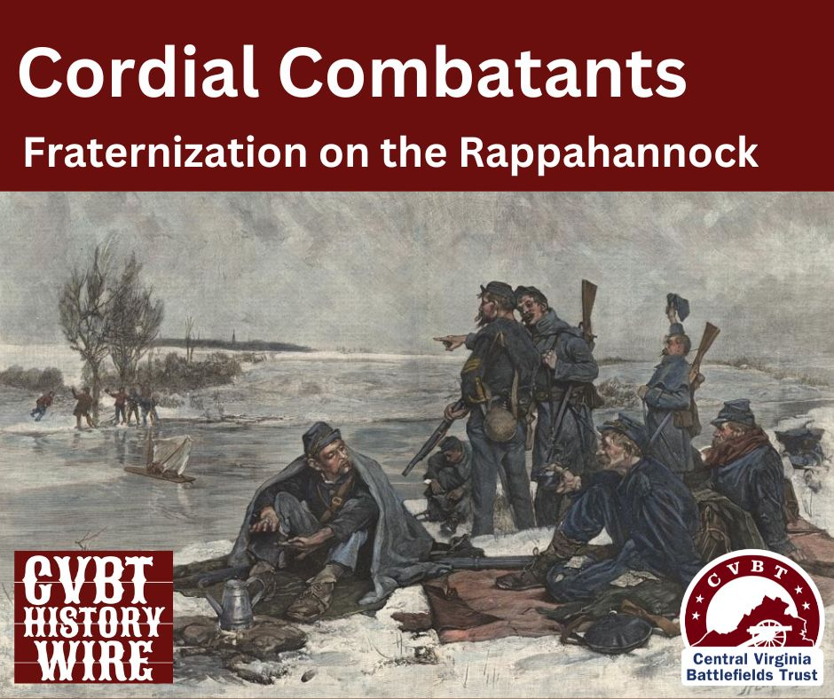

April, 1861 found two countries where there had been one, and this couldn’t remain. Forts that were U.S. owned had troops living inside but were on Southern ground, some states with slavery very active had not seceded, and the seven that had, were setting up a new government. President Lincoln was setting up his cabinet, trying to treat those seven as if they were still a part of the country that he was elected to govern.

And then on Friday, April 12, at 11 p.m., the cannons started. 34 hours later, Fort Sumter was forced to surrender.

On the 19th, as troops were headed into Washington D.C., riots in Baltimore broke out between civilians of the city and the Sixth Massachusetts. Harper’s Ferry was given up by the Federals to troops from Virginia and the Navy Yard at Norfolk was evacuated. State troops in North Carolina took over the U.S. Arsenal in Fayetteville, and Arkansas troops converged on Fort Smith.

Men were volunteering, money was flowing in, women were meeting with sewing groups to make clothes, communities volunteered to take care of the families of those who went off to fight.

Citizens from the North and South were fired up, with people thinking this was to be over in a few weeks and some soldiers fearful that they would miss out on the action. They were wrong.

The 2024 Field Trip is going to be held in September this year, to avoid potential colder weather, and it will be covering some of the battlefields in Virginia: Chancellorsville, The Wilderness, Fredericksburg, and Spotsylvania.

Chancellorsville is where “Stonewall” Jackson was mortally wounded; one of our stops will be to visit his arm. That’s what I said! The rest of his body is buried elsewhere in Virginia.
In addition to the battlefield in Fredericksburg, we will make a stop at Chatham Manor, a Union headquarters and field hospital.
At the Wilderness, we will see Grant’s headquarters, Ellwood Manor, and of course, the battlefield itself, where the fighting was so intense over two days. This battle ended in a tactical draw and the Union men expected that General Grant would withdraw as the others before him. Instead, he gave the orders to press on towards Spotsylvania, which h has been called the “best preserved” battlefield, with 7.5 mile of trails, weaving through the battlefield. There are reconstructed earthworks, just near the Harrison House.

This Field Trip will be a 3 day journey in mid September and should have beautiful scenery. We plan to stay in Fredericksburg overnight both nights while on the road.

Details are still in the works, so mark your calendars for Sept. 13th – 15th.

Our May meeting will be held in Marietta, with a presentation by Robert Wallace on Frederick Douglass’s travels in Ohio. This will be May 16th.

On Saturday, May 18th, we will be holding a marker dedication in front of the Fearing House, in conjunction with the Fearing House Museum and the Washington County Historical Society. The Fearing House will be open for your visit and I have heard that several new exhibits will be on display. This ceremony will start at 11 and refreshments will be served.

July 13th watch for the first ever History in the Park, immediately following the Sons of the American Revolution ceremony at the Northwest Ordinance monument in Muskingum Park. We have invited history organizations from easter Ohio and western West Virginia, along with reenactors to display their camps, food vendors, and more. Plus we are arranging tours of the First Congregation Church, located across from the park on Front Street.

Then, on August 3rd , we will dedicated the newest and latest marker to Rufus Dawes. This dedication will be held at the First Congregational Church.

Details for all of these events are still in progress – please get involved! We welcome your help with any one of these or all of them; much planning and work goes into the details for all of our activities. Call Nancy at 740-525-7479 and ask what you can do.

