HARDSCRABBLE
Civil War Round Table of the Mid-Ohio Valley Newsletter
August 2022 – Vol 20

Notes by Nancy Arthur
In all the times I’ve gone to Gettysburg, I find things new to me plus the favorites that the trip wouldn’t be the same without seeing. And this in spite of my youngest son telling me “Spoiler alert – the North won” and “There is nothing new”. Well, there is!

If you make it to this very special place, check out the Ticket To The Past. Located at the famous train station where Lincoln rode into town to give his Gettysburg Address, there is now a virtual exhibit.

In 2007 the Gettysburg Foundation took over the historic building from the NPS. Assorted programs and displays have been on view since then. The virtual exhibit is to interest the younger generation. Visitors can “meet” 3 people who were there during the battle and listen to their experiences.

Eli Blanchard was 18 and a member of the 24th Michigan (the famous Iron Brigade) as a musician. He assisted his wounded partners located in the train station, after turning it into a medical location.

Cornelia Hancock rode into the train station from New Jersey simply to aid and assist the wounded.

And Basil Biggs was a local African American who reburied Union soldiers at the new Soldiers’ National Cemetery.

This exhibit just opened at the end of April.

And the Spangler Farm has been open a couple of years but is still an interesting visit, with new programs listed through October.

Also new to the town is the Children of Gettysburg 1863 Museum, located on Baltimore Street, across from the Inn of 1863.

And of course, improvements are being made to Devils Den, where paths had eroded and to Little Round Top, making it safer after many years and many, many visitors.

Plus there is a new exhibit at the Visitors’ Museum and Welcome Center: A Day in the Life of a Soldier; I intend to check on my next trip to Gettysburg!

Stories by Bill Teegarden

Tour the tunnels below Cleveland’s Soldiers’ and Sailors’ Monument
The Soldiers’ and Sailors’ Monument has been a prominent fixture in Downtown Cleveland’s Public Square since its dedication in 1894. The structure’s 125-foot column, once one of the tallest in the city, is surrounded by four bronze large-scale groupings that depict the four branches of the military. The interior walls bear the names of 9,000 men from Cuyahoga County who fought during the Civil War.
While the monument is open year-round to visitors, there’s a part of the structure that’s only shown once a year and draws in crowds from near and far. The annual “Tunnel Tours” were back this past weekend after a two-year hiatus due to the pandemic.
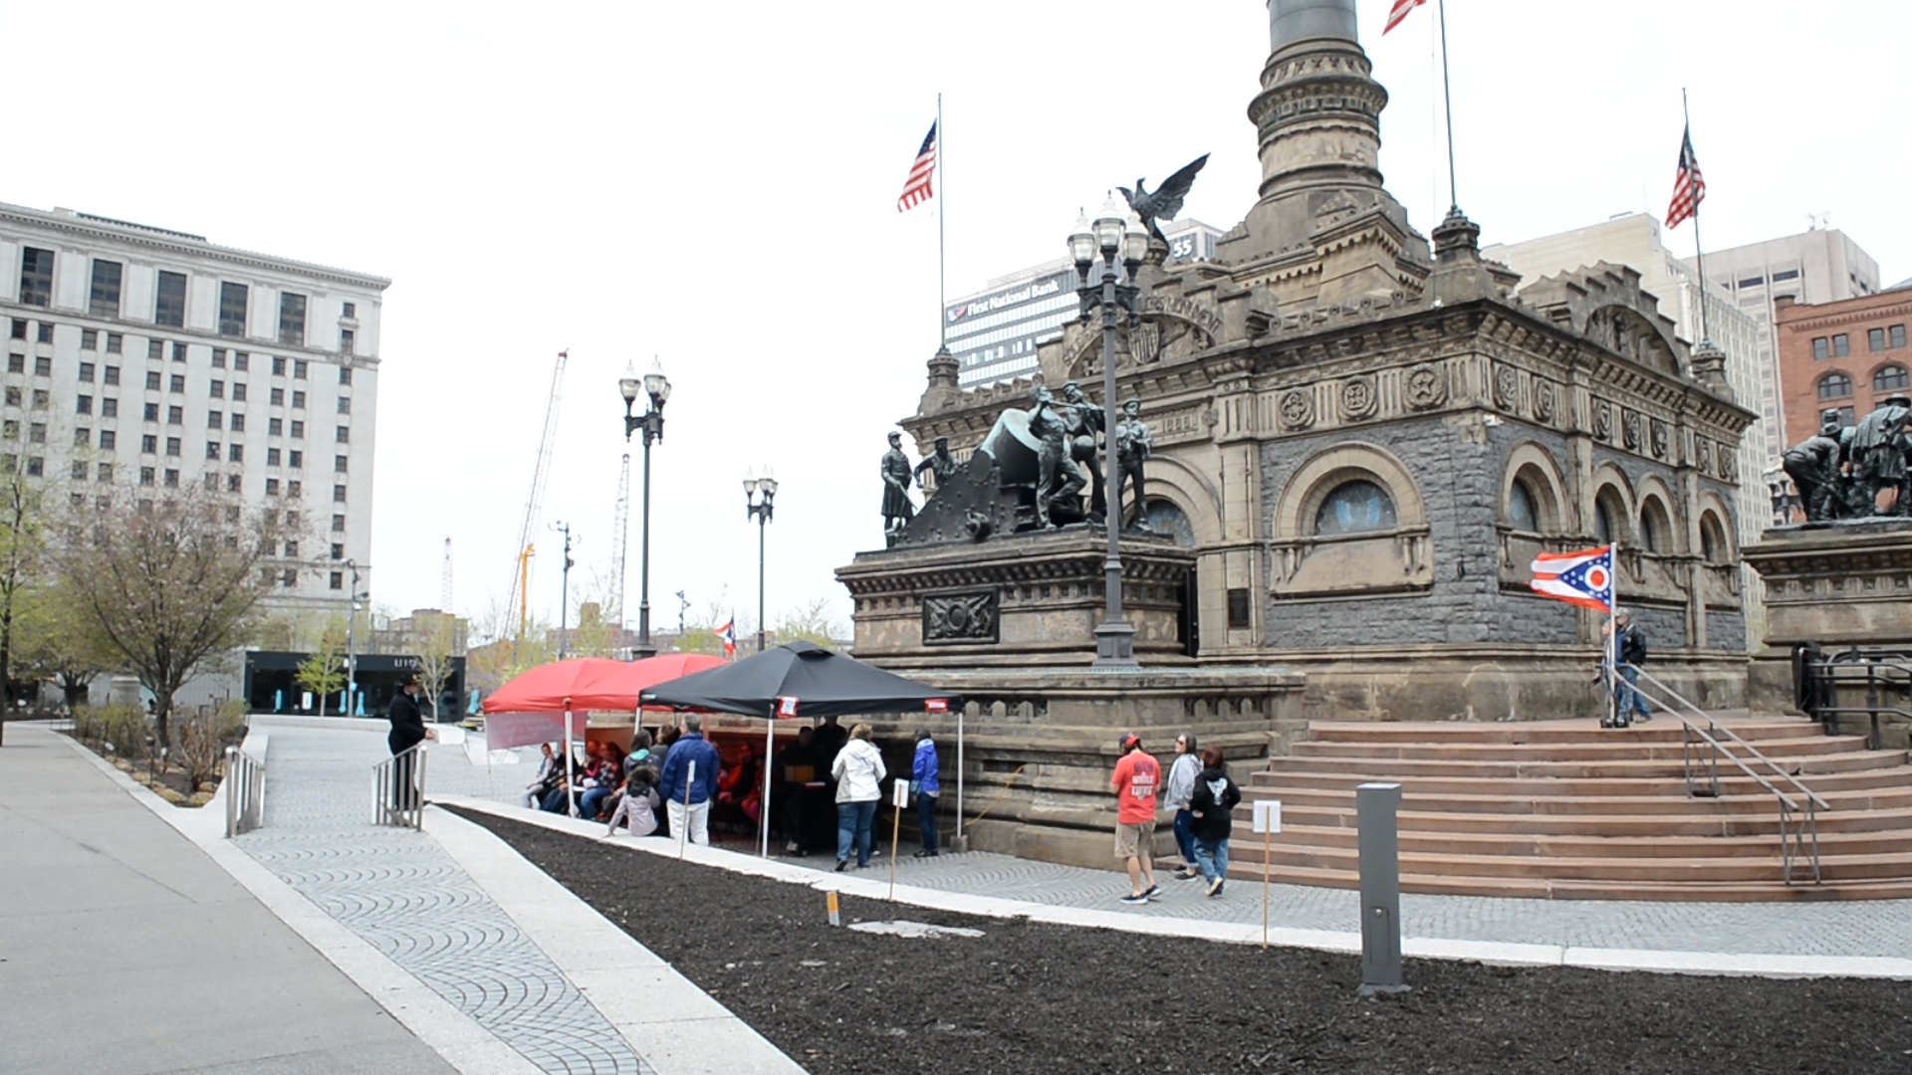
Greg Palumbo, executive director of the Soldiers’ and Sailors’ Monument, said people often ask: “Are they connected to other tunnels? Where can I go to with those tunnels? What were they used for? Why are they there?”
Many myths and legends have developed over the decades, creating a sense of mystery and intrigue. One popular theory is that the tunnels were part of the Underground Railroad, which doesn’t quite check out.
“The Underground Railroad was during the Civil War, and we were built about 30 years after,” Palumbo said.
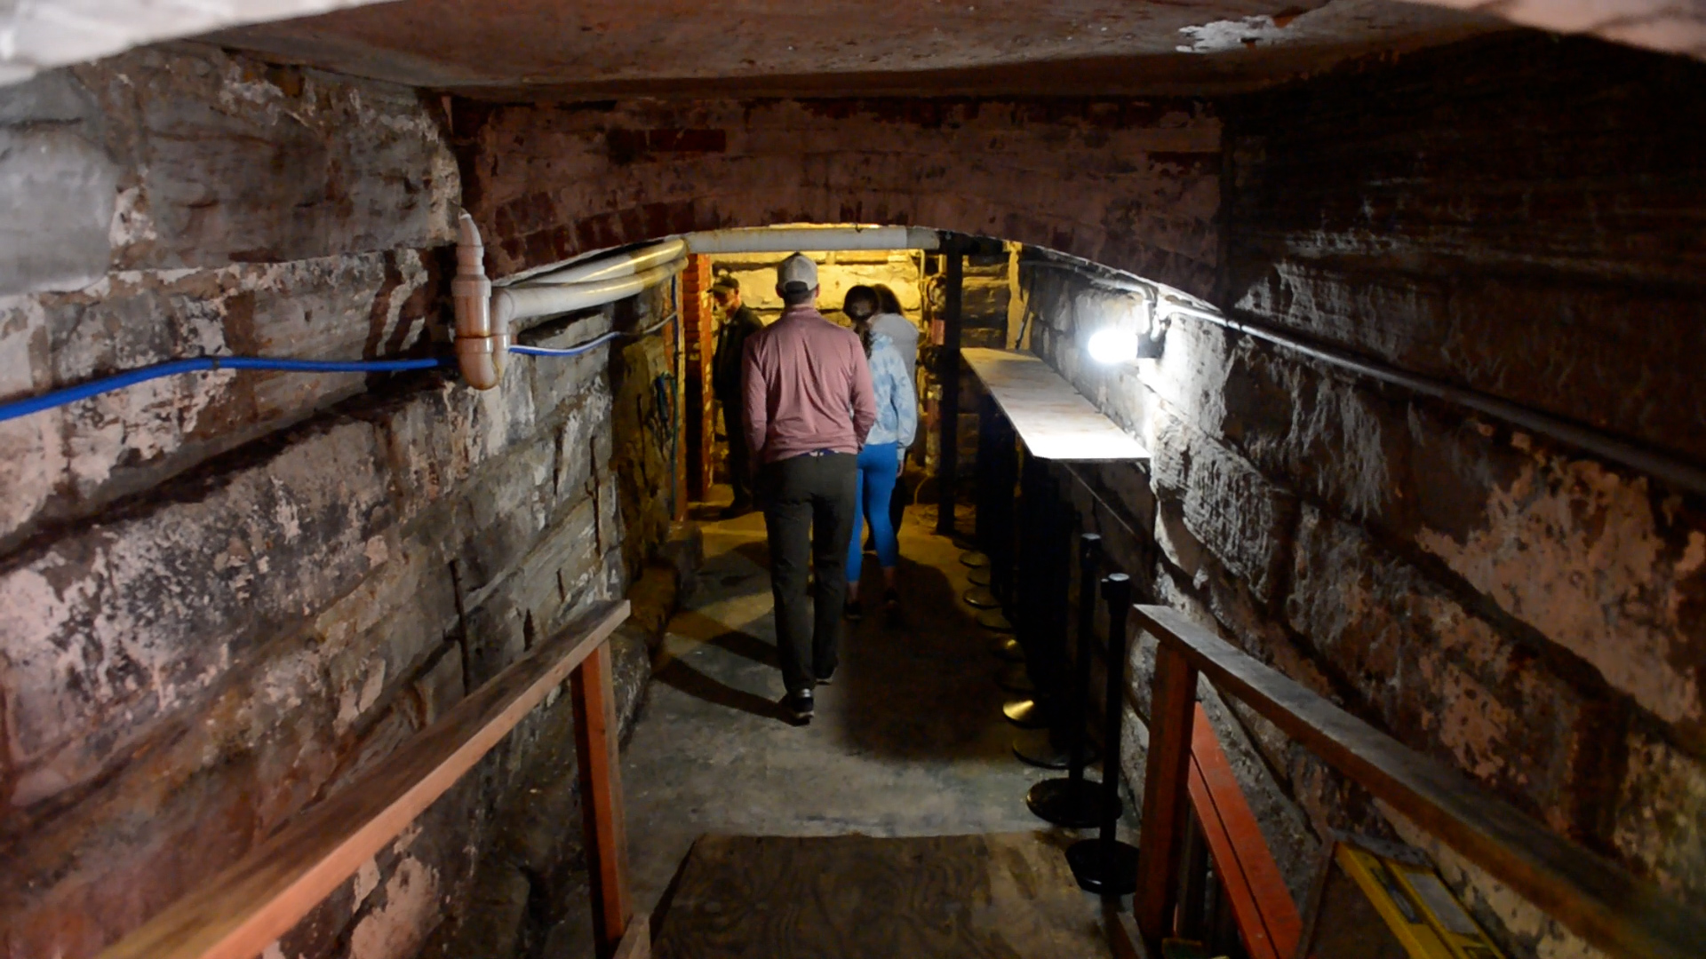
The tunnels under the monument run in concentric circles around its base and actually don’t connect to anything else. They were built during the construction, which began in 1891.
Another legend is that the tunnels connect to a series of underground passageways that run throughout Public Square.
“You see somebody go down into a manhole to deal with steam, or you knew someone who worked in a building, which my mother did, who could walk from E. 9th all the way to Public Square through a tunnel,” Palumbo explained. “Everybody’s heard of these tunnels, but not everybody’s been in them, so they don’t know what connects to what.”
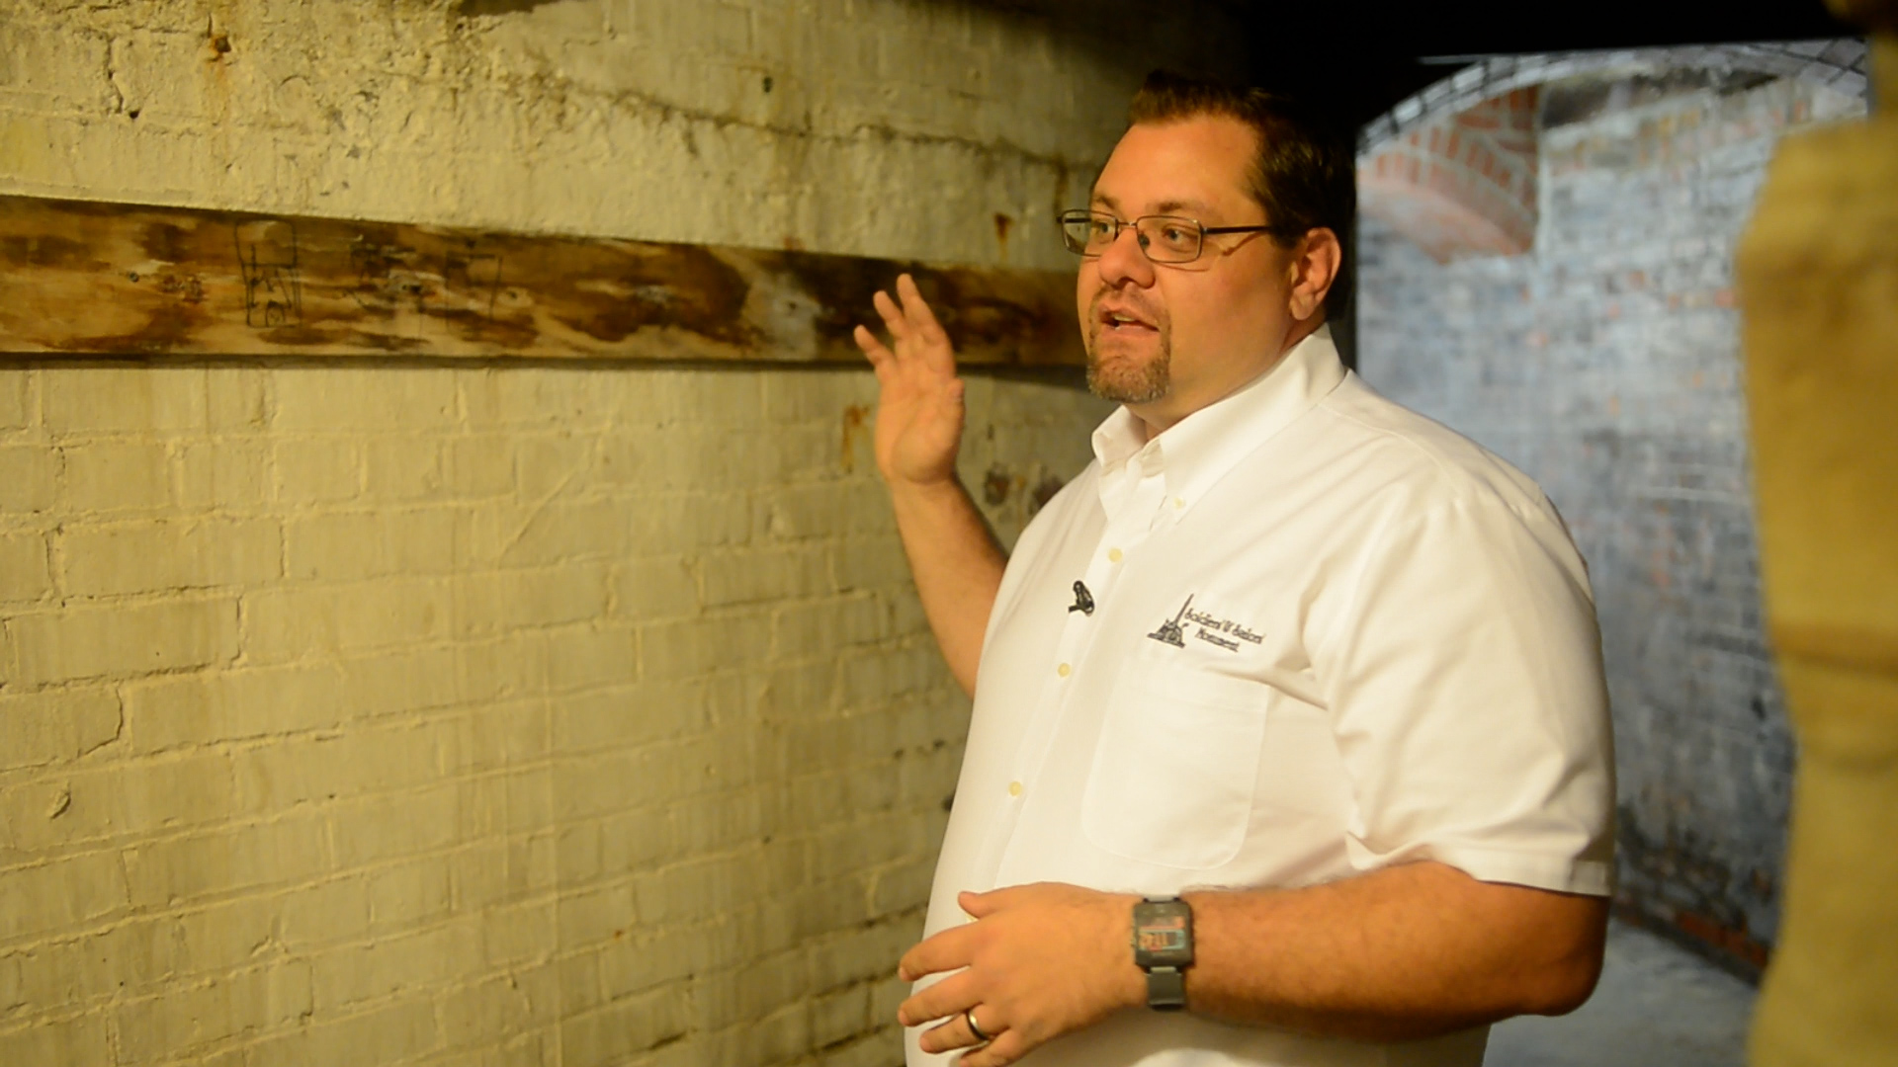
The tunnels under the monument run in concentric circles around its base and actually don’t connect to anything else. They were built during the construction, which began in 1891.
“We have two types of tunnels that run underneath the monument,” Palumbo said. “Under the outside, we have tunnels that hold up the decking, and they're made of archways and walls. The arch holds up every seam of the big stone slabs that make up the walkway around all of the statues on the outside.”
Below the interior of the monument are the inner tunnels, made of Roman style barrel vaults – thick archways that hold up the stone walls, flooring and statuary.
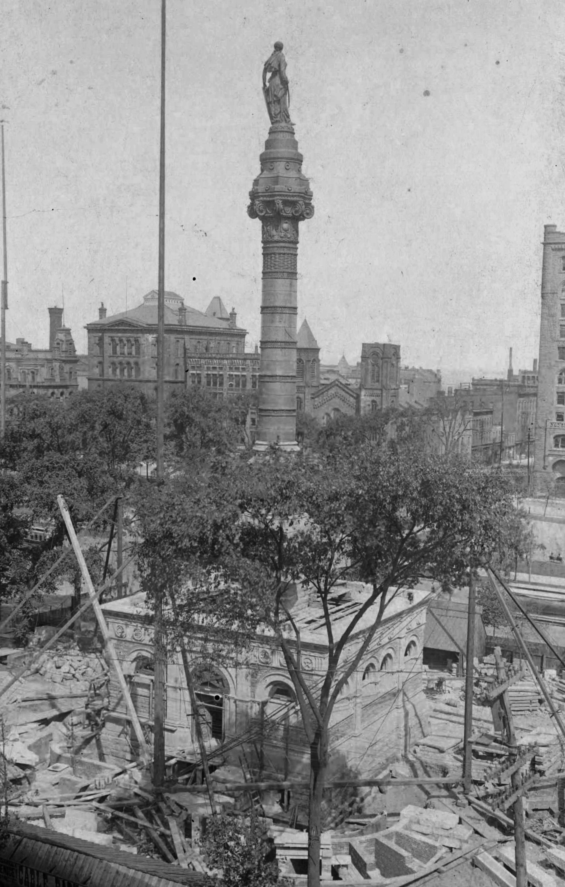
Palumbo said a lot of the intrigue surrounding the tunnels is because they’re a part of the monument that people usually don’t get to see.
“A lot of those different myths or legends are what draw people in,” he said. “And then we hope that they’ll learn a little bit about the engineering of the monument and a little bit about what we’re here to honor, which are the men on the walls.”

Up, Up, and Away!: The Balloon Corps During Civil War
by SOFREPMay 24, 2022
SHARE THIS:
FacebookTwitterLinkedIn
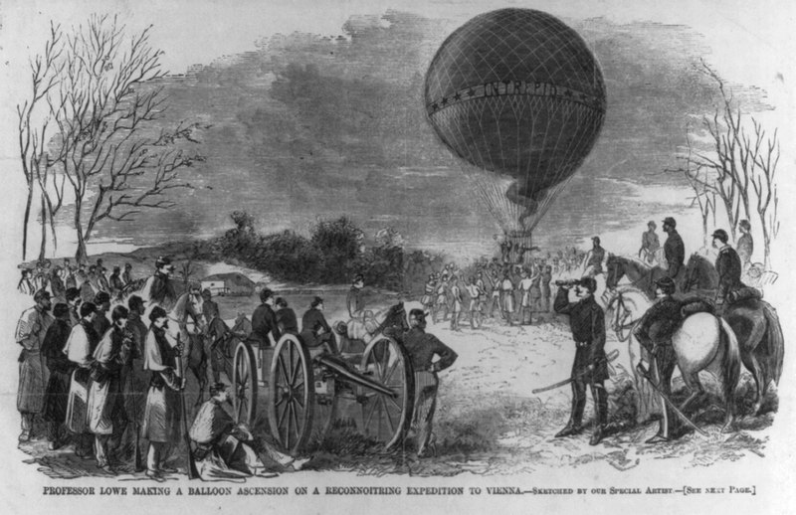
Prof. T. Lowe making a balloon ascension on a reconnoitering expedition to Vienna, Va. Abstract/medium: 1 print : wood engraving. (Miscellaneous Items in High Demand, PPOC, Library of Congress, Public domain, via Wikimedia Commons)
Before a formal Air Corps was conceived by the US military, the Union Army came up with the idea of utilizing air balloons during the American Civil War. Although they had not fully utilized the capabilities of air space in terms of gaining an advantage over enemies, they managed to use the balloons as a primitive means of forward observers and reconnaissance. The birth (and death) of the Balloon Corps would be the base of what soon would become the Air Force that we know.

Chief Aeronaut
The idea of using balloons during the American Civil War came from highly educated and respected scientist and inventor Thaddeus Lowe. Before the war broke out in 1861, he was making use of his time in preparing for a transatlantic crossing with the use of a balloon. When the Civil War ensued, Lowe thought these balloons could be utilized on the battlefield. He shared the idea, and US President Abraham Lincoln saw the balloons’ potential and gave it a green light.
This, however, was not the first time that balloons would be used for military purposes, as the French also used them during the French Revolutionary Wars in 1792.
At that time, a formal Air Corps was still around 50 years away, and the US government had not dealt with anything like that yet, so they decided it would be best to combine all related activities into a specific unit to be led by someone who had vast knowledge and plenty of experience in the field. This, of course, was Lowe.
With Lowe’s well-respected reputation, he was designated by the government as the “Chief Aeronaut.” He was invited to Washington D.C. to demonstrate the use of the balloon to President Lincoln. Lowe boarded his balloon and rose to about 5,000 ft above. With his telegraph, he started to describe his view to the president below. Lincoln was impressed and decided for Lowe to lead the Balloon Corps as Chief Aeronaut.

Balloon Corps Went to War
Before 1862, the Balloon Corps of the Union was already up and all set.
The Balloon Corps saw little action during the war, but they were perfect in providing an exceptional vantage point, especially in observing the enemy activities. The general in command was the one to decide how the balloons would be used, and most of them did not really see the importance of these air balloons.
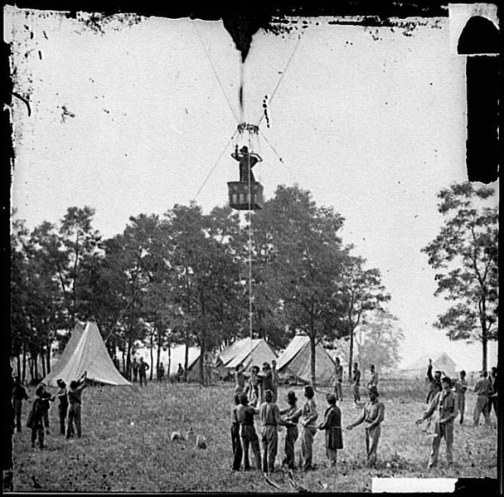
Fair Oaks, Va. Prof. Thaddeus S. Lowe observing the battle from his balloon “Intrepid” (Civil War Glass Negatives, Public domain, via Wikimedia Commons)
In total, the Union Balloon Corps had seven different balloons that they operated. The larger ones, like the Intrepid and the Union, could carry up to five people. It could contain around 32,000 cubic feet of lifting gas supplied by hydrogen generators, with the downside being it needed quite a long time to inflate and take flight. Hydrogen is also highly flammable and the telegraph used electricity to operate. The guys who went up in these balloons were taking quite a risk
On the other hand, the smallest one could carry one person but could be prepared in a short period of time.
The observer in the air balloon, during a battle, could see the entire battlefield and report necessary information to the army below through telegraph. In 1861, Lowe effectively utilized the balloon when he manned one near Washington D.C. to direct artillery fire on an enemy position. He used flags to signal and direct adjustment to the artillery that the rounds were soon landing accurately on enemy positions.
General Fitz John Porter had quite a different experience. He was also from the Union side who also realized the value of balloons in winning the war. He joined Lowe to experience the reconnaissance platform. Now, it’s important to note that these balloons were always attached to the ground using tethering rope to prevent them from drifting away. One time, Porter decided to use only one tethering rope to speed his way up instead of the usual three or four, as per Lowe’s suggestion. This resulted in that single rope snapping and his balloon drifting toward the Confederate lines below. The Confederate soldiers fired a few shots but thankfully, for Porter, his balloon drifted back to the Union position.

Gone with the Wind
The journey of the air balloons and the corps started to die down when Lowe caught malaria in mid-1862. When he returned after his rest and recovery, he found out that all of his equipment and resources for operating the balloons were given back to the Army.
Due to some pay disputes and eventually not becoming the Union Army’s favored scientist, Lowe decided to resign and leave the Balloon Corps in May of 1863. The Balloon Corps was still up by then, and controls were transferred to the Allen brothers instead. The brothers, however, were not able to lead the units as well as Lowe, so before that year ended, the Balloon Corps was already gone with the wind.
Books by Bill Teegarden
To OPEN HYPERLINKS with PC -place cursor on Subject line, hold down Control and Left Click mouse / with Smart Phone – touch with finger or stylus
New Perspectives on The Civil War
Finding Paradise
It Happened in Windham
William Faulkner’s Civil War
The Kidnapping Club
The Silver Bugle
Faces of Civil War Nurses
The Loyal Republic
An Environmental History of the Civil War
Monument Myths
The Woman's Fight
CW Author Roy Morris Jr. & 9 Books
Landmines in the Civil War
Journal of the Shenandoah Valley # 4
Tecumseh and the Prophet
Disorder on the W. Virginia Border
South to Freedom
Make Way For Liberty
My Dear Mother - Dedham Bros.
Twenty Books on Racism
The Black Civil War Soldier
Every Drop of Blood
Civil War History
Civil War Hospitals in Gettysburg

