Special Note: if you no longer wish to receive emails from the Civil War Round Table, send a request to cwrtmov@gmail.com and you will be removed from our mailing list.
HARDSCRABBLE
Civil War Round Table of the Mid-Ohio Valley Newsletter
January – Vol 27

Notes from Nancy Arthur
January was a busy month during all of the years of the Civil War, starting January 9th, 1861. Mississippi seceded first, followed by Florida, Alabama, Georgia and Louisiana. But the Union gained a state with Kansas being admitted as the 34th state.

Five senators gave farewell speeches in Congress. And Abraham Lincoln was preparing to move to Washington D.C. from Springfield.

Moving to 1862, The Confederate Army, under Stonewall Jackson, moved from Bath, located in western Virginia to Hancock, Maryland and bombed the town for two days, then turned their sites on Romney in the western part of Virginia.

General McClellan dealt with symptoms of what was thought to be typhoid fever.

The U.S. Senate confirmed Stanton as the Secretary of War; as a critic of Lincoln and a supporter of McClellan, Stanton became one of the most controversial persons of the war.

In the opening weeks of 1863, the Emancipation Proclamation was signed by President Lincoln.
General Joseph Hooker took command of the Army of the Potomac, taking duties from General Burnside.

The organization of the first regiment of the Union Negro S. C. soldiers was completed on the coast.

General Grant took command of the march on Vicksburg.

This sounds familiar – 1864 started with extreme cold weather over most of the country!

Southern newspapers report positive news to the Southern people to boost their spirits, despite negative news in many areas.

President Lincoln began intense focus on reconstruction in individual states.

Pro-Northern citizens of Tennessee met to propose the abolition of slavery.
Lincoln approved a policy that plantation owners would free their slaves and hire them at a fair wage.

1865 found Republican J.M. Ashley promoting – again – the 13th Amendment , to abolish slavery. This had passed in the Senate but not the House.

The Constitutional Convention of Missouri adopted an ordinance to abolish slavery.

General Sherman was still on the march, now headed northward from Savannah.

And the fight goes on….

^^^^^^^^^^^^^^^^^^^^^^^^^^^^^^^^^^^

Kudo’s for Scott Britton
One of the Mid-Ohio Valley Civil War Round Table founders, long time president, and narrator on our field trips, Castle Director Scott Britton, was recently awarded the Historic Preservation Recognition Award by the Blennerhassett Chapter, NS DAR.

“This award recognizes and honors an individual or group that has done remarkable volunteer work at the community level. The award may be presented to DAR members and non-members and recognizes achievements in all areas of historic preservation.” It includes writings… serving as historical guides, interpreters, or docents.”

Britton is asked to present local history at a variety of venues across Ohio and beyond. He writes articles for various publications, is involved in working on the church archives at the First Congregational Church on Front Street in Marietta, assists in the programs of the Mid-Ohio Valley Civil War Round Table, researches history for various groups and individuals, participates in patriotic celebrations for Memorial Day, 4th of July, and Veterans’ Day, often in uniform.

He has volunteered for various organizations, including SAR, CWRT, WCHS, CVB, and the First Congregational Church, while also working full time as Director of The Castle.

And his most time-consuming research is done for the Round Table field trips. He narrates on the trip to provide the guests with background on the various places we visit, as well as those local soldiers who fought at those destinations but didn’t make it home.

These field trips are used as fund raisers, which provide funds for our historical marker programs throughout the community.

Congratulations Scott – well deserved!

Kudo’s for the Round Table

From the Marietta Times Letters to the Editor 12/7/23 from Sharon Powell

I want the general public to be aware of a great organization: The Civil Round Table of the Mid Ohio Valley. There are no dues, the meetings are every other month with a speaker covering a specific topic (donations accepted), and the meetings, times, and locations are published in The Marietta Times.
My husband, Sam, and I just recently returned from a trip organized by the Round Table. The trip was five (5) days and four (4) nights into and around South Carolina where we visited Civil War and Revolutionary War sites. We all learned something new by visiting Camden, Mt. Pleasant, Sullivan’s Island, Forts Moultrie and Sumter, Charleston, Beaufort, the Cowpens, and Salisbury, South Carolina. Learning about the H.L. Hunley submarine was also memorable. The planning committee did a wonderful job and the itinerary was followed. The weather was great with rain falling only when we were on the bus. The motels/hotels were first rate with complimentary breakfasts. Brewster Travel provided the “kneeling” bus and the driver was very accommodating and friendly.
The next meeting of the Civil War Round Table should be in January near the middle of the month. Look for the notification in the “Meetings” section.
Stories from Bill Teegarden

Queen City Crime: A boat built in Cincinnati carrying Civil War prisoners exploded in 1865
Amber Hunt
Cincinnati Enquirer
View Comments
AD
0:04
The Cincinnati region has been connected to monumental crimes and criminals in years past. Here is a look at one of them.
The hook: A Cincinnati-built steamboat exploded in April 1865, killing some 2,000 people in what remains to this day the worst maritime disaster in the history of the United States.
The SS Sultana was a 260-foot wooden-sided steam transport built in 1862 at the John Litherbury Shipyard on Front Street in Cincinnati. The factory is long gone, but a plaque about a mile from where it once stood commemorates the disaster and the role Cincinnati played in it.
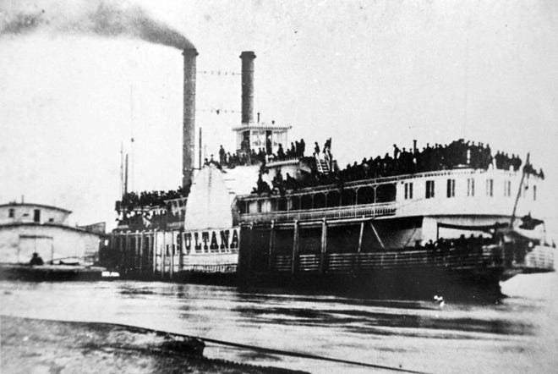
“In the mid-19th century, Cincinnati was a major (riverboat) construction site,” Barbara Dawson, then a librarian at the Cincinnati Historical Society, told The Enquirer in 1999 when the plaque was proposed by history buff Chris Heather.
“Cincinnati’s role in the (Civil) War has always been downplayed,” Heather said. “The city had a number of factories that cast cannons, Cincinnati supplied many soldiers, including my own great-great-grandfather.”
While exploding steamboats weren’t unheard of at the time, the Sultana disaster immediately stood out: Not only was the boat filled well beyond legal capacity with Union prisoners of war eager to return home, but the decision to pack so many aboard one steamboat was made by military men promised financial kickbacks for doing so.
The steamboat: Sultana was a “mammoth looking craft for these times,” according to an 1862 Cleveland Daily Leader story announcing that the steamboat was “fitted out and ready for sea” and about to embark on its first trip.
A few months later, the newspaper noted the boat had hauled “the largest cargo ever taken from the Saginow (sic) valley” when it passed by with 750,000 feet of lumber.
Steamers were novel enough in the mid-19th century that local newspapers announced their arrivals and departures so people could line the river to watch. While the first steamboat was built by a Scotsman toward the end of the 1700s, the first successful U.S.-built steamboat came from Robert Fulton in 1807. As the decades passed, the boats got bigger, requiring more and larger boilers, which always posed an explosion risk.
The biggest danger facing steamboats was boiler explosion,” according to “A History of Steamboats,” published by the U.S. Army Corps of Engineers. “If boilers were not carefully watched and maintained, pressure could build up in the boiler and cause a spectacular and deadly explosion.”
The victims: The Sultana, initially intended to haul cotton along a regular route between St. Louis and New Orleans, was only approved to carry a regular crew of 85 and 376 passengers. And yet, when disaster struck, the boat had nearly 2,500 people aboard, plus dozens of horses, mules and hogs.
The reason for the overcrowding came down to money and opportunity. As the Civil War ended in April 1865, thousands of federal prisoners who were held at Confederate prisoner of war camps in Alabama and Georgia were paroled and brought to Vicksburg, and they hoped to head home. The U.S. government paid between $5 and $10 per prisoner to riverboat companies willing to take on the passengers. That government money trickled down to riverboat captains who were given a per-soldier bonus payment to jam as many prisoners aboard their boats as possible.
That’s how the Sultana came to be so overfilled. Its captain, James Cass Mason, stood to pocket at least $700 – or more than $13,000 in today’s money.
The blast: Capt. Mason not only erred when he agreed to take on far more passengers than the Sultana was allowed to carry, but he did so knowing that two of his four boilers had been giving him trouble. He had them repaired twice in recent voyages, and before the boat reached Vicksburg, where the prisoners of war were set to board, they gave out again. A local boilermaker found a bulge in the middle larboard boiler that was bad enough that he was amazed the thing had made the trip from its prior stop, New Orleans. Capt. Mason refused the boilermaker’s plea to dock a few days to give him time for a proper repair. Instead, the boilermaker slapped on a patch and watched as Mason refused to divert his stream of passengers to other steamers able and willing to take on some of the prisoners, too.
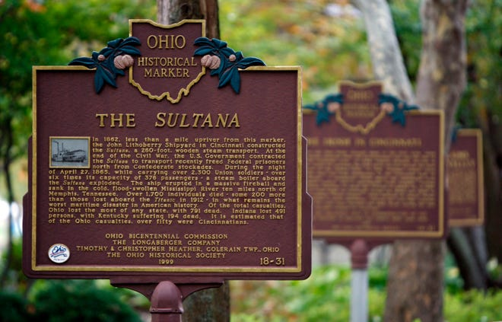
At 2 a.m. April 27, 1865, a few miles north of Memphis, Tennessee, as the thousands of passengers huddled awkwardly in hopes of getting some sleep, the patch affixed to the larboard boiler blew, causing two more boilers to explode simultaneously. Hundreds of people were instantly killed, while others awoke in the water disoriented. Most didn’t know how to swim and were in poor health from years as prisoners, making surviving the Mississippi River’s frigid water nearly impossible.
The alligator: This part of the story sounds made up, but it’s true: Aboard the Sultana was a pet alligator named Sal that the crew kept in a sturdy crate. A private named William Lugenbeal remembered that crate, sought it out, and killed Sal with a bayonet. (He apparently decided that tossing a live alligator into the river with drowning men would be ill advised.) Then he threw the crate into the water and rode it to safety. There’s a Sultana-devoted museum in Marion, Arkansas, outside Memphis, that still sells Sal the Alligator toys to this day.
The aftermath: Capt. Mason wasn’t injured in the initial explosion but apparently knew that he was at least in part to blame for the blast. Survivors reported seeing him tearing off pieces of wood from the wreckage and throwing them into the water for survivors to cling to. He was never seen leaving the wreck, apparently going down with his ship at 34 years old.
One of Mason’s superiors, Lt. Col. Reuben Hatch, was spared legal charges (or court-martialing, in military terms) largely thanks to his brother, Ozias Mather Hatch, who served as Abraham Lincoln’s Illinois Secretary of State. Lincoln had previously written letters of support when Reuben Hatch had been repeatedly accused of scheming to steal tons of money from the government. Although Lincoln had been assassinated two weeks prior to the Sultana’s explosion, Ozias Hatch still had considerable pull with the powers that be.
Another of Mason’s superiors – Capt. Frederick Speed – was the only one who couldn’t avoid a court martial. Speed was in charge of properly documenting which prisoners of war were boarding the Sultana but he decided to cut corners. Instead of carefully preregistering each prisoner, he opted to let them check in as they boarded, which led to hundreds more being allowed aboard than expected. Speed’s sloppiness initially got him convicted, but that was later overturned. No one else was ever tried for the disaster.
The tally of dead has never been confirmed – The Enquirer in 2011 put the count at around 1,800 – but most estimates put the count above 2,000. Only about 900 people survived, and that figure isn’t definite either because some 200 of the soldiers initially marked as survivors ended up dying from their injuries before ever making it home to their loved ones.
Enquirer journalist Amber Hunt is host of the podcast "Crimes of the Centuries" and co-founder of the Grab Bag Collab podcast network.

^^^^^^^^^^^^^^^^^^^^^^^^^^^^^^^^^^^^^^^^^^^^^^^^^^^^

A Tribute to Charley King: The Youngest Casualty of the American Civil War
September 14, 2023 - by Aiden Alexander
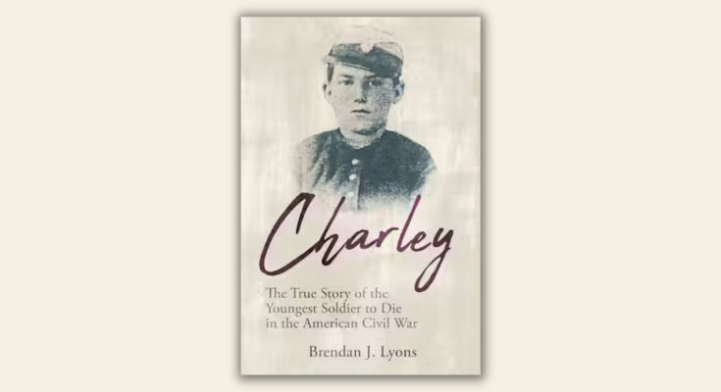Submitted Image
In every war, there are stories that captivate us, stories of courage, determination, and sacrifice. One such story is that of Charley King, a 12-year-old boy from West Chester, Pennsylvania, who became the youngest soldier to die in the American Civil War. His remarkable tale has been meticulously researched and brilliantly narrated by local author Brendan Lyons in his book Charley: The True Story of the Youngest Soldier to Die in the American Civil War.

Unveiling the Monument
Lyons first encountered Charley’s story as part of his Eagle Scout project. With assistance from the Bradbury Camp of the Sons of Union Veterans in West Chester, he launched a fundraising campaign to erect a monument in honor of Charley. Today, the monument stands proud in Greenmount Cemetery, an enduring symbol of Charley’s sacrifice. However, the exact location of Charley’s final resting place remains a mystery.

Delving Deeper into Charley’s Story
Intrigued by Charley’s tale, Lyons embarked on a journey to uncover more about this young soldier. His extensive research culminated in a book, released on July 15th, 2023, which is a riveting blend of narrative non-fiction and historical documentation.
Drawing from numerous historical references, Lyons traces Charley’s path from enlistment to his death at the Battle of Antietam. Despite the scarcity of direct references to Charley’s activities during this time, Lyons meticulously constructs a vivid portrayal of Charley’s experiences.

The Journey of a Young Soldier
The book begins in West Chester, where 12-year-old Charley, sensing the impending war, leads his neighborhood children in marching around town. When a neighbor, Benjamin Sweeney, decides to form Company F to join the 49th Pennsylvania Infantry, Charley’s persistence convinces his parents to allow him to enlist.
Charley’s story unfolds as he marches with the Army of the Potomac, experiencing grueling marches, fierce battles, loss, sickness, and fear. His life tragically ends at the Battle of Antietam, marking the end of the journey for the youngest soldier to die in the Civil War.

Unveiling Charley King
Charley: The True Story of the Youngest Soldier to Die in the American Civil War by Brendan J. Lyons offers an in-depth look into Charley King’s life. The book has received rave reviews, with Argunners.com praising it for its engrossing depiction of the Civil War era. It also comes highly recommended for young readers, making it a valuable addition to middle school, high school, and community library collections.
Brendan Lyons hails from Downingtown, Pennsylvania. He is a proud alumnus of Villanova University, where he earned a degree in History Education. His passion for history led him to Charley’s story in 2004, and he has since dedicated his efforts to honoring Charley’s memory.
As we approach the anniversary of the Battle of Antietam on September 17th, let us remember the bravery and sacrifice of the young Charley King, whose story serves as a stark reminder of the harsh realities of war.
Interested in delving into Charley’s fascinating story? Charley: The True Story of the Youngest Soldier to Die in the American Civil War is available for purchase on Amazon. For more information about the book and the publisher, visit the publisher’s page.
++++++++++++++++++++++++++++++++++++++++++++++++++++++++++
To OPEN HYPERLINKS with PC -place cursor on Subject line, hold down Control and Left Click mouse / with Smart Phone – touch with finger or stylus

Books from Bill Teegarden
Lincoln and The American Struggle - Jon Meacham
Canada and the Civil War - Brian Martin
Ways and Means - Roger Lowenstein
Radical Warrior - David Dixon
Irish American Civil War Songs - Catherine V. Bateson
Decisions at Fredericksburg - Chris Mackowski
Slavery and American Economic Development - Gavin Wright
From Binghamton to the Battlefield - Amy J. Truesdell
The Lion And The Fox - Alexander Rose
Team Photograph - Lauren Haldeman
Animal Histories of the Civil War - Earl Hess
The Abolitionist’s Journal - Rev. James Richardson
France and the American Civil War - Steve Sainlaude

